Reception Newsletter Term 4 2025

Hello and welcome back to Term 4. We hope you had a lovely half term and ready for a busy Spring Term!

Topic
Reception’s topic in term 4 will be ‘Go On An Adventure!’. We will be reading the books ‘The Gruffalo’ and ‘Little red riding hood’. We will be learning about springtime and taking part in spring crafts and activities. We will also be learning about maps and creating our own. We will also be learning about the past and present and we will explore this further on our school trip.

Visits

Reception are looking forward to our visit to the Swindon Museum and art on Wednesday 5th (RLI) 12th (RL) and 19th (RCR). Packed lunches will be provided for all children. However, please ensure you provide your child with a labelled water bottle, suitable coat and footwear.

Lunchtimes

All children who have a hot dinner provided by school will have a balanced, healthy meal. However, if you are choosing to provide your child with a packed lunch, please refer to below which is taken from our school packed lunch guidance.

Packed lunches need to include a main like a sandwich or rice dish. They can also include foods like fruit, vegetables, or cheeses. They may have one treat. For example, crisps or a piece of cake, not both. Packed lunches need to be of the right size for the age of the child who is going to eat it. Children need to eat different amounts as they grow. They do not need to eat the same amount as adults. Nuts are not allowed. Many children are allergic and this is a risk to their health. Fizzy drinks are also not allowed, during the day children should have water provided to drink in the classroom. During lunch they may have another drink in their lunch like a juice or smoothie.

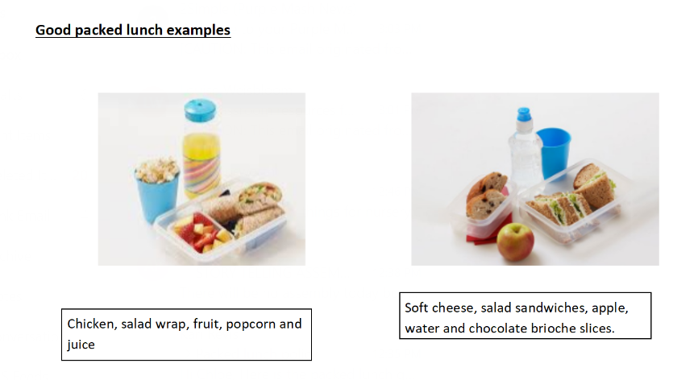

Important Dates

Reception are planning on doing some more local walks around the area this term. If you would like to volunteer to come on walks with Reception, then look out for some upcoming dates on ClassDojo.

Spare Clothes

Please ensure your child has spare clothes in their bag/on their peg every day in case of accidents or needing to change after a messy activity. Now that we are entering the Spring term we will be spending more time outdoors, exploring mud and water. The mud kitchen and water areas are an essential part of the Early Years curriculum and all children are invited to take part in exploring these areas. We will always ensure that if your child does get too wet or muddy then we will ask them to change into their spare clothes.

Thank you for your continued support
Miss Leach, Miss Liddiard, Miss Coleman and Mrs Revis

