Reception Newsletter Term 4 2026

Hello and welcome back to Term 4. We hope you had a lovely half term and ready for a busy Spring Term!

Topic
Reception’s topic in term 4 will be ‘Terrific Tales!’. We will be reading the books ‘The Gruffalo’ and ‘Little red riding hood’. We will be learning about springtime and taking part in spring crafts and activities. We will also be learning about maps and creating our own.

Events

Reception are looking forward to hosting you in school for a Spring crafts session. The session will be on Thursday 12th March @ 2.15PM. More information to follow.

There are also lots of fun easter activites next term that the whole school will be taking part in, please keep an eye on your Arbor app messages for these dates and times.

Lunchtimes

All children who have a hot dinner provided by school will have a balanced, healthy meal. These meals are free for reception aged children, you just need to book them on Arbor a week in advance.

However, if you are choosing to provide your child with a packed lunch, please refer to below which is taken from our school packed lunch guidance.

Packed lunches need to include a main like a sandwich or rice dish. They can also include foods like fruit, vegetables, or cheeses. They may also have a treat i.e. crisps, chocolate biscuit bar (not sweets). Packed lunches need to be of the right size for the age of the child who is going to eat it. Children need to eat different amounts as they grow. They do not need to eat the same amount as adults. Nuts are not allowed. Many children are allergic and this is a risk to their health. Fizzy drinks are also not allowed, during the day children should have water provided to drink in the classroom. During lunch they may have another drink in their lunch like a juice or smoothie.

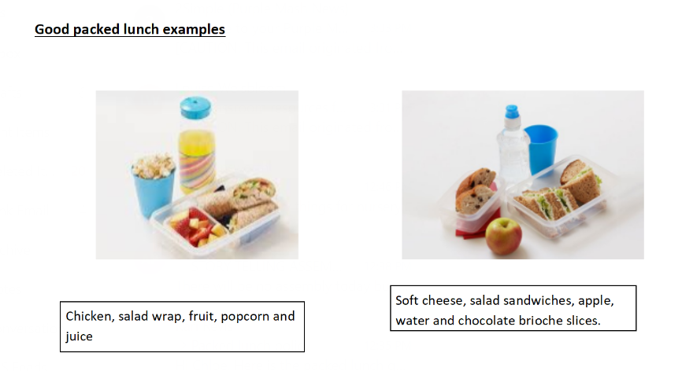

Important Dates

Reception are planning an upcoming trip and welly walks round the local area. In order to provide these opportunities to the children, we require parent volunteers. Please keep an eye out on class dojo for messages asking for volunteers when the time comes.

Spare Clothes

Please ensure your child has spare clothes in their bag/on their peg every day in case of accidents or needing to change after a messy activity. This includes, tops, bottoms (joggers, leggings etc), socks and underwear. Now that we are entering the Spring term we will be spending more time outdoors, exploring mud and water. The mud kitchen and water areas are an essential part of the Early Years curriculum and all children are invited to take part in exploring these areas. We will always ensure that if your child does get too wet or muddy then we will ask them to change into their spare clothes.

Thank you for your continued support
Mrs Hooper, Mrs Sheen and Miss Liddiard

