Reception Newsletter Term 4 2024

Hello and welcome back to Term 4. We hope you had a lovely half term and ready for a busy Spring Term!

Topic
Reception’s topic in term 4 will be ‘Come Outside’. We will be learning about planting and growing, growing our own beanstalks. We will also be keeping a close eye on the mini beasts we find in our garden, creating observational drawings along with lots of new stories, including ‘Jack and the Beanstalk’ and ‘The Tiny Seed’.

Lunchtimes
All children who have a hot dinner provided by school will have a balanced, healthy meal. However, if you are choosing to provide your child with a packed lunch, please refer to below which is taken from our school packed lunch guidance.

Packed lunches need to include a main like a sandwich or rice dish. They can also include foods like fruit, vegetables, or cheeses. They may have one treat. For example, crisps or a piece of cake, not both. Packed lunches need to be of the right size for the age of the child who is going to eat it. Children need to eat different amounts as they grow. They do not need to eat the same amount as adults. Nuts are not allowed. Many children are allergic and this is a risk to their health. Fizzy drinks are also not allowed, during the day children should have water provided to drink in the classroom. During lunch they may have another drink in their lunch like a juice or smoothie.

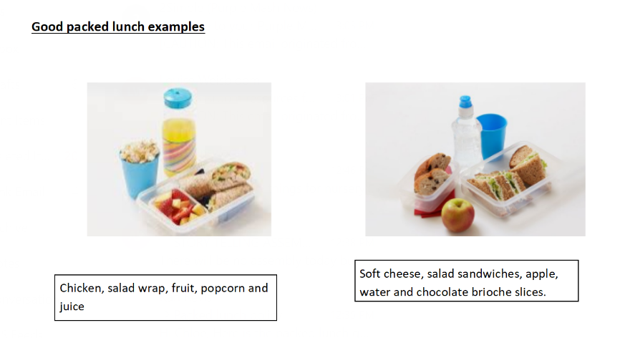

Important Dates

Reception are planning on doing some more local walks around the area this term. Unfortunately, we did not have many parents volunteer for our last trip. Trips cannot go ahead without volunteers as we need a lot of adults to leave school to ensure the children are safe. If you would like to volunteer to come on walks with Reception, then look out for some upcoming dates on ClassDojo.

Spare Clothes
Please ensure your child has spare clothes in their bag/on their peg every day in case of accidents or needing to change after a messy activity. Now that we are entering the Spring term we will be spending more time outdoors, exploring mud and water. The mud kitchen and water areas are an essential part of the Early Years curriculum and all children are invited to take part in exploring these areas. We will always ensure that if your child does get too wet or muddy then we will ask them to change into their spare clothes.

Thank you for your continued support
Miss Leach, Miss Liddiard, Miss Barnes-Long

