What should I already know?

(Substantive Knowledge)

* Understand that we can use different media (sometimes combined in one drawing) to capture the nature of things we find.
* Understand that we can hold our drawing tools in a variety of ways, experimenting with pressure, grip and speed to affect line.
* Continue to build understanding that sketchbooks are places for personal experimentation.
* Understand that the way each persons’ sketchbook looks is unique to them.

Key Vocabulary:

|  |  |
| --- | --- |
| Sketchbook   | A book or pad of drawing paper for sketches. |
| Patterns   | A repeated decorative design. |
|  | A piece of art that combines different ways of making a mark like a painting with fabric and paper. |
| Symmetry   | The quality of being made up of exactly similar parts facing each other. |
| Natural Form   | An object found in nature that has not been changed or altered. |
| Composition   | The way something is put together in a piece of art or a photograph. |

What will I learn?

(Implicit Knowledge/Skills)

* Explore different environment, collect natural objects, explore composition and qualities of objects through arranging, sorting & representing.
* The role of Photographs in art.
* Use drawing exercises to focus an exploration of observational drawing (of objects above) combined with experimental mark making, using graphite, soft pencil, handwriting pen.

* Work with care and focus, enjoying making drawings which are unrushed in our sketch books.
* Explore the qualities of different media.

Focus Artists

Rosie James and Alice Fox

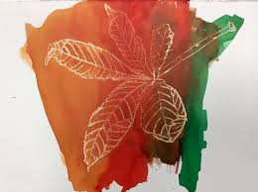

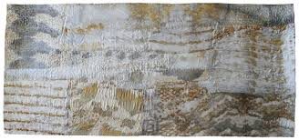

Blooms Taxonomy – Specific Verbs to Use in Lesson Aims

Knowledge: Describe, find, identify, list, locate, name, recognise, retrieve Comprehension: Classify, compare, explain, infer, interpret, paraphrase, summarise Application: Carry out, implement, use Analysis: Deconstruct, Organise, outline, structure Synthesis: Construct, design, devise, invent, make, plan, produce, Evaluation: Appraise, assess, choose,

Glue here.

My Learning Ladder

|  |  |  |  |
| --- | --- | --- | --- |
| Learning Objective | | Pupil Voice | Teacher Assessment |
| to understand that artists are often collectors and explorers | |  |  |
| to create patterns in nature | |  |  |
| to explore a range of media through continuous line drawings | |  |  |
| to create an autumn floor drawing | |  |  |
| to create an autumn floor drawing focusing on final composition | |  |
| to evaluate my autumn floor drawing | | See below. |  |
| Evaluation of my Final Piece | | | |
|  |  | | |
|  |  | | |
|  |  | | |