Key Vocabulary and Definitions:

|  |  |
| --- | --- |
| conductor | is a substance or material that allows electricity or heat to flow through it. |
| electrical | Relating to items with an electrical current. |
| insulator | Materials that do not allow electricity or heat to pass through them. |
| materials | the matter from which a thing is or can be made. |
| permeable | Allowing liquids or gases to pass through. |
| properties | A quality or trait belonging to an object. E.g. colour or texture. |
| States of Matter | All materials can be classified in to 3 groups: solid, liquid or gas. |
| thermal | relating to heat. |

What should I already know?

• Identify and compare the suitability of a variety of everyday materials, including wood, metal, plastic, glass, brick, rock, paper and cardboard for particular uses. (Y2 - Uses of everyday materials)

• Find out how the shapes of solid objects made from some materials can be changed by squashing, bending, twisting and stretching. (Y2 - Uses of everyday materials)

• Compare and group together a variety of everyday materials on the basis of whether they are attracted to a magnet, and identify some magnetic materials. (Y3 - Forces and magnets).

• Compare and group materials together, according to whether they are solids, liquids or gases. (Y4 - States of matter)

• Observe that some materials change state when they are heated or cooled, and measure or research the temperature at which this happens in degrees Celsius (°C). (Y4 - States of matter).

• Identify the part played by evaporation and condensation in the water cycle and associate the rate of evaporation with temperature. (Y4 - States of matter

Scientific Knowledge:

• Compare and group together everyday materials on the basis of their properties, including their hardness, solubility, transparency, conductivity (electrical and thermal), and response to magnets.

• Give reasons, based on evidence from comparative and fair tests, for the particular uses of everyday materials, including metals, wood and plastic.

Teaching Sequence

1. To compare different materials according to their properties.
2. To describe uses of materials based on their properties.
3. To investigate which electrical conductors make a bulb shine brightest.
4. To investigate thermal conductors and insulators (TAPS.)

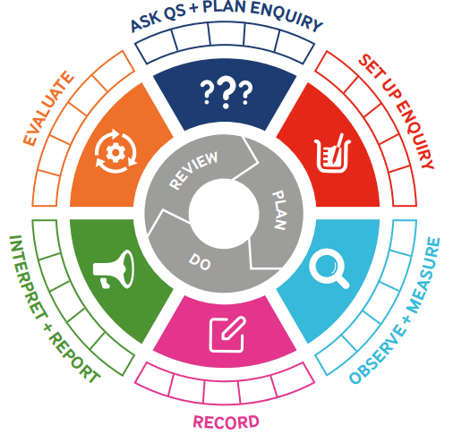

Blooms Taxonomy – Specific Verbs to Use in Lesson Aims

Knowledge: Describe, find, identify, list, locate, name, recognise, retrieve Comprehension: Classify, compare, explain, infer, interpret, paraphrase, summarise Application: Carry out, implement, use Analysis: Deconstruct, Organise, outline, structure Synthesis: Construct, design, devise, invent, make, plan, produce, Evaluation: Appraise, assess, choose,

|  |  |  |  |
| --- | --- | --- | --- |
| Term 1 | Let’s Talk (Explorify) | Scientific Knowledge | Scientific skill |
| Lesson 1 | Odd one out <https://explorify.uk/en/activities/odd-one-out/tiny-grains> | * Compare and group together everyday materials on the basis of their properties, including their hardness, solubility, transparency, conductivity (electrical and thermal), and response to magnets | To observe |
| Lesson 2 | What if…  <https://explorify.uk/en/activities/what-if/there-was-no-plastic> | * Compare and group together everyday materials on the basis of their properties, including their hardness, solubility, transparency, conductivity (electrical and thermal), and response to magnets | Making predictions |
| Lesson 3 | Electrifying metals  [Electrifying metals - Explorify](https://explorify.uk/en/activities/mystery-bag/electrifying-metals) | * Compare and group together everyday materials on the basis of their properties, including their hardness, solubility, transparency, conductivity (electrical and thermal), and response to magnets. * Give reasons, based on evidence from comparative and fair tests, for the particular uses of everyday materials, including metals, wood and plastic | Set up an enquiry (teach) |
| Lesson 4 | Hot or cold:  <https://explorify.uk/en/activities/whats-going-on/hot-or-cold> | * Compare and group together everyday materials on the basis of their properties, including their hardness, solubility, transparency, conductivity (electrical and thermal), and response to magnets. * Give reasons, based on evidence from comparative and fair tests, for the particular uses of everyday materials, including metals, wood and plastic, | Set up an enquiry (assess) |