What should I already know?
That History means something that happened in the past. Mary Seacole and Rosa Parks changed History.

Key Vocabulary and Definitions:

Castle - A type of home that was built to protect the people inside. The people that lived there were rich.

Drawbridge -A bridge that can move up and down. They were used to keep people in and out of a castle.

Dungeon -A little bit like a prison. Found inside a castle.

Knight - A little bit like a soldier.

Lance - A weapon with a long handle used by knights.

Moat - A ditch around a castle usually filled with water.
Portcullis - A heavy metal gate.

Ramparts - Part of the castle at the top of a turret to add protection.
Suit of armour - A piece of protective clothing often worn by a knight before fighting.

Turret - A round tower on the corners of a building.

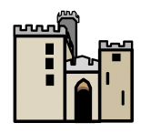

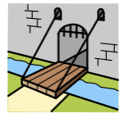

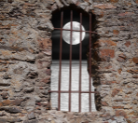
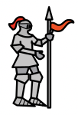
History Skills:

- To compare different time periods and their key features.
- To use a range of sources to find out characteristic features of the past.

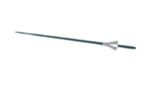

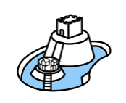
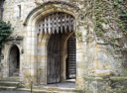

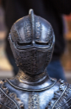
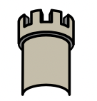

Teaching Sequence
- What is History?
- Hook – To understand the difference between classes in the medieval times (invite the children to dress up as Kings, Queens and Knights)
- To know what it was like to live in the Medieval times.
- To understand the role of a Knight in the Medieval times.
- To learn about the need for castles.
- Castle trip – To be able to understand the features of a castle.

