Key Vocabulary:

Diagonal line | It is made out of a straight line that's set at an angle instead of straight up or across.
Horizontal line | It is a straight line that is drawn from left to right or right to left.
Mosaic 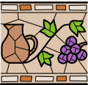 | It is a pattern or image made of small regular or irregular pieces of coloured stone, glass or ceramic, held in place by plaster/mortar, and covering a surface.
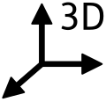 | Three dimensional, refers to the three spatial dimensions of width, height and depth.
Expand  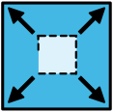 | To become or make larger or more extensive.
Sculpture  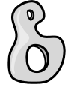 | It is an artistic form in which hard or plastic materials are worked into three-dimensional art objects.

What should I already know?
(Substantive Knowledge)
- Look at the work of illustrators and graphic artists, painters and sculptors. Understand the processes, intentions an outcomes of different artists, using visual notes in a sketchbook to help consolidate and own the learning.

- Understand artists often collaborate on projects, bringing different skills together.

- Understand that artists use sketchbooks for different purposes and that each artist will find their own ways of working in a sketchbook

- To understand that make sculpture can be challenging. To understand its takes a combination of skills, but that we can learn through practice. That it is ok to take creative risks and ok if things go wrong as well as right.

What will I learn?
(Implicit Knowledge/Skills)

- Practice drawing skills.

- Make visual notes to record ideas and processes discovered through looking at other artists.

- Test and experiment with materials.

- Reflect.

- Develop our construction skills, creative thinking and resilience skills by making sculpture which combines lots of materials. Use tools to help us construct and take creative risks by experimenting to see what happens. Use Design through Making philosophy and reflect at all stages to inform future making.

- Work collaboratively to present outcomes to others where appropriate. Present as a team.

- Share responses to classmates work, appreciating similarities and differences. Listen to feedback about your own work and respond.

Focus Artists
Lorenzo Possenti, Jan van Kessel
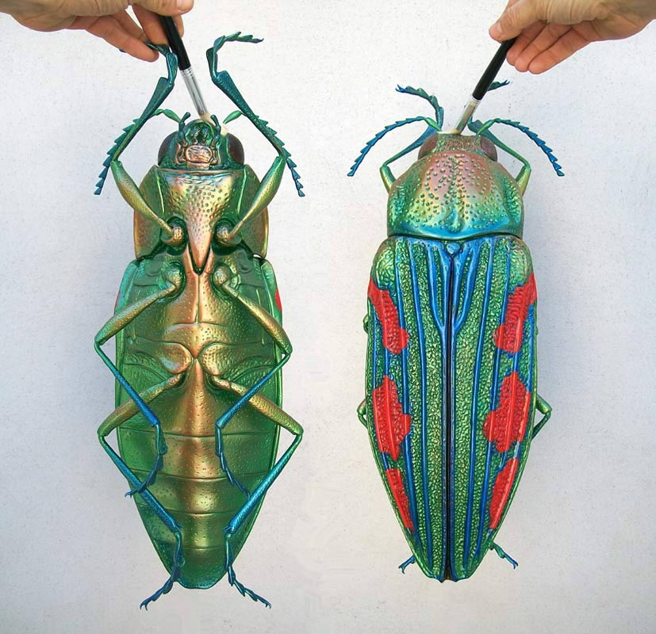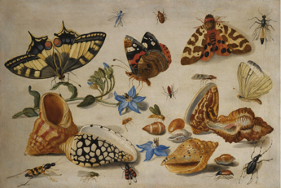
And Emile Galle
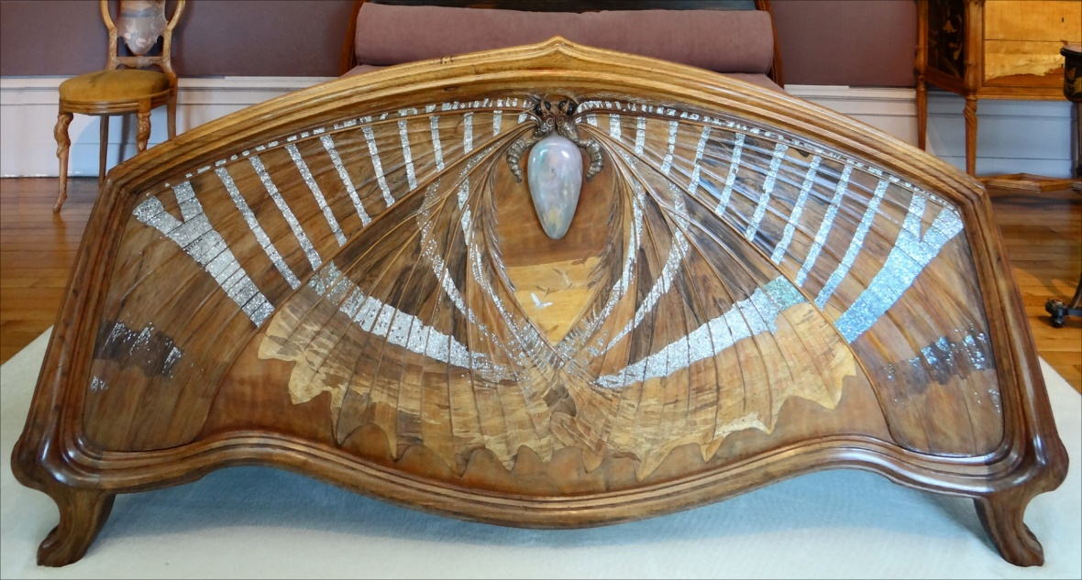

Blooms Taxonomy – Specific Verbs to Use in Lesson Aims
Knowledge: Describe, find, identify, list, locate, name, recognise, retrieve Comprehension: Classify, compare, explain, infer, interpret, paraphrase, summarise Application: Carry out, implement, use Analysis: Deconstruct, Organise, outline, structure Synthesis: Construct, design, devise, invent, make, plan, produce, Evaluation: Appraise, assess, choose,

Glue here.
My Learning Ladder

Learning Objective |  | Pupil Voice | Teacher Assessment
to explore the work of different insect artists
to draw details of an insect using pencils and crayons
to expand and image of an insect to create a mosaic
to create a 3D model of an insect

to create a 3D model of an insect

to evaluate my 3D model |  | See below.
Evaluation of my Final Piece


