What should I already know?
(Substantive Knowledge)

- Understand that set designers can design/make sets for theatres or for animations.

- Understand that designers often create scaled models to test and share ideas with others.

- Understand we may all have different responses in terms of our thoughts and the things we make. That we may share similarities. Understand all responses are valid.
Key Vocabulary:

Set  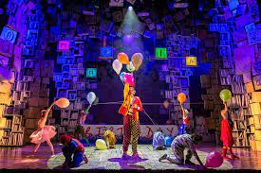 | The setting - the scenery and furniture onstage.
Maquettes  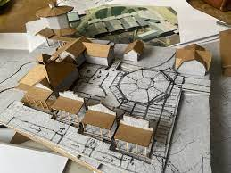 | A sculptor's small preliminary model or sketch.
Lighting  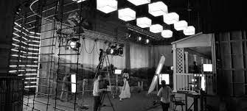 | Illuminate the performers, sets and props so the audience can clearly see everything they're meant to see onstage.
Focus  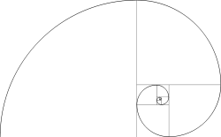 | A key point of interest in your painting that you want your viewers to notice first.
Atmosphere  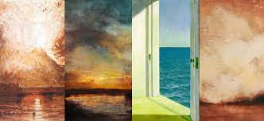 | Using different colours to show temperature, feelings and intentions.
Composition | The way something is put together in a piece of art or a photograph.

What will I learn?
(Implicit Knowledge/Skills)
  - Use charcoal, graphite, pencil, pastel to create drawings of atmospheric “sets” to help inform set design.
  - Explore ideas relating to design (though do not use sketchbooks to design on paper), exploring thoughts about inspiration source, materials, textures, colours, mood, lighting etc.
  - Make visual notes to capture, consolidate and reflect upon the artists studied.
  - Brainstorm ideas generated when reading poetry or prose.
  - Use Design through Making, inspired by a brief, to create a scale model “set” for a theatre production or an animation.
  - Construct with a variety of media, using tools. Think about scale, foreground, background, lighting, texture, space, structure and intention.
  - Work collaboratively to present outcomes to others where appropriate. Present as a team.
  - Share responses to classmates work, appreciating similarities and differences. Listen to feedback about your own work and respond.

Focus Artists
Rae Smith

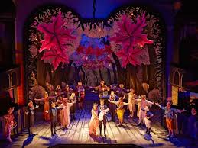

Blooms Taxonomy – Specific Verbs to Use in Lesson Aims
Knowledge: Describe, find, identify, list, locate, name, recognise, retrieve Comprehension: Classify, compare, explain, infer, interpret, paraphrase, summarise Application: Carry out, implement, use Analysis: Deconstruct, Organise, outline, structure Synthesis: Construct, design, devise, invent, make, plan, produce, Evaluation: Appraise, assess, choose,

Glue here.
My Learning Ladder

Learning Objective |  | Pupil Voice | Teacher Assessment
to explore the work of Rae Smith
to create a sense of drama through drawing and sculpture
to design mini scene of *book/chosen text
to build my maquette of *book/chosen text
to add details to my maquette of *book/chosen text
to evaluate my maquette |  | See below.
Evaluation of my Final Piece


