Key Vocabulary and Definitions:

Animation  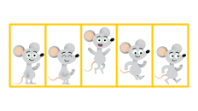 | A method by which still figures are moved to create a new image.
Flip book  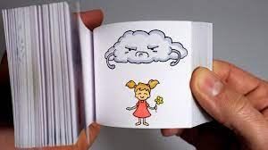 | A flipbook is a small book which has images that appear to move.
Stop-frame animation  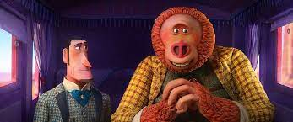 | An animation that is drawn one frame at time, with physical objects that are moved between.
Sequence  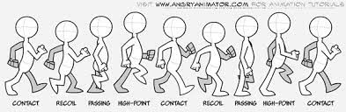 | A particular order in which the images move.
Image | A visual representation of something.
Photograph | A picture made using a camera or iPad.
Setting  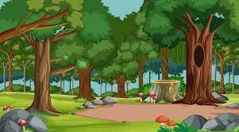 | The place or type of setting where something is takes place.
Character  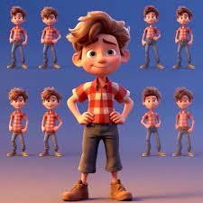 | A person in a novel, play, or film.
Events | An event is an action recognised by software.
Onion skinning  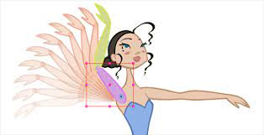 | An editing technique used to see several frames of an animation at the same time.

Overview
Learners will develop their understanding of animation. This unit progresses students’ knowledge and understanding of using digital devices to create media, exploring how they can create stop-frame animations. Following this unit, learners will further develop their video editing skills in Year 3.

National Curriculum:
Computing
- Use sequence, selection, and repetition in programs; work with variables and various forms of input and output.
- Select, use and combine a variety of software (including internet services) on a range of digital devices to design and create a range of programs.
- Select, use and combine a variety of software (including internet services) on a range of digital devices to design and create a range of programs, systems and content that accomplish given goals, including collecting, analysing, evaluating and presenting data and information.
Internet safety
- Use technology safely, respectfully, and responsibly; recognise acceptable/unacceptable behaviour.

Teaching Sequence
Systems and Searches
- To explain that animation is a sequence of drawings or photographs.
- To relate animated movement with a sequence of images.
- To plan an animation
- To identify the need to work consistently and carefully.
- To review and improve an animation.
- To evaluate the impact of adding other media to an animation.
Online Safety: Online Bullying
1. To describe appropriate ways to behave towards other people online.
2. To understand why it is important to behave appropriately online.
3. To give examples of how bullying behaviour could appear online.
4. To understand the smart rules with a focus on T(tell) (2 lessons)
Blooms Taxonomy – Specific Verbs to Use in Lesson Aims
Knowledge: Describe, find, identify, list, locate, name, recognise, retrieve Comprehension: Classify, compare, explain, infer, interpret, paraphrase, summarise Application: Carry out, implement, use Analysis: Deconstruct, Organise, outline, structure Synthesis: Construct, design, devise, invent, make, plan, produce, Evaluation: Appraise, assess, choose,

Key Vocabulary and Definitions:

Animation | A method by which still figures are moved to create a new image.
Flip book | A flipbook is a small book which has images that appear to move.
Stop-frame animation | An animation that is drawn one frame at time, with physical objects that are moved between.
Sequence | A particular order in which the images move.
Image | A visual representation of something.
Photograph | A picture made using a camera or iPad.
Setting | The place or type of setting where something is takes place.
Character | A person in a novel, play, or film.
Events | An event is an action recognised by software.
Onion skinning | An editing technique used to see several frames of an animation at the same time.

Overview
Learners will develop their understanding of animation. This unit progresses students’ knowledge and understanding of using digital devices to create media, exploring how they can create stop-frame animations. Following this unit, learners will further develop their video editing skills in Year 3.

National Curriculum:
Computing
- Use sequence, selection, and repetition in programs; work with variables and various forms of input and output.
- Select, use and combine a variety of software (including internet services) on a range of digital devices to design and create a range of programs.
- Select, use and combine a variety of software (including internet services) on a range of digital devices to design and create a range of programs, systems and content that accomplish given goals, including collecting, analysing, evaluating and presenting data and information.
Internet safety
- Use technology safely, respectfully, and responsibly; recognise acceptable/unacceptable behaviour.

Teaching Sequence
Systems and Searches
- To explain that animation is a sequence of drawings or photographs.
- To relate animated movement with a sequence of images.
- To plan an animation
- To identify the need to work consistently and carefully.
- To review and improve an animation.
- To evaluate the impact of adding other media to an animation.
Online Safety: Online Bullying
1. To describe appropriate ways to behave towards other people online.
2. To understand why it is important to behave appropriately online.
3. To give examples of how bullying behaviour could appear online.
4. To understand the smart rules with a focus on T(tell) (2 lessons)
Blooms Taxonomy – Specific Verbs to Use in Lesson Aims
Knowledge: Describe, find, identify, list, locate, name, recognise, retrieve Comprehension: Classify, compare, explain, infer, interpret, paraphrase, summarise Application: Carry out, implement, use Analysis: Deconstruct, Organise, outline, structure Synthesis: Construct, design, devise, invent, make, plan, produce, Evaluation: Appraise, assess, choose,

Key knowledge

