Key Vocabulary and Definitions:

Instructions 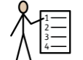 | A direction or order
Create  | To make something.
Command  | The ability to use or control something
Modify  | To change something.
Sequence 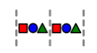 | A particular order in which related things follow each other.
Present 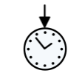 | To show your work.
Retrieve  | To find something that has previous been saved.
Save  | To store something on a computer or device.
Repetition  | The action of repeating something that has already been said or written
Program 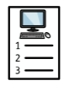 | A series of coded software instructions to control the operation of a computer or other machine.
Pattern  | An arrangement of lines or shapes.
Loop  | a structure, series, or process, the end of which is connected to the beginning

What should I already know?
- Predict what will happen for a more complex sequence of instructions which uses repetition.
- Investigate how a problem can be solved by decomposing it into smaller steps and by planning a solution.
- Make algorithms that solve problems which use sequences and repetition.
- Input commands using a keyboard on any device (including on a tablet) with increased fluency, using efficient shortcuts where possible i.e. Shift + ‘letter’ instead of Caps Lock.
- Create, modify and present work using different software/apps.

Computing Skills:
- Online Safety – online bullying: to recognise when someone is upset, hurt or angry online, describe ways people can be bullied through a range of media, explain why people need to think carefully about how content they post might affect others, their feelings and how it may affect how others feel about them.
- To create programs by planning, modifying, and testing commands to create shapes and patterns. They will use Turtle academy, a text-based programming language.

Blooms Taxonomy – Specific Verbs to Use in Lesson Aims
Knowledge: Describe, find, identify, list, locate, name, recognise, retrieve Comprehension: Classify, compare, explain, infer, interpret, paraphrase, summarise Application: Carry out, implement, use Analysis: Deconstruct, Organise, outline, structure Synthesis: Construct, design, devise, invent, make, plan, produce, Evaluation: Appraise, assess, choose,

Teaching Sequence
1a. To recognise when someone is upset, hurt or angry online.
1b. To identify that accuracy in programming is important and create a program in a text-based language.
2a. To describe ways people can be bullied through a range of media (e.g., image, video, text, chat).
2b. To explain what ‘repeat’ means and use it to produce a given outcome.
3a. To explain why I need to think to think carefully about how content I post might affect others, their feelings and how it may affect how others feel about them (their reputation).
3b. To modify codes to produce a given outcome.
4b. To create a program that uses repetition and patterns to produce a given outcome.

Key Vocabulary and Definitions:

Instructions | A direction or order
Create | To make something.
Command | The ability to use or control something
Modify | To change something.
Sequence | A particular order in which related things follow each other.
Present | To show your work.
Retrieve | To find something that has previous been saved.
Save | To store something on a computer or device.
Repetition | The action of repeating something that has already been said or written
Program | A series of coded software instructions to control the operation of a computer or other machine.
Pattern | An arrangement of lines or shapes.
Loop | a structure, series, or process, the end of which is connected to the beginning

What should I already know?
- Predict what will happen for a more complex sequence of instructions which uses repetition.
- Investigate how a problem can be solved by decomposing it into smaller steps and by planning a solution.
- Make algorithms that solve problems which use sequences and repetition.
- Input commands using a keyboard on any device (including on a tablet) with increased fluency, using efficient shortcuts where possible i.e. Shift + ‘letter’ instead of Caps Lock.
- Create, modify and present work using different software/apps.

Computing Skills:
- Online Safety – online bullying: to recognise when someone is upset, hurt or angry online, describe ways people can be bullied through a range of media, explain why people need to think carefully about how content they post might affect others, their feelings and how it may affect how others feel about them.
- To create programs by planning, modifying, and testing commands to create shapes and patterns. They will use Turtle academy, a text-based programming language.

Blooms Taxonomy – Specific Verbs to Use in Lesson Aims
Knowledge: Describe, find, identify, list, locate, name, recognise, retrieve Comprehension: Classify, compare, explain, infer, interpret, paraphrase, summarise Application: Carry out, implement, use Analysis: Deconstruct, Organise, outline, structure Synthesis: Construct, design, devise, invent, make, plan, produce, Evaluation: Appraise, assess, choose,

Teaching Sequence
1a. To recognise when someone is upset, hurt or angry online.
1b. To identify that accuracy in programming is important and create a program in a text-based language.
2a. To describe ways people can be bullied through a range of media (e.g., image, video, text, chat).
2b. To explain what ‘repeat’ means and use it to produce a given outcome.
3a. To explain why I need to think to think carefully about how content I post might affect others, their feelings and how it may affect how others feel about them (their reputation).
3b. To modify codes to produce a given outcome.
4b. To create a program that uses repetition and patterns to produce a given outcome.

Key Knowledge
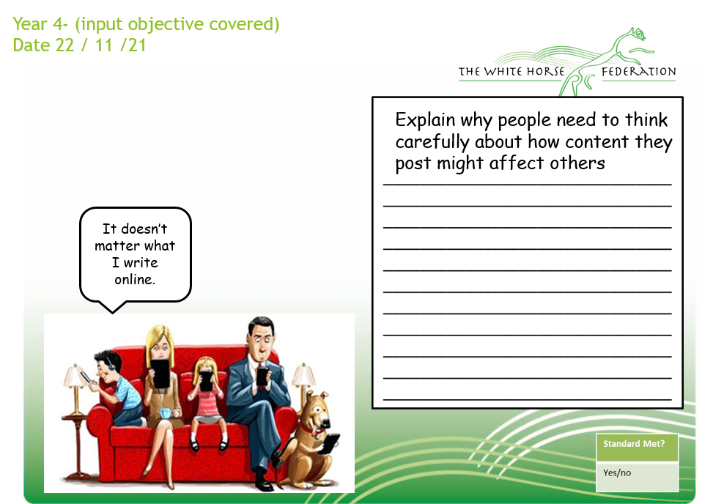

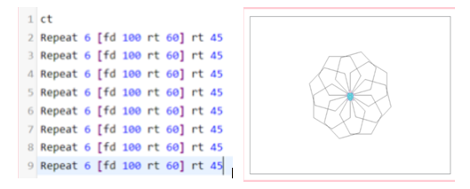

In Term 2, children will create a programme where they will be repeating shapes. They will combine the skills learnt throughout the term (e.g. patterns and repeats). The children will use their designs to program wrapping paper.

