Technical Knowledge and skills:

- begin to measure with some accuracy and join materials, with some support

- describe differences in materials with some help

- suggest ways to make material/product stronger with some help
What should I already know?
Use what they have learnt about materials,
thinking about uses and purposes
Think about and discuss what they want to make.
Discuss their work as it progresses with support.

DT Skills:
Discuss and evaluate the existing products to understand their purpose. Discus the given design brief and the design criteria.
Design their own product using labelled drawings. Be able to discuss what resources they require for their products.
Based on their individual designs, choose from a variety of materials and perform practical skills e.g cutting joining and finishing the product with some independence etc
Testing their products.
Evaluate their ideas and products against the design criteria provided using a sheet with sentence starters.

Key Vocabulary:

Function  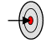 | The purpose or task of (a specified thing).
Man-made   | Made or caused by human beings as opposed to occurring naturally
Natural  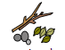 | Existing in or derived from nature; not made or caused by humankind.
Stable  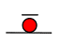 | Not likely to give way or overturn; firmly fixed.
Stiff  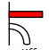 | Not easily bent or changed in shape; rigid.
Strong  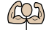 | able to withstand force, pressure, or wear.

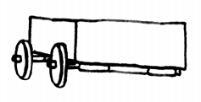

Focused designer/ company

Tom Raffield

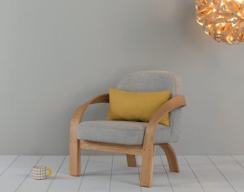

Blooms Taxonomy – Specific Verbs to Use in Lesson Aims
Knowledge: Describe, find, identify, list, locate, name, recognise, retrieve Comprehension: Classify, compare, explain, infer, interpret, paraphrase, summarise Application: Carry out, implement, use Analysis: Deconstruct, Organise, outline, structure Synthesis: Construct, design, devise, invent, make, plan, produce, Evaluation: Appraise, assess, choose,

Examples

