Key Vocabulary and Definitions:
Archaeology  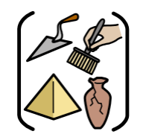 | The study of things that people made, used, and left behind.
Artefact  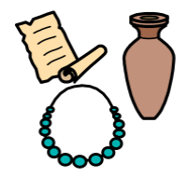 | An object made by humans, often used to find out about a period in history.
Mesolithic   | The middle part of the Stone Age.
Neolithic  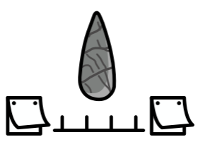 | The later part of the Stone Age.
Paleolithic  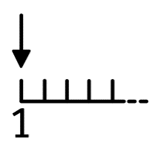 | The early part of the Stone Age.
Prehistoric  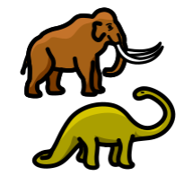 | The period of time before written records began.
Settlement  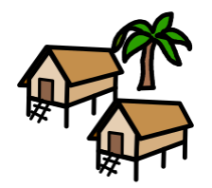 | A place where a group of people decide to live for the first time
Stonehenge  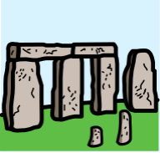 | A world-famous monument built between the Stone Age and Bronze Age

What should I already know?
- History is divided into BC and AD.
- Historical artefacts and written evidence can be used to give us information about the past
- Use common words and phrases relating to the passing of time.

Historical Skills:
- Sequence events or artefacts;
- Find out about everyday lives of people in time studied compare with our life today;
- Understand why people may have had to do something
- Identify and give reasons for different ways in which the past is represented
- Use a range of sources to find out about a period
- Select and record information relevant to the study
- Communicate their knowledge through discussion, drawing pictures, drama/ role play, making models, writing and using ICT

Teaching Sequence
- To understand the term ‘prehistory’ and its place in British History.
- To understand how the hunter-gatherers survived in the Stone Age.
- To examine sources of evidence about the Stone Age.
- To research how houses changed during the Stone Age
- To research the history of Skara Brae.
- To explore different theories about the building of Stonehenge.
- To compare Stone Age and modern life.

Blooms Taxonomy – Specific Verbs to Use in Lesson Aims
Knowledge: Describe, find, identify, list, locate, name, recognise, retrieve Comprehension: Classify, compare, explain, infer, interpret, paraphrase, summarise Application: Carry out, implement, use Analysis: Deconstruct, Organise, outline, structure Synthesis: Construct, design, devise, invent, make, plan, produce, Evaluation: Appraise, assess, choose,

Key Vocabulary and Definitions:
Archaeology | The study of things that people made, used, and left behind.
Artefact | An object made by humans, often used to find out about a period in history.
Mesolithic | The middle part of the Stone Age.
Neolithic | The later part of the Stone Age.
Paleolithic | The early part of the Stone Age.
Prehistoric | The period of time before written records began.
Settlement | A place where a group of people decide to live for the first time
Stonehenge | A world-famous monument built between the Stone Age and Bronze Age

What should I already know?
- History is divided into BC and AD.
- Historical artefacts and written evidence can be used to give us information about the past
- Use common words and phrases relating to the passing of time.

Historical Skills:
- Sequence events or artefacts;
- Find out about everyday lives of people in time studied compare with our life today;
- Understand why people may have had to do something
- Identify and give reasons for different ways in which the past is represented
- Use a range of sources to find out about a period
- Select and record information relevant to the study
- Communicate their knowledge through discussion, drawing pictures, drama/ role play, making models, writing and using ICT

Teaching Sequence
- To understand the term ‘prehistory’ and its place in British History.

- To understand how the hunter-gatherers survived in the Stone Age.

- To examine sources of evidence about the Stone Age.

- To research how houses changed during the Stone Age

- To research the history of Skara Brae.

- To explore different theories about the building of Stonehenge.

- To compare Stone Age and modern life.

Blooms Taxonomy – Specific Verbs to Use in Lesson Aims
Knowledge: Describe, find, identify, list, locate, name, recognise, retrieve Comprehension: Classify, compare, explain, infer, interpret, paraphrase, summarise Application: Carry out, implement, use Analysis: Deconstruct, Organise, outline, structure Synthesis: Construct, design, devise, invent, make, plan, produce, Evaluation: Appraise, assess, choose,

Key Knowledge
Timeline of Key Events: Four different types of Stone Age dwelling:
15,000 BC | People begin to make cave paintings.
13,000 BC | Animal hide is used to make shelters
4,500 BC | Farming starts and begins to spread
3,500 BC | The first pottery is made and used
2,500 BC | Metal starts to be used
1,800 BC | The first copper mines are dug
1,200 BC | Metal tools are made and used
800-700 BC | The first hill forts are made
100 BC | Coins are made and used for the first time

Cave Paintings:

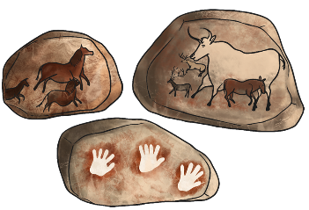

Most cave paintings were of animals or hunters.
They used natural colours from mineral pigments.

