What should I already know?
- To know if God important to everyone.

- To remember the Christmas story and start to explain that Christians believe Jesus was a gift from God.
Key Vocabulary and Definitions:

Bethlehem 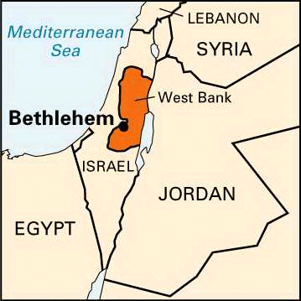 | The town where Jesus was born in a stable.
Christian | A person who follows the teachings of Jesus Christ.
Nativity 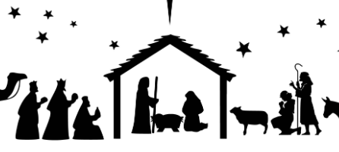 | The story of the birth of Jesus celebrated by Christians.
Shepherds  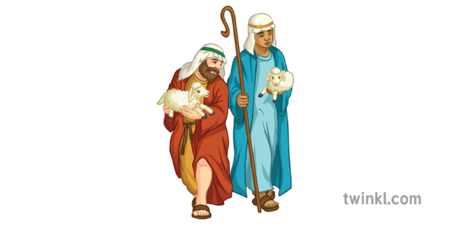 | First people to learn of the birth of Christ.
Stable  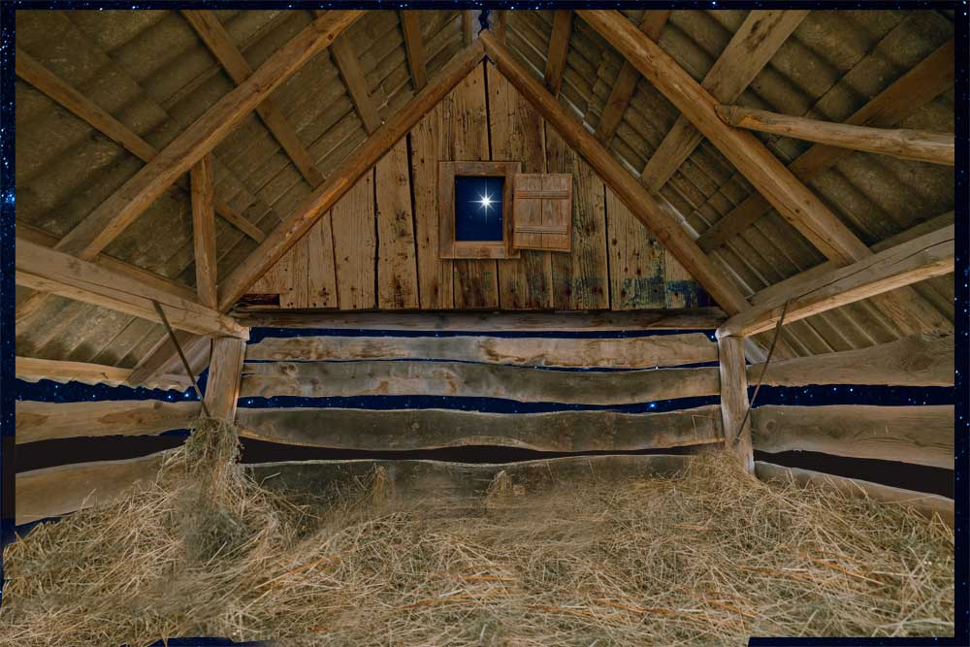 | Royalty would be born in a palace, but Jesus was born in a stable.
Star | The star led the wise men to Jesus. It also portrays to Christians that Jesus is the light of the world.
Wise men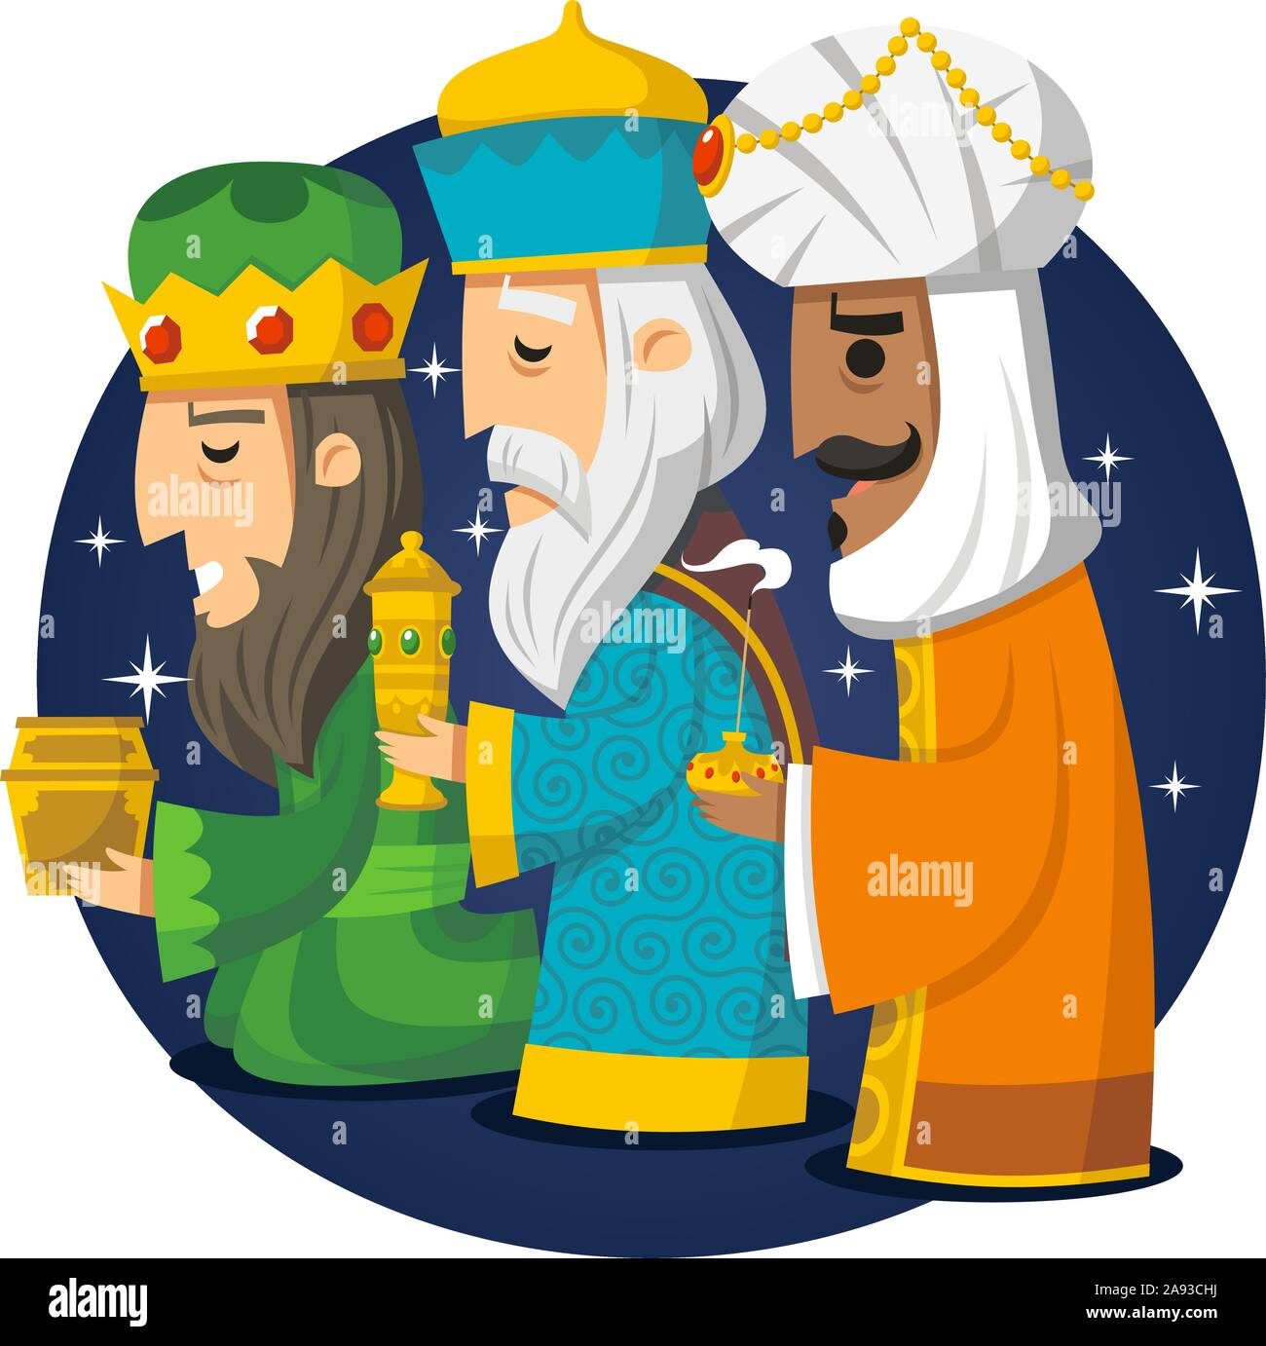 | The wise men travelled a great distance because the star signified that a king had been born. They chose gifts fit for royalty.

RE Skills:
- To explain what Christmas means to me and talk about whether this involves giving and receiving gifts.

- To start to explain the Christian belief that Jesus was God in human form and why God gave him to the world.

- To start to tell you what Christmas means to Christians and what it means to me.

Teaching Sequence

- To know what Christmas means to me.
- To explore the meaning of Christmas to Christians.
- To know that the nativity story tells Christians about Jesus.
- To understand why Christmas is meaningful to Christians.
- What is the true meaning of Christmas to Christians?
- To design a Christmas gift to make the world a better place.
Blooms Taxonomy – Specific Verbs to Use in Lesson Aims
Knowledge: Describe, find, identify, list, locate, name, recognise, retrieve Comprehension: Classify, compare, explain, infer, interpret, paraphrase, summarise Application: Carry out, implement, use Analysis: Deconstruct, Organise, outline, structure Synthesis: Construct, design, devise, invent, make, plan, produce, Evaluation: Appraise, assess, choose,

What should I already know?
- To know if God important to everyone.

- To remember the Christmas story and start to explain that Christians believe Jesus was a gift from God.
Key Vocabulary and Definitions:

Bethlehem | The town where Jesus was born in a stable.
Christian | A person who follows the teachings of Jesus Christ.
Nativity | The story of the birth of Jesus celebrated by Christians.
Shepherds | First people to learn of the birth of Christ.
Stable | Royalty would be born in a palace, but Jesus was born in a stable.
Star | The star led the wise men to Jesus. It also portrays to Christians that Jesus is the light of the world.
Wise men | The wise men travelled a great distance because the star signified that a king had been born. They chose gifts fit for royalty.

RE Skills:
- To explain what Christmas means to me and talk about whether this involves giving and receiving gifts.

- To start to explain the Christian belief that Jesus was God in human form and why God gave him to the world.

- To start to tell you what Christmas means to Christians and what it means to me.

Teaching Sequence

- To know what Christmas means to me.
- To explore the meaning of Christmas to Christians.
- To know that the nativity story tells Christians about Jesus.
- To understand why Christmas is meaningful to Christians.
- What is the true meaning of Christmas to Christians?
- To design a Christmas gift to make the world a better place.
Blooms Taxonomy – Specific Verbs to Use in Lesson Aims
Knowledge: Describe, find, identify, list, locate, name, recognise, retrieve Comprehension: Classify, compare, explain, infer, interpret, paraphrase, summarise Application: Carry out, implement, use Analysis: Deconstruct, Organise, outline, structure Synthesis: Construct, design, devise, invent, make, plan, produce, Evaluation: Appraise, assess, choose,

Key Knowledge

