Key Vocabulary and Definitions:
Changes of State | 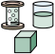 | The process of turning solid into gas or liquid, and vice versa.
dissolve | 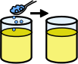 | A solid becomes part of a liquid and in known as solution.
evaporation | 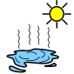 | The process of turning from liquid into a gas.
filtration | 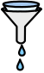 | The process of removing unwanted material.
irreversible change |  | A change that cannot be undone.
permeable | 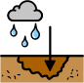 | Allowing liquids or gases to pass through.
properties | 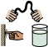 | A quality or trait belonging to an object. E.g. colour or texture.
reversible change | 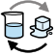 | A change that can be undone or reversed.
soluble |  | A substance that is able to be dissolved.
Solution | 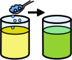 | A mixture of two or more substances that stays evenly mixed.

What should I already know?
• Identify and compare the suitability of a variety of everyday materials, including wood, metal, plastic, glass, brick, rock, paper and cardboard for particular uses. (Y2 - Uses of everyday materials)
• Find out how the shapes of solid objects made from some materials can be changed by squashing, bending, twisting and stretching. (Y2 - Uses of everyday materials)
• Compare and group together a variety of everyday materials on the basis of whether they are attracted to a magnet, and identify some magnetic materials. (Y3 - Forces and magnets).
• Compare and group materials together, according to whether they are solids, liquids or gases. (Y4 - States of matter)
• Observe that some materials change state when they are heated or cooled, and measure or research the temperature at which this happens in degrees Celsius (°C). (Y4 - States of matter).
• Identify the part played by evaporation and condensation in the water cycle and associate the rate of evaporation with temperature. (Y4 - States of matter

Scientific Knowledge:
- Know that some materials will dissolve in liquid to form a solution and describe how to recover a substance from a solution.
- Use knowledge of solids, liquids and gases to decide how mixtures might be separated, including through filtering, sieving and evaporating.
- Demonstrate that dissolving, mixing and changes of state are reversible changes.
- Explain that some changes result in the formation of new materials, and that this kind of change is not usually reversible, including changes associated with burning and the action of acid on bicarbonate of soda.

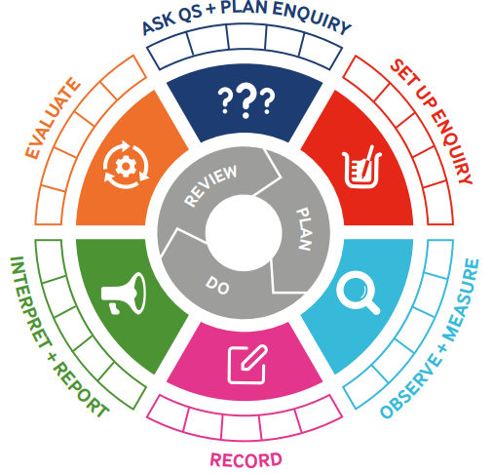
Teaching Sequence

- To discuss states of matter.
- To investigate dissolving soluble material in liquids. (TAPS)
- To use knowledge of solids, liquids and gases to decide how mixtures and solutions might be separated
- To explain that some changes form new materials, and that these changes are not usually reversible.
- To identify when a change caused by heating or cooling is reversible or irreversible
- To investigate the materials needed for something to burn and the new materials formed by burning
Blooms Taxonomy – Specific Verbs to Use in Lesson Aims
Knowledge: Describe, find, identify, list, locate, name, recognise, retrieve Comprehension: Classify, compare, explain, infer, interpret, paraphrase, summarise Application: Carry out, implement, use Analysis: Deconstruct, Organise, outline, structure Synthesis: Construct, design, devise, invent, make, plan, produce, Evaluation: Appraise, assess, choose,

Term 1 | Let’s Talk (Explorify) | Scientific Knowledge | Scientific skill
Lesson 1 | https://explorify.uk/en/activities/who-is/marie-curie | - Compare and group materials together, according to whether they are solids, liquids or gases. (Y4 - States of matter
Lesson 2 | https://explorify.uk/en/activities/have-you-ever/tasted-sugar-in-your-cereal-milk | - Know that some materials will dissolve in liquid to form a solution and describe how to recover a substance from a solution.  - Demonstrate that dissolving, mixing and changes of state are reversible changes. | Ask Questions and plan an enquiry
Lesson 3 | https://explorify.uk/en/activities/have-you-ever/watched-water-being-drained-from-rice-or-pasta | - Use knowledge of solids, liquids and gases to decide how mixtures might be separated, including through filtering, sieving and evaporating.
Lesson 4 | https://explorify.uk/en/activities/odd-one-out/hot-drinks-for-cold-days | - Explain that some changes result in the formation of new materials, and that this kind of change is not usually reversible, including changes associated with burning and the action of acid on bicarbonate of soda.
Lesson 5 | https://explorify.uk/en/activities/whats-going-on/baking-cookies | - Demonstrate that dissolving, mixing and changes of state are reversible changes.  - Explain that some changes result in the formation of new materials, and that this kind of change is not usually reversible, including changes associated with burning and the action of acid on bicarbonate of soda.
Lesson 6 | https://explorify.uk/en/activities/have-you-ever/burnt-your-toast | - Demonstrate that dissolving, mixing and changes of state are reversible changes.  - Explain that some changes result in the formation of new materials, and that this kind of change is not usually reversible, including changes associated with burning and the action of acid on bicarbonate of soda.

