Key Vocabulary and Definitions:

Fossil  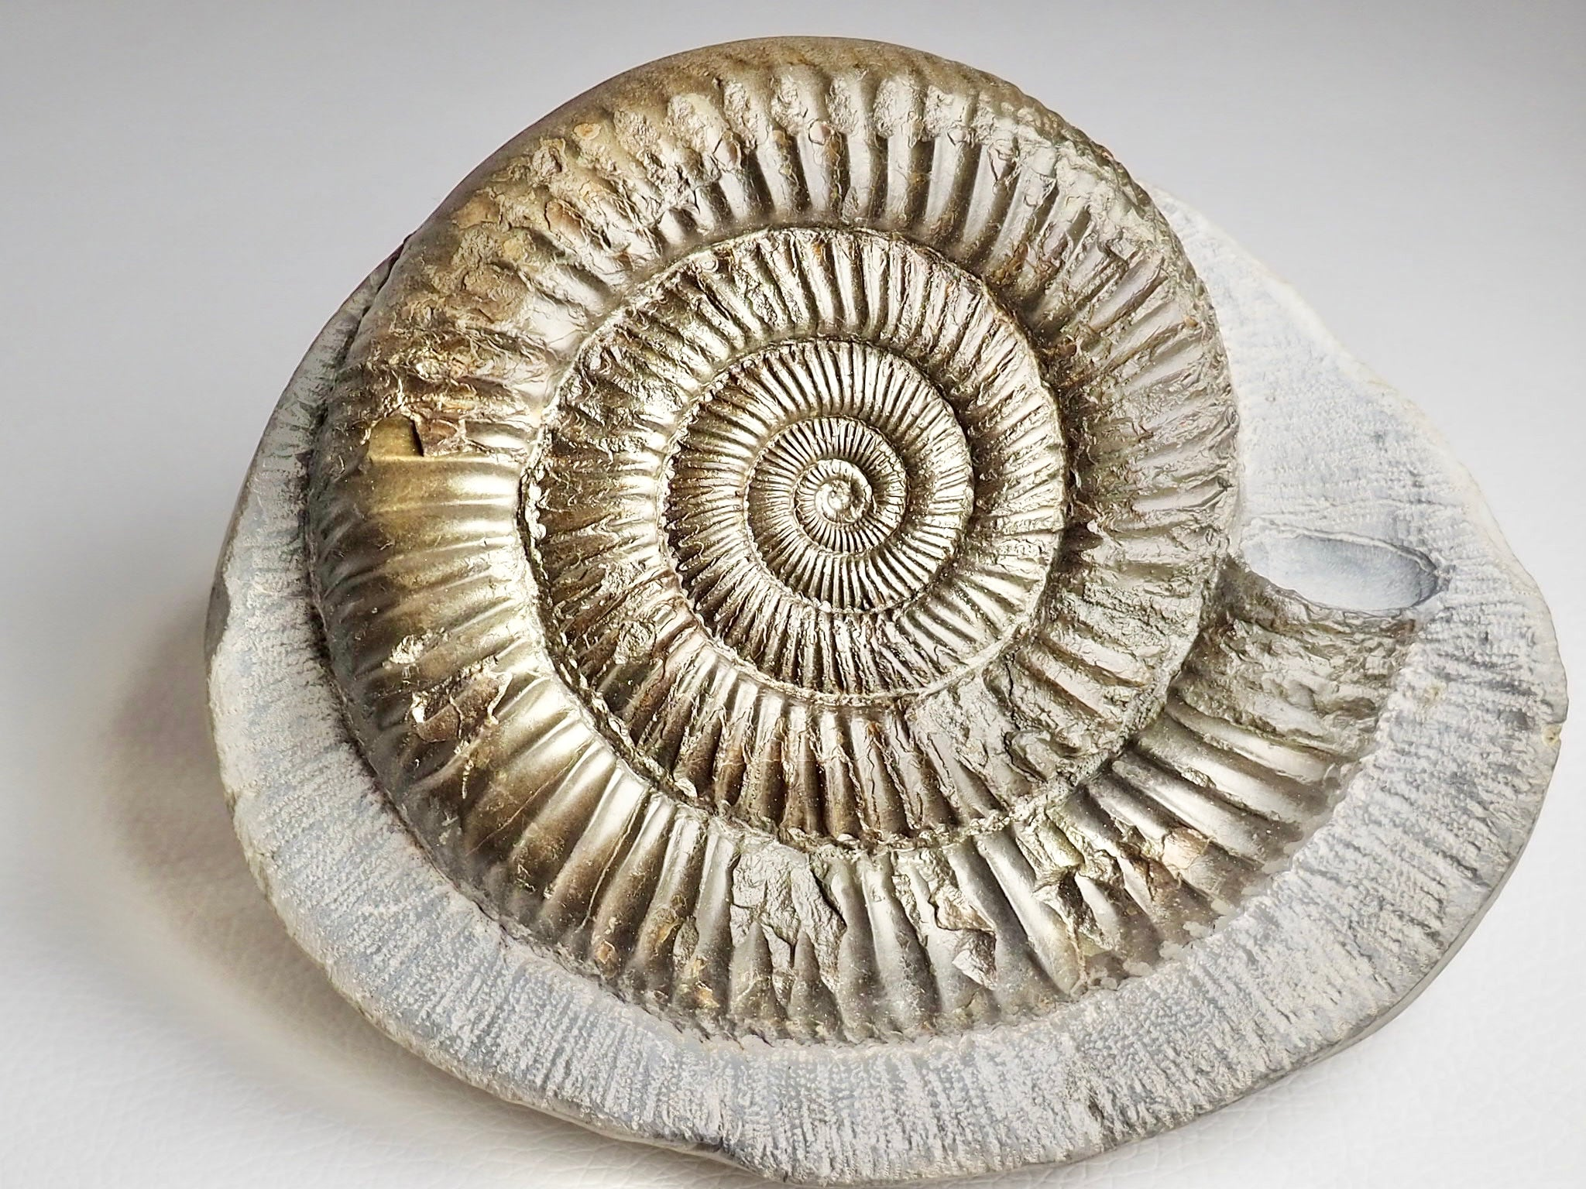 | Fossils are the remains or traces of plants and animals that lived long ago.
Impermeable  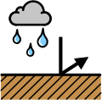 | An impermeable surface prevents especially liquids to pass through.
Minerals  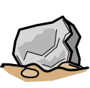 | Minerals make up Earth’s rocks, sands and soils. They do not come from an animal or a plant.
Organic matter  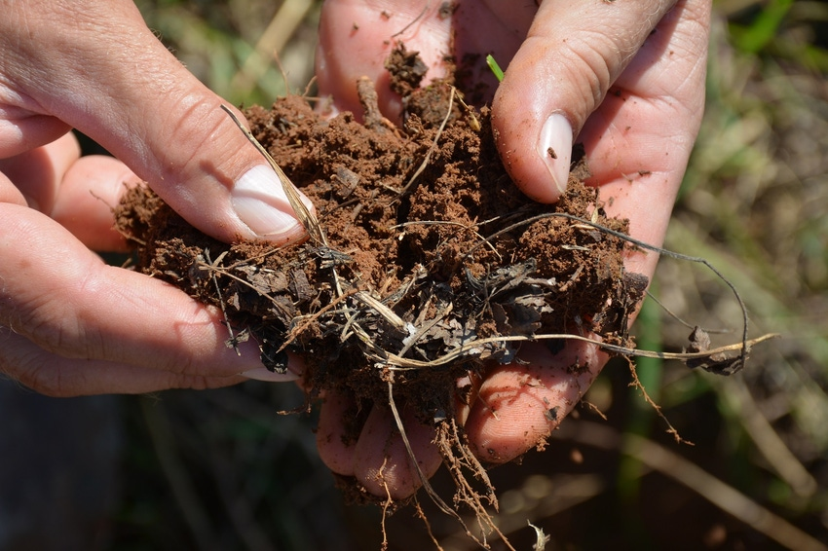 | Organic matter has come from a recently living organism. It is capable of decay or is the product of decay.
Permeable  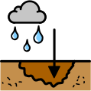 | A permeable surface allows materials like liquids to pass through.
Rock  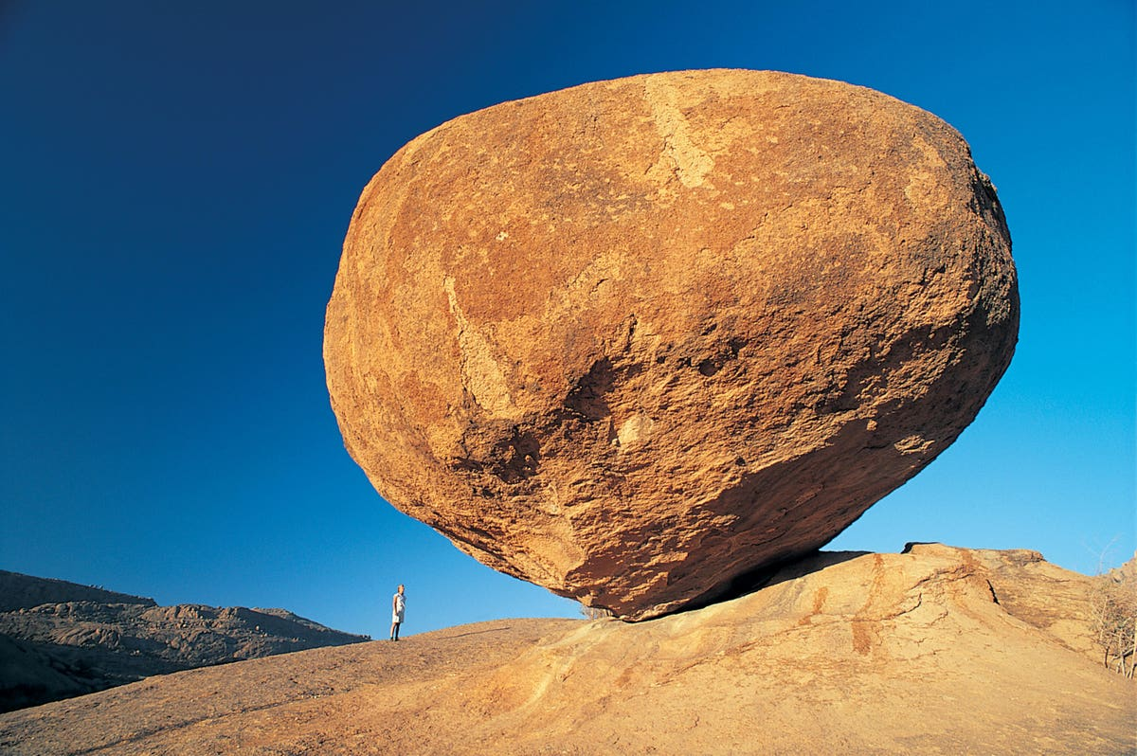 | Rock is a hard material made up of one or more minerals.
Sedimentary rock  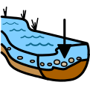 | They are formed of layers of sediment build up over thousands of years, they are compressed or squashed and become bonded together.
Soil  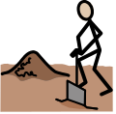 | Soil is a mixture of minerals and organic material that covers much of Earth’s surface.

What should I already know?
- Distinguish between an object and the material from which it is made. (Y1 - Everyday materials)
- Identify and name a variety of everyday materials, including wood, plastic, glass, metal, water, and rock. (Y1 - Everyday materials)
- Describe the simple physical properties of a variety of everyday materials. (Y1 - Everyday materials)
- Compare and group together a variety of everyday materials on the basis of their simple physical properties. (Y1 - Everyday materials)
- Identify and compare the suitability of a variety of everyday materials, including wood, metal, plastic, glass, brick, rock, paper and cardboard for particular uses. (Y2 - Uses of everyday materials)

Scientific Knowledge:

- Compare and group together different kinds of rocks on the basis of their appearance and simple physical properties.
- Describe in simple terms how fossils are formed when things that have lived are trapped within rock.
- Recognise that soils are made from rocks and organic matter.

Teaching Sequence

- To know how fossils are formed.
- To identify naturally occurring rocks and explore their uses.
- To group rocks according to their properties.
- To compare and group together different kinds of rocks
on the basis of their properties. (TAPS)
- To recognise that soils are made from rocks and organic matter.

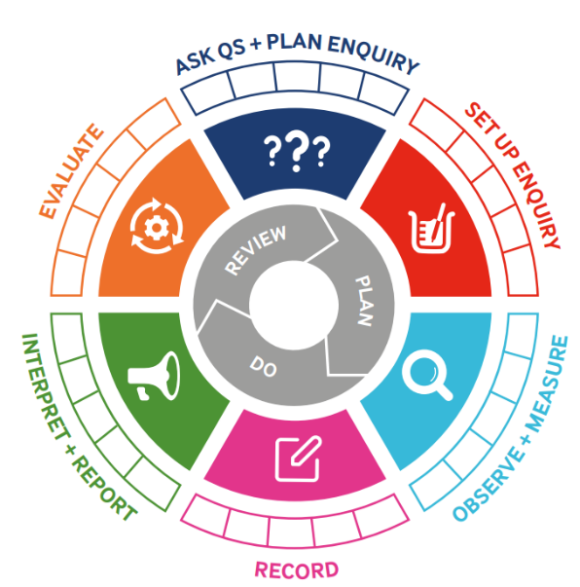
Blooms Taxonomy – Specific Verbs to Use in Lesson Aims
Knowledge: Describe, find, identify, list, locate, name, recognise, retrieve Comprehension: Classify, compare, explain, infer, interpret, paraphrase, summarise Application: Carry out, implement, use Analysis: Deconstruct, Organise, outline, structure Synthesis: Construct, design, devise, invent, make, plan, produce, Evaluation: Appraise, assess, choose,

Key Vocabulary and Definitions:

Fossil | Fossils are the remains or traces of plants and animals that lived long ago.
Impermeable | An impermeable surface prevents especially liquids to pass through.
Minerals | Minerals make up Earth’s rocks, sands and soils. They do not come from an animal or a plant.
Organic matter | Organic matter has come from a recently living organism. It is capable of decay or is the product of decay.
Permeable | A permeable surface allows materials like liquids to pass through.
Rock | Rock is a hard material made up of one or more minerals.
Sedimentary rock | They are formed of layers of sediment build up over thousands of years, they are compressed or squashed and become bonded together.
Soil | Soil is a mixture of minerals and organic material that covers much of Earth’s surface.

What should I already know?
- Distinguish between an object and the material from which it is made. (Y1 - Everyday materials)
- Identify and name a variety of everyday materials, including wood, plastic, glass, metal, water, and rock. (Y1 - Everyday materials)
- Describe the simple physical properties of a variety of everyday materials. (Y1 - Everyday materials)
- Compare and group together a variety of everyday materials on the basis of their simple physical properties. (Y1 - Everyday materials)
- Identify and compare the suitability of a variety of everyday materials, including wood, metal, plastic, glass, brick, rock, paper and cardboard for particular uses. (Y2 - Uses of everyday materials)

Scientific Knowledge:

- Compare and group together different kinds of rocks on the basis of their appearance and simple physical properties.
- Describe in simple terms how fossils are formed when things that have lived are trapped within rock.
- Recognise that soils are made from rocks and organic matter.

Teaching Sequence

- To know how fossils are formed.
- To identify naturally occurring rocks and explore their uses.
- To group rocks according to their properties.
- To compare and group together different kinds of rocks
on the basis of their properties. (TAPS)
- To recognise that soils are made from rocks and organic matter.

Blooms Taxonomy – Specific Verbs to Use in Lesson Aims
Knowledge: Describe, find, identify, list, locate, name, recognise, retrieve Comprehension: Classify, compare, explain, infer, interpret, paraphrase, summarise Application: Carry out, implement, use Analysis: Deconstruct, Organise, outline, structure Synthesis: Construct, design, devise, invent, make, plan, produce, Evaluation: Appraise, assess, choose,

Scientific Skills:

Term 2 | Let’s Talk (Explorify) | Scientific Knowledge | Scientific Skill
Lesson 1 | Odd one out  Animal Fossils  https://explorify.uk/en/activities/odd-one-out/animal-fossils | 2. Describe in simple terms how fossils are formed when things that have lived are trapped within rock. | Interpret and report
Lesson 2 | The big question  Which rock would be best for a skate ramp?  https://explorify.uk/en/activities/the-big-question/which-rock-would-be-best-for-a-skate-ramp | 1. Compare and group together different kinds of rocks on the basis of their appearance and simple physical properties. | Observe and Measure
Lesson 3 | Zoom in zoom out  Surprising surface  https://explorify.uk/en/activities/zoom-in-zoom-out/surprising-surface | 1. Compare and group together different kinds of rocks on the basis of their appearance and simple physical properties. | Interpret and report
Lesson 4 | Zoom in zoom out  Kaleidoscope of Colour  https://explorify.uk/en/activities/zoom-in-zoom-out/kaleidoscope-of-colour | 1. Compare and group together different kinds of rocks on the basis of their appearance and simple physical properties. | Interpret and report (TAPS)
Lesson 5 | Zoom in zoom out  Why doesn’t all soils look the same?  https://explorify.uk/en/activities/zoom-in-zoom-out/the-mystery-grows/classroom | 3. Recognise that soils are made from rocks and organic matter. | Observe and Measure

