Progression:

That you can control technology using a sequence of instructions.

Key Vocabulary and Definitions:

|  |  |
| --- | --- |
| Task | What is needed |
| Designhttps://symbols.widgitonline.com/widgit/col/92.25x66.375/bycc/English_UK/design/NOUN/Sg/30820400440000000.sym.png?showPlurals=0&showPronouns=0&showDemonstratives=0&showImperatives=0&skinTone=1&varyGroupSkinTones=1 | What it should do |
| Code | How it is done |
| Running the code | What it does |
| Forwardshttps://symbols.widgitonline.com/widgit/col/92.25x65.25/bycc/English_UK/forwards/ADV/NoTags/40300010130100000.sym.png?showPlurals=0&showPronouns=0&showDemonstratives=0&showImperatives=0&skinTone=1&varyGroupSkinTones=1 | To move forwards |
| Backwardshttps://symbols.widgitonline.com/widgit/col/92.25x66.375/bycc/English_UK/backwards/ADV/NoTags/40300010120100000.sym.png?showPlurals=0&showPronouns=0&showDemonstratives=0&showImperatives=0&skinTone=1&varyGroupSkinTones=1 | To move backwards |
| Lefthttps://symbols.widgitonline.com/widgit/col/92.25x65.25/bycc/English_UK/left/ADJ/NoTags/40300010280000000.sym.png?showPlurals=0&showPronouns=0&showDemonstratives=0&showImperatives=0&skinTone=1&varyGroupSkinTones=1 | Direction of left |
| Righthttps://symbols.widgitonline.com/widgit/col/92.25x65.25/bycc/English_UK/right/ADJ/NoTags/40300010330000000.sym.png?showPlurals=0&showPronouns=0&showDemonstratives=0&showImperatives=0&skinTone=1&varyGroupSkinTones=1 | Direction of right |
| Tturnhttps://symbols.widgitonline.com/widgit/col/92.25x66.375/bycc/English_UK/turn/NOUN/Sg/30230020790000000.sym.png?showPlurals=0&showPronouns=0&showDemonstratives=0&showImperatives=0&skinTone=1&varyGroupSkinTones=1 | To make a directional turn |
| Robot |  |
| Sequence |  |

National Curriculum:

To understand what algorithms are; how they are implemented as programs on digital devices; and that programs execute by following precise and unambiguous instructions

To create and debug simple programs.

Final Outcome:

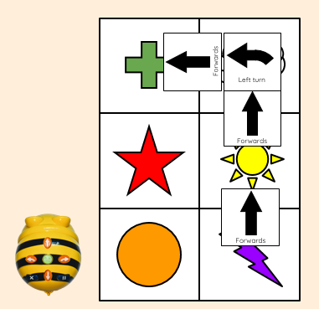

Computing: Teaching Sequence

1. To explain what a given command will do
2. To act out a given word
3. To combine forwards and backwards commands to make a sequence
4. To combine four direction commands to make sequences
5. To plan a simple program
6. To find more than one solution to a problem

On Line Safety: Health and Well-Being

1. I can explain rules to keep me safe online
2. I can give examples of some of these rules

Blooms Taxonomy – Specific Verbs to Use in Lesson Aims

Knowledge: Describe, find, identify, list, locate, name, recognise, retrieve Comprehension: Classify, compare, explain, infer, interpret, paraphrase, summarise Application: Carry out, implement, use Analysis: Deconstruct, Organise, outline, structure Synthesis: Construct, design, devise, invent, make, plan, produce, Evaluation: Appraise, assess, choose,