Key Vocabulary and Definitions:

|  |  |  |
| --- | --- | --- |
| **Experiment** |  | A carefully planned test used to find out the answer to something you don’t know. |
| **Investigate** |  | To look at or explore something carefully to learn the facts about it. |
| **Material** |  | Anything used for building or making something else. |
| **Object** |  | Anything that has shape or form and can be seen or touched. |
| **Observe** |  | To notice or see something by looking or watching carefully. |
| **Predict** |  | To use your knowledge to say what you think will happen before that thing happens. |
| **Recycle** |  | To put something through a process that allows it to be reused. |

What should I already know?

• Use all their senses in hands-on exploration of natural materials. (Nursery - Materials, including changing materials)

• Explore collections of materials with similar and/or different properties. (Nursery - Materials, including changing materials)

• Talk about the differences between materials and changes they notice. (Nursery - Materials, including changing materials)

Scientific Knowledge:

• Distinguish between an object and the material from which it is made.

• Identify and name a variety of everyday materials, including wood, plastic, glass, metal, water, and rock.

• Describe the simple physical properties of a variety of everyday materials.

• Compare and group together a variety of everyday materials on the basis of their simple physical properties.

Teaching Sequence

1. To distinguish between object and material.
2. To sort materials based on their properties.
3. To work scientifically to predict what will happen in a simple experiment and discuss its outcome. (Test transparency).
4. To work scientifically to evaluate results in a simple experiment and discuss the outcome. (Test transparency).
5. To perform a simple test to compare and group. TAPS Assessment [Floating and Sinking]

Blooms Taxonomy – Specific Verbs to Use in Lesson Aims

Knowledge: Describe, find, identify, list, locate, name, recognise, retrieve Comprehension: Classify, compare, explain, infer, interpret, paraphrase, summarise Application: Carry out, implement, use Analysis: Deconstruct, Organise, outline, structure Synthesis: Construct, design, devise, invent, make, plan, produce, Evaluation: Appraise, assess, choose,

Science Skills

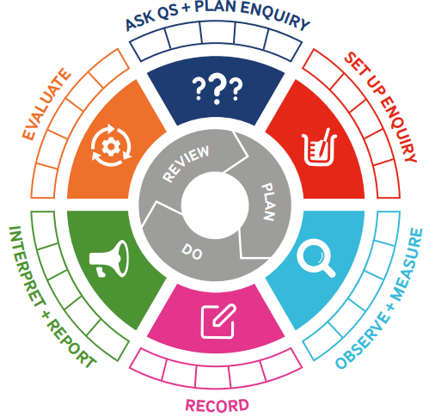

|  |  |  |  |
| --- | --- | --- | --- |
| Term 2 | Let’s Talk (Explorify) | Scientific Knowledge | Scientific skill |
| Lesson 1 | Zoom in, zoom out : <https://explorify.uk/en/activities/zoom-in-zoom-out/cosy-comfort> | Distinguish between an object and the material from which it is made. | To observe |
| Lesson 2 | What’s going on? : <https://explorify.uk/en/activities/whats-going-on/spinning-a-yarn> | Describe the simple physical properties of a variety of everyday materials.  Identify and name a variety of everyday materials, including wood, plastic, glass, metal, water, and rock. | To Observe and Measure  Ask Q’s and Plan Enquiry  Interpret and Report |
| Lesson 3 | What if… : <https://explorify.uk/en/activities/what-if/all-materials-were-transparent> | Compare and group together a variety of everyday materials on the basis of their simple physical properties. | To Observe and Measure  To Record  Ask Q’s and Plan Enquiry |
| Lesson 4 | The Big Question : <https://explorify.uk/en/activities/the-big-question/how-would-you-make-a-shelter-for-a-human> | Compare and group together a variety of everyday materials on the basis of their simple physical properties. | Interpret and Report  Evaluate |
| Lesson 5 | Zoom in, Zoom out : <https://explorify.uk/en/activities/zoom-in-zoom-out/the-space-in-between> | Compare and group together a variety of everyday materials on the basis of their simple physical properties. | To Observe and Measure  To Record  Interpret and Report  Plan a scientific enquiry to answer a question recognising and controlling variables. (TAPS) |