What should I already know?
(Substantive Knowledge)

- Understand that artists reinvent and as artists, we can take the work of others and re-form it to suit us. That we can be inspired by the past and make things for the future.

- Develop Mark Making.

- Make visual notes to capture, consolidate and reflect upon the artists studied.

- Understand we may all have different responses in terms of our thoughts and the things we make. That we may share similarities. Understand all responses are valid.
Key Vocabulary:

Shadow Puppets  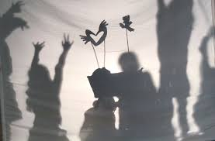 | An ancient form of storytelling and entertainment which uses flat articulated cut-out figures which are held between a source of light and a translucent screen or scrim.
Narrative   | A spoken or written account of connected events; a story.
Performance   | An act of presenting a play, concert, or other form of entertainment.
Characterisation  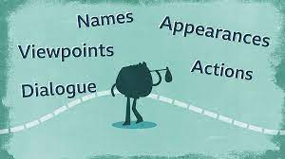 | The creation or construction of a fictional character.  A description of the distinctive nature or features of someone or something.

What will I learn?
(Implicit Knowledge/Skills)

- Combine making with drawing skills to create shadow puppets using cut and constructed lines, shapes and forms from a variety of materials. Working collaboratively to perform a simple show sharing a narrative which has meaning to you.

- Work collaboratively to present outcomes to others where appropriate. Present as a team.

- Share responses to classmates work, appreciating similarities and differences. Listen to feedback about your own work and respond.

- Document work using still image (photography) or by making a drawing of the work. If using photography consider lighting and focus. Some children may make films thinking about viewpoint, lighting & perspective.

Focus Artists
Lotte Reiniger

Blooms Taxonomy – Specific Verbs to Use in Lesson Aims
Knowledge: Describe, find, identify, list, locate, name, recognise, retrieve Comprehension: Classify, compare, explain, infer, interpret, paraphrase, summarise Application: Carry out, implement, use Analysis: Deconstruct, Organise, outline, structure Synthesis: Construct, design, devise, invent, make, plan, produce, Evaluation: Appraise, assess, choose,

Glue here.
My Learning Ladder

Learning Objective |  | Pupil Voice | Teacher Assessment
to discover artists and approaches to puppets
to develop a narrative for a puppet show
to create the characters for the performance
to rehearse our puppet show

to evaluate our performance |  | See below.
Evaluation of my Final Piece


