What should I already know?
(Substantive Knowledge)
- Understand that designers create fonts and work with Typography.
- Understand that some artists use graphic skills to create pictorial maps, using symbols (personal and cultural) to map identity as well as geography.
- Explore mark making.
- Make visual notes to capture, consolidate and reflect upon the artists studied.
- Understand we may all have different responses in terms of our thoughts and the things we make. That we may share similarities. Understand all responses are valid

Key Vocabulary:

Typography  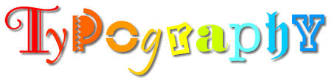 | The art of arranging letters and text in a way that makes the copy legible, clear, and visually appealing to the reader.
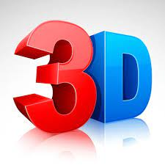 | Refers to the three spatial dimensions of width, height and depth.
Shape  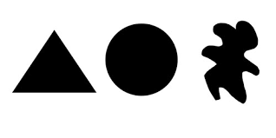 | An element of art that is two-dimensional, flat, or limited to height and width
Culture  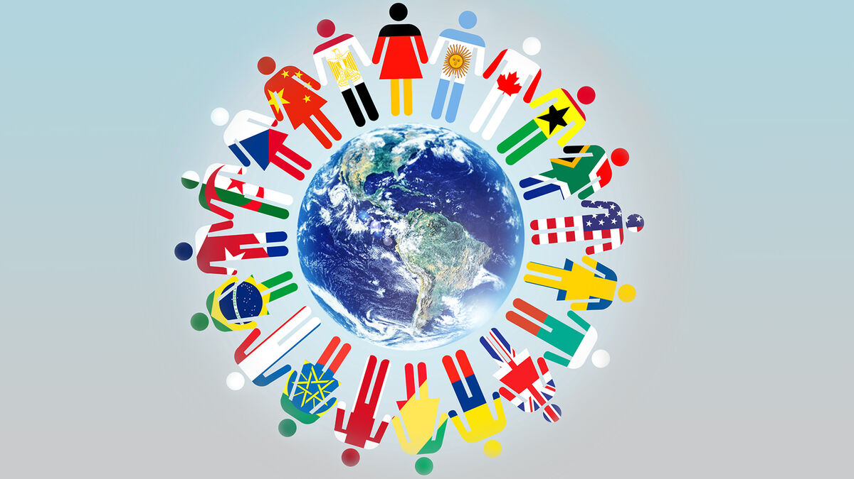 | The ideas, customs, and social behaviour of a particular people or society.
Place   | A particular position, point, or area in space; a location. The where.
Time  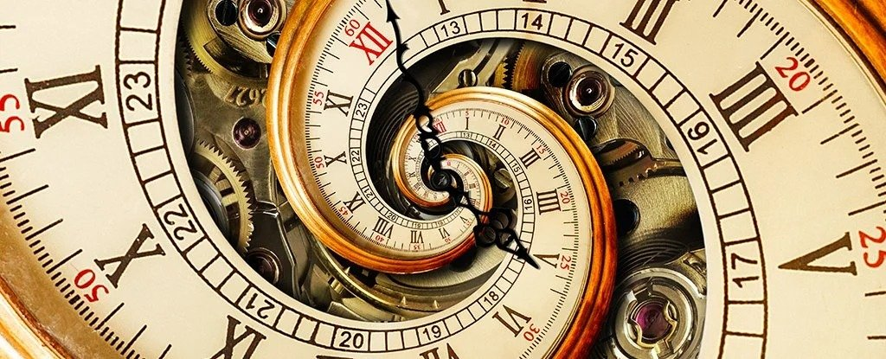 | The indefinite continued progress of existence and events in the past, present, and future regarded as a whole. The when.

What will I learn?
(Implicit Knowledge/Skills)
  - Create fonts inspired by objects/elements around you. Use close observational drawing with pen to inspire, and use creative skills to transform into letters.
  - Draw over maps/existing marks to explore how you can make mark making more visually powerful.
  - Combine drawing with making to create pictorial / 3 dimension maps which explore qualities of your personality or otherwise respond to a theme. Explore line weight, rhythm, grip, mark making and shape, and explore how 2d can become 3d through manipulation of paper.
  - Document work using still image (photography) or by making a drawing of the work. If using photography consider lighting and focus. Some children may make films thinking about viewpoint, lighting & perspective.
  - Discuss the ways in which artists have a responsibility to themselves/society. What purpose does art serve?

Focus Artists
Louise Fili, Grayson Perry

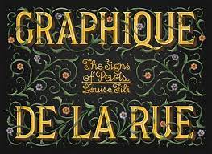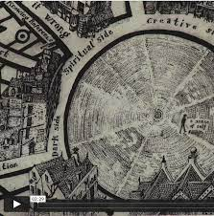
Paula Scher and Marauder’s Map 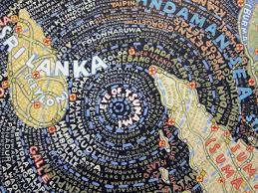

Blooms Taxonomy – Specific Verbs to Use in Lesson Aims
Knowledge: Describe, find, identify, list, locate, name, recognise, retrieve Comprehension: Classify, compare, explain, infer, interpret, paraphrase, summarise Application: Carry out, implement, use Analysis: Deconstruct, Organise, outline, structure Synthesis: Construct, design, devise, invent, make, plan, produce, Evaluation: Appraise, assess, choose,

Glue here.
My Learning Ladder

Learning Objective |  | Pupil Voice | Teacher Assessment
to discover what typography is through artist Louise Fili
to create my own typography
to explore making powerful imagery
to design and begin to build my own 3D visual map
to annotate my 3D visual map
to evaluate my map |  | See below.
Evaluation of my Final Piece


