Progression
This unit looks at how a flat-file database can be used to organise data in records. Pupils use tools within a database to order and answer questions about data. They create graphs and charts from their data to help solve problems. They use a real-life database to answer a question and present their work to others.

Key Vocabulary and Definitions:

Database 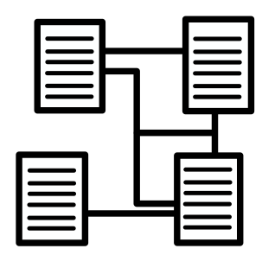 | A collection of organised data that is stored on a computer
Data  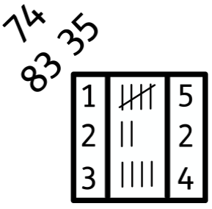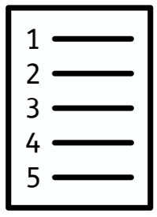 | These can be letters, words, numbers, dates, images, sounds etc.
Information   | Data as processed, stored, or transmitted by a computer.
Record | Records are formed from one or more fields of data.
Field | One specific piece of data in a database record.
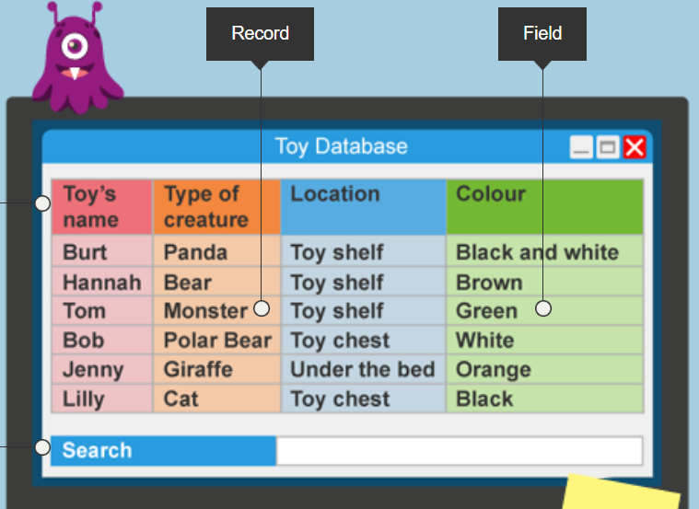
Attribute | These have a name and a value, for example, “a ball is red” – “colour” is the attribute name, “red” is the attribute value.
Criteria   | Standard by which something may be judged or decided.

National Curriculum:
Computing
- Use search technologies effectively, appreciate how results are selected and ranked, and be discerning in evaluating digital content
- Select, use, and combine a variety of software (including internet services) on a range of digital devices to design and create a range of programs, systems, and content that accomplish given goals, including collecting, analysing, evaluating, and presenting data and information

Internet safety
Use technology safely, respectfully, and responsibly; recognise acceptable/unacceptable behaviour.

red

Blooms Taxonomy – Specific Verbs to Use in Lesson Aims
Knowledge: Describe, find, identify, list, locate, name, recognise, retrieve Comprehension: Classify, compare, explain, infer, interpret, paraphrase, summarise Application: Carry out, implement, use Analysis: Deconstruct, Organise, outline, structure Synthesis: Construct, design, devise, invent, make, plan, produce, Evaluation: Appraise, assess, choose,
Teaching Sequence
Data and Information – Flat-file databases

- To use a form to record information.
- To compare paper and computer-based databases.
- To outline how you can answer questions by grouping them and then sorting data.
- To explain that tools can be used to select specific data.
- To explain that computer programs can be used to compare data visually.
- To use a real-world database to answer questions.
Online Safety – Health, well-being and lifestyle
- I can describe ways technology can affect health and well-being both positively (e.g. mindfulness apps) and negatively.
- I can describe some strategies, tips or advice to promote health and wellbeing with regards to technology.
- I recognise the benefits and risks of accessing information about health and well-being online and how we should balance this with talking to trusted adults and professionals.
- I can explain how and why some apps and games may request or take payment for additional content (e.g. in app purchases, lootboxes) and explain the importance of seeking permission from a trusted adult before purchasing.

Subject knowledge
You will need to know that a flat-file database is a collection of data organised in a single table. The term ‘database’ means ‘a collection of organised data that is stored on a computer’. Databases allow people to search and sort large quantities of data to find information. Data can be letters, words, numbers, dates, images, sounds, etc. In addition, you will need to be familiar with the basic structure of a database, and the concept of ‘grouping’ and ‘sorting’ data records based on different fields. For example, grouping objects by colour, or sorting into alphabetical order.

A database is composed of ‘records’, which are sets of data on a particular object. Records are formed from one or more ‘fields’ of data. A field is one specific piece of data in a database record. For example, a record all about a country could have fields such as ‘country name’ and ‘country population’. The value within the record is the ‘answer’ to each field, e.g. Mexico is the value in the ‘country name’ field and ‘126.2 million’ is the value in the ‘country population’ field.

You will also need to be aware that all objects have attributes. An attribute includes its ‘name’ and a ‘value’. For example, a ball will have a ‘colour’, which might be ‘red’. ‘Colour’ is the attribute ‘name’; ‘red’ is the attribute ‘value’. In a flat-file database the attribute names become the fields when the data about the object is stored as a record. The values of the attributes become the values that are saved in the database fields.

