Key Vocabulary and Definitions:

Castle- A type of [home](https://www.theschoolrun.com/homework-help/houses-and-homes) that was built to protect the people inside. The people that lived there were rich.

Drawbridge-A bridge that can move up and down. They were used to keep people in and out of a castle.

Dungeon-A little bit like a prison. Found inside a castle.

Knight -A little bit like a soldier.

Lance-A weapon with a long handle used by knights.

Moat-A ditch around a castle usually filled with water.

Portcullis-A heavy metal gate.

Ramparts- Part of the castle at the top of a turret to add protection.

Suit of armour-A piece of protective clothing often worn by a knight before fighting.

Turret-A round tower on the corners of a building.

What should I already know?

That rich and poor people had different life styles in Tudor England.

People in the past used different methods to protect their country/land.

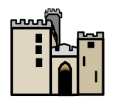

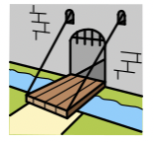

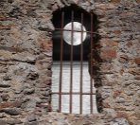

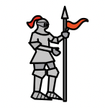

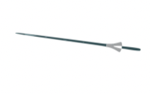

History Skills:

* To compare different time periods and their key features.
* To use a range of sources to find out characteristic features of the past.

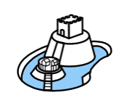

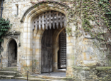

Teaching Sequence

1. To know what it was like to live in the Medieval times.
2. To understand the role of a knight in the Medieval times.
3. To learn about the need for castles and be able to label their parts.

