What should I already know?

That Jewish people follow Judaism and worship one God. They also celebrate Shabbat.

Key Vocabulary and Definitions:

**Judaism**

The religion followed by Jewish people.

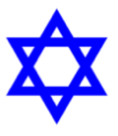

**Jew**

A person whose ancestors were Biblical Hebrews or a person whose religion is Judaism.

**Rosh Hashanah**

The day Jewish people celebrate the creation of the universe.

**Yom Kippur**

A day of atonement, 10 days after Rosh Hashanah.

RE Skills:

* To be able to consider the views and beliefs of others looking through their eyes.
* Empathy.
* To be reflective about the values that religions hold that could be applicable to our own lives.

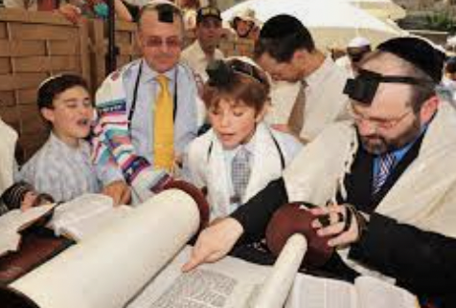



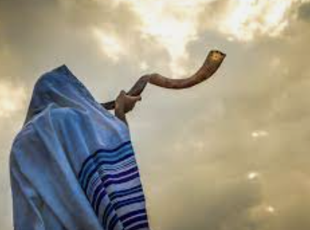

Teaching Sequence

1. To explore the meaning of forgiveness and the need for it.
2. To learn how and why Jewish people celebrate Rosh Hashanah and Yom Kippur.
3. To reflect on the message of perseverance taught at Rosh Hashanah and the importance of Rosh Hashanah and Yom Kippur to Jewish people.