What should I already know?

That there are 4 seasons: Winter, Spring and Summer and Autumn.

Signs of Winter in the UK include: cold temperatures, snow/ice and no leaves on deciduous trees.

Key Vocabulary and Definitions:

Sun-The star which orbits around the earth.

Sun dial-An object which shows the time and movement of the sun using shadows.

Shadow-A dark shape produced by an object blocking the sunlight.

Summer-One of the 4 seasons. In the UK this season has the most sunlight and warmest weather.

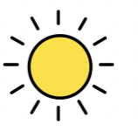

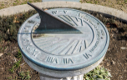

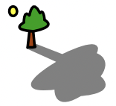

Scientific knowledge:

* There are 4 seasons: Winter, Spring, Summer and Autumn.
* Summer is the warmest season in the UK and the season with most hours of sunlight each day.
* Shadows are created when an object blocks direct sunlight.



Teaching Sequence

1. To recap the four seasons and talk about/look at the signs of Summer outside.
2. Learn about the use of sundials, make one and create a chart to track the sun with our sun dials.
3. Use our sundials to track the movement of the sun over a day.

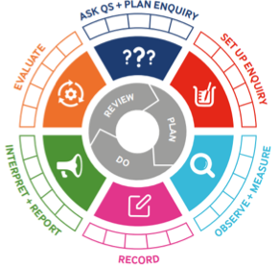

|  |  |  |  |
| --- | --- | --- | --- |
| Term 4 | Let’s Talk (Explorify) | Scientific Knowledge | Scientific skill |
| Lesson 1 | Have your ever gone to bed when it is light outside?  https://explorify.uk/en/activities/have-you-ever/gone-to-bed-when-it-is-still-light-outside | * There are 4 seasons: Winter, Spring, Summer and Autumn. * Summer is the warmest season in the UK and the season with most hours of sunlight each day. | Observe and measure |
| Lesson 2 | What if there was only one season?  https://explorify.uk/en/activities/the-big-question/what-if-there-was-only-one-season | * Summer is the warmest season in the UK and the season with most hours of sunlight each day. * Shadows are created when an object blocks direct sunlight. | Ask Qs and plan enquiry  Set up enquiry |
| Lesson 3 | In the shadows.  https://explorify.uk/en/activities/odd-one-out/in-the-shadows | * Summer is the warmest season in the UK and the season with most hours of sunlight each day. * Shadows are created when an object blocks direct sunlight. | Observe and measure  record |