Key Vocabulary and Definitions:

aerial view  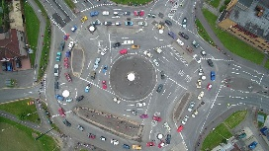 | The view from above.
landmark   | An object that is easily seen and recognised from far away. It helps someone to know where they are.
local  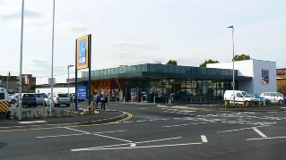 | Somewhere close to you.
map  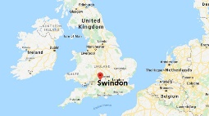 | A picture of land or sea showing cities, roads, rivers, mountains etc.
observations   | Looking at things around me.
Swindon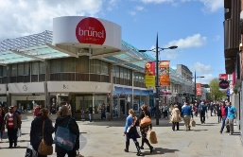 | The town in Wiltshire. The place where you all live.

What should I already know?
- Use appropriate words, e.g. ‘town’, ‘village’, ‘road’, ‘path’, ‘house’, ‘flat’, ’temple’ and ‘synagogue’, to help children make distinctions in their observations.
- To talk about the features of where they live and how environments may change from one another.

Geography Skills:
- To understand about the local area and name key landmarks.
- Make observations about, and describe, the local area and the nearest green space.
- Show awareness of the local area and compare to a distant place.
- Locate places on a map of the local area using directional language.
- Use aerial photos to identify features of a locality.
- Draw a simple map.

Teaching Sequence

- To talk about what Geography means.

- To talk about where we live and our local area including landmarks.

- To identify key features of our local area. Local Walk.

- To identify the key features of our local area. Aerial Photos.

- To draw a simple map of the local area.

- To compare the local area to a distant place.

Blooms Taxonomy – Specific Verbs to Use in Lesson Aims
Knowledge: Describe, find, identify, list, locate, name, recognise, retrieve Comprehension: Classify, compare, explain, infer, interpret, paraphrase, summarise Application: Carry out, implement, use Analysis: Deconstruct, Organise, outline, structure Synthesis: Construct, design, devise, invent, make, plan, produce, Evaluation: Appraise, assess, choose,

Key Knowledge

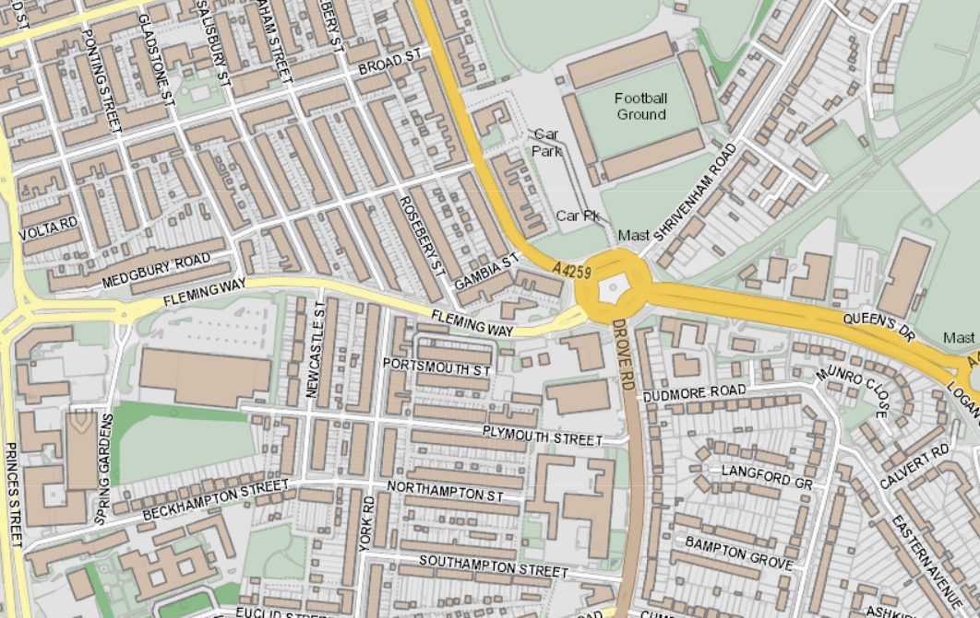
Map of Drove Primary School

