Key Vocabulary and Definitions:

Technology  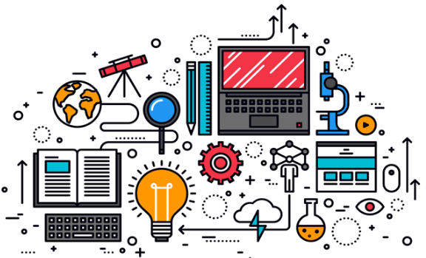 | Knowledge for practical use.
Computer   | An electronic device that processes data.
Keyboard  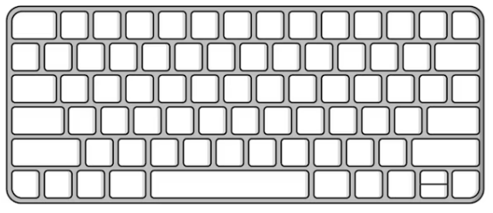 | An input device to add text by pressing keys.
Mouse   | A device to control direction and selection within a computer programme.
Logging on | To begin using a computer programme.

What should I already know?

Computing Skills:
- To recognise common uses of information technology beyond school
- Use technology purposefully to create, organise, store, manipulate, and retrieve digital content
- Use technology safely and respectfully, keeping personal information private; identify where to go for help and support when they have concerns about content or contact on the internet or other online technologies.

Computing Teaching Sequence
- To investigation the term ‘Technology’
- To identify a computer and its main parts
- To use a mouse in different ways
- To use a keyboard to type on a computer
- To use the keyboard to edit text
- To create rules for using technology responsibly
Online Safety – Self Image and Identity
- To recognise there may be people online who could make someone feel sad, embarrassed or upset.
- To give examples of when and how to speak to an adult I can trust and how they can help.

Blooms Taxonomy – Specific Verbs to Use in Lesson Aims
Knowledge: Describe, find, identify, list, locate, name, recognise, retrieve Comprehension: Classify, compare, explain, infer, interpret, paraphrase, summarise Application: Carry out, implement, use Analysis: Deconstruct, Organise, outline, structure Synthesis: Construct, design, devise, invent, make, plan, produce, Evaluation: Appraise, assess, choose,

