What should I already know?
• Show sensitivity to their own and others’ needs.
• Talk about the lives of the people around them and their roles in society.
• Understand the past through settings, characters and events encountered in books read in class and storytelling.
• Know some similarities and differences between different religious and cultural communities in this country, drawing on their experiences and what has been read in class.
Key Vocabulary and Definitions:

Angel  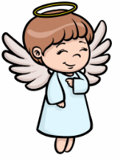 | A spiritual messenger of God.
Bethlehem | The town Jesus was born in.
Frankincense and Myrrh  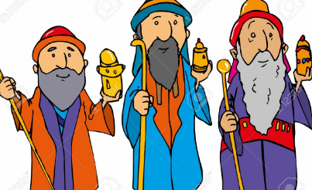 | Perfumes given as a gift.
Gift   | A present.
Shepherds  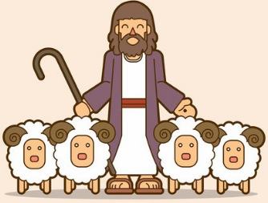 | A person who looks after sheep.
Stable  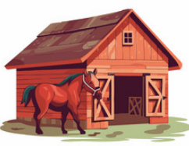 | The wooden building Jesus was born in.
Wise Men  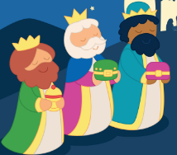 | The three kings who brought gifts to Jesus.

RE Skills:
- I can tell you / talk about what concepts like belonging, commitment, kindness, forgiveness mean to me in my world
- I can verbalise and / or express my own thoughts
- I can recall facts about the religions / beliefs I have studied, begin to use the religious vocabulary and start to explain the significance and meaning of the facts, practices etc.
- I can start to think through the enquiry question using some facts and am beginning to see there could be more than one answer.

Teaching Sequence

- To discuss why gifts are meaningful
- To share the Christmas Story
- To retell the Christmas Story
- Comparing gifts from the Christmas Story to gifts today
- To design a new baby card
- To design a gift for the baby Jesus

Blooms Taxonomy – Specific Verbs to Use in Lesson Aims
Knowledge: Describe, find, identify, list, locate, name, recognise, retrieve Comprehension: Classify, compare, explain, infer, interpret, paraphrase, summarise Application: Carry out, implement, use Analysis: Deconstruct, Organise, outline, structure Synthesis: Construct, design, devise, invent, make, plan, produce, Evaluation: Appraise, assess, choose,

Key Knowledge

The Christmas Story

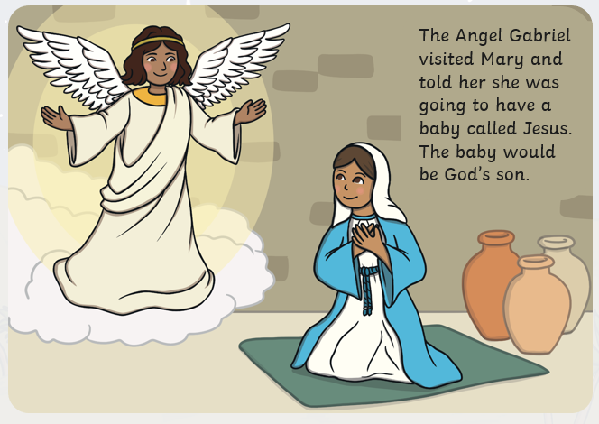 | 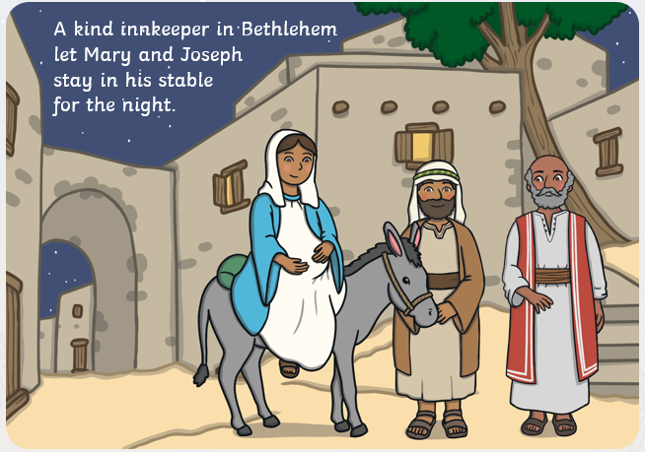
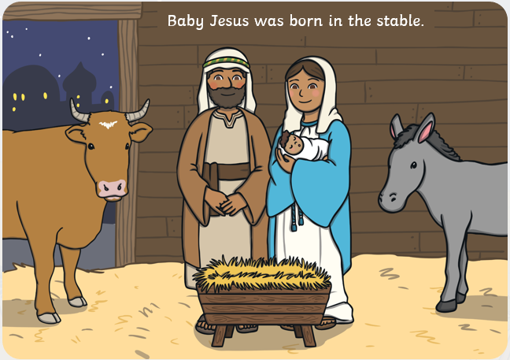 | 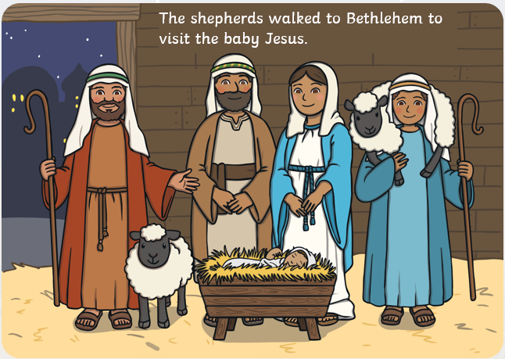
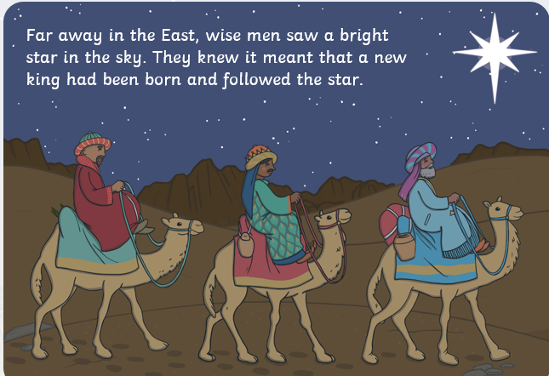 | 