What should I already know?
To be able to use all my senses in hands-on exploration of natural materials. (Nursery - Humans)
To be able to name and describe people who are familiar to me. (Reception - Humans)

Key Vocabulary and Definitions:

hearing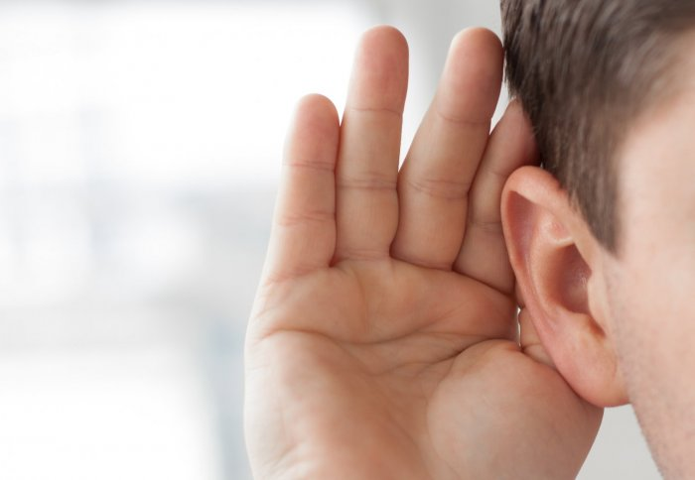 | To interpret sound information that reaches the ears
human  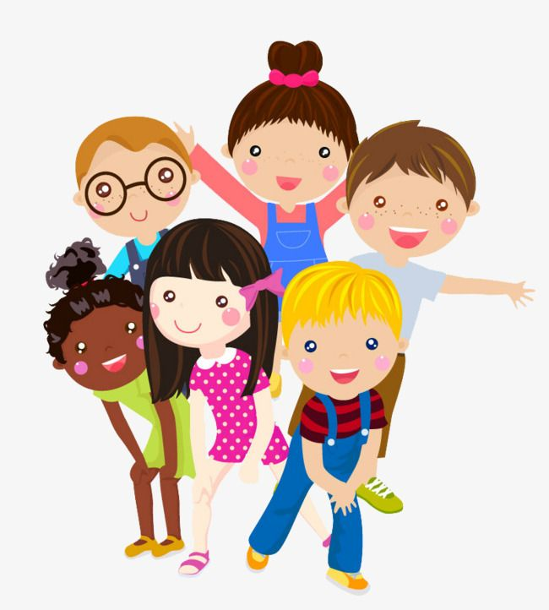 | A human is a type of animal that belongs to the group of mammals called primates.
sense 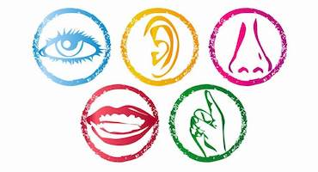 | Any of the five ways to understand or experience our surroundings.
sight  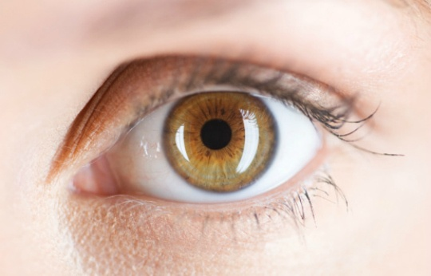 | To interpret light information that reaches the eyes.
smell   | The sense through which scent is recognized.
taste  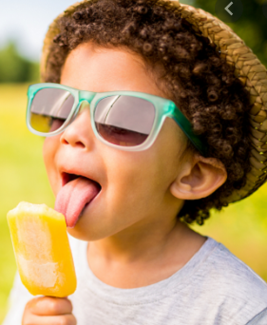 | To experience and recognize the flavour of something by putting it into the mouth.
touch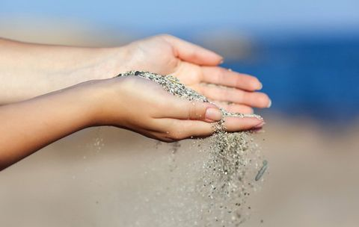 | To make contact with something.

Scientific Knowledge:
- Identify, name, draw and label the basic parts of the human body and say which part of the body is associated with each sense.

- Humans have key parts in common, but these vary from person to person. Humans (and other animals) find out about the world using their senses. Humans have five senses – sight, touch, taste, hearing and smelling. These senses are linked to particular parts of the body.

Blooms Taxonomy – Specific Verbs to Use in Lesson Aims
Knowledge: Describe, find, identify, list, locate, name, recognise, retrieve Comprehension: Classify, compare, explain, infer, interpret, paraphrase, summarise Application: Carry out, implement, use Analysis: Deconstruct, Organise, outline, structure Synthesis: Construct, design, devise, invent, make, plan, produce, Evaluation: Appraise, assess, choose,

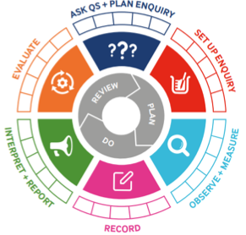
Teaching Sequence – Aim of each lesson

- To label basic parts of the human body

- To label parts of the face

- To say which part of the body is associated with each sense

- To use flash cards in partners to match parts of the human body and the senses (verbally)

- TAPS in partners label with post it notes, body parts and senses

Term 4 | Let’s Talk (Explorify) | Scientific Knowledge | Scientific skill
Lesson 1 | What’s going on?  Born to dance. | - To label basic parts of the body | Observe  Record
Lesson 2 | Zoom in zoom out  Pink and bumpy | - To label parts of the face | Observe  Record
Lesson 3 | Have you ever  Smelt something that made you happy? | To say which part of the body is associated with each sense | Observe
Lesson 4 | What if?  Everything tasted the same | - To use flash cards in partners to match parts of the human body and the senses (verbally) | Record
Lesson 5 |  | - TAPS in partners label with post it notes, body parts and senses | Record

