What should I already know?
• Show sensitivity to their own and others’ needs.
• Talk about the lives of the people around them and their roles in society.
• Understand the past through settings, characters and events encountered in books read in class and storytelling.
• Know some similarities and differences between different religious and cultural communities in this country, drawing on their experiences and what has been read in class.
Key Vocabulary and Definitions:

Bible  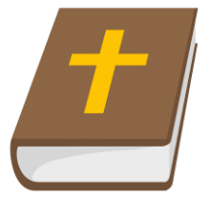 | The Holy book that Christians follow.
Old Testament  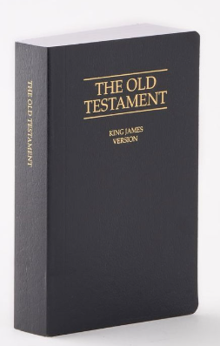 | the part of the Bible which explains God’s relationship with his people before Jesus, whom most Christians believe is the Son of God, came to earth
Genesis  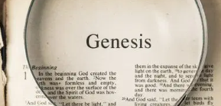 | First book of the Bible
New Testament  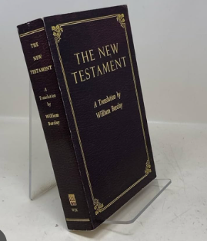 | the part of the Bible which tells the story of Jesus’ life and the actions of his disciples.

RE Skills:
- Say how it felt to make something.
- Remember the Christian Creation story and talk about it.
- Express an opinion about the Christian belief about creation.

Teaching Sequence

- To respect the work of a creator
- To retell the Christian Creation Story
- To understand how Christians think God wants them to behave (towards the world)
- To understand how Christians think God wants them to behave (towards others)
- To explain some Christian beliefs about God and talk about them
- To explain how it feels to take care of the world or somebody

Blooms Taxonomy – Specific Verbs to Use in Lesson Aims
Knowledge: Describe, find, identify, list, locate, name, recognise, retrieve Comprehension: Classify, compare, explain, infer, interpret, paraphrase, summarise Application: Carry out, implement, use Analysis: Deconstruct, Organise, outline, structure Synthesis: Construct, design, devise, invent, make, plan, produce, Evaluation: Appraise, assess, choose,

Key Knowledge

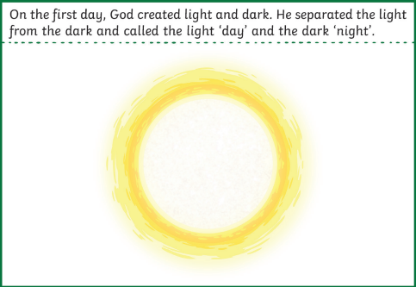 | 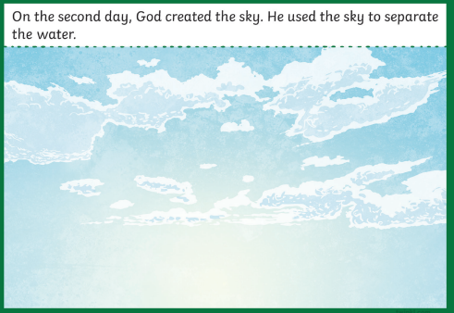
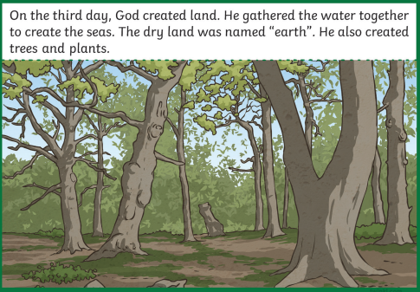 | 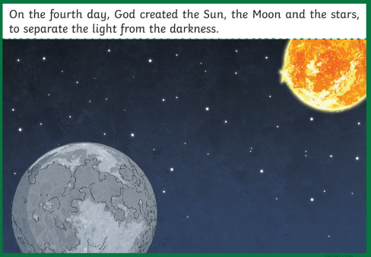
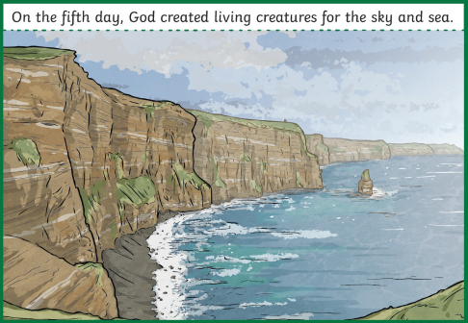 | 