Key Vocabulary and Definitions:

|  |  |
| --- | --- |
| Object | A material thing that can be seen and touched. |
| Label | A classifying phrase or name applied to a person or thing. |
| Group | A number of people or things that are located, gathered or classed together. |
| Search | To try and find something. |
| Image | A picture. |
| Property | An attribute, quality or characteristic of something. |
| Size | Measurement of an object or thing. |
| Shape | A form of an object or it’s outline |
| Value | The worth of something. |
| Data set | A group of information. |

Progression:

That you can control technology using a sequence of instructions.

National Curriculum:

Use technology purposefully to create, organise, store, manipulate and retrieve digital content.

Final Outcome:

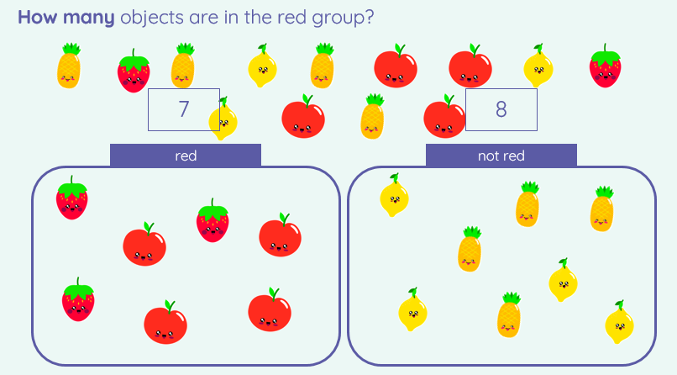

Computing: Teaching Sequence

1. To describe, match and label a group of objects.
2. To count and group objects.
3. To find objects with similar properties.
4. To group objects in more than one way.
5. To choose how to group objects and record.
6. To decide how to group objects and answer a question.

On Line Safety: Health and Well-Being

1. To be able to explain how to keep myself safe online at home

Blooms Taxonomy – Specific Verbs to Use in Lesson Aims

Knowledge: Describe, find, identify, list, locate, name, recognise, retrieve Comprehension: Classify, compare, explain, infer, interpret, paraphrase, summarise Application: Carry out, implement, use Analysis: Deconstruct, Organise, outline, structure Synthesis: Construct, design, devise, invent, make, plan, produce, Evaluation: Appraise, assess, choose,