Key Vocabulary and Definitions:

Object | A material thing that can be seen and touched.
Label 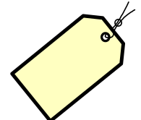 | A classifying phrase or name applied to a person or thing.
Group 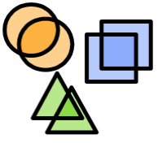 | A number of people or things that are located, gathered or classed together.
Search 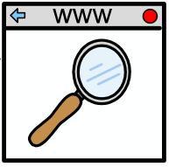 | To try and find something.
Image 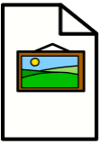 | A picture.
Property  | An attribute, quality or characteristic of something.
Size | Measurement of an object or thing.
Shape  | A form of an object or it’s outline
Value | The worth of something.
Data set | A group of information.

Progression:
That you can control technology using a sequence of instructions.

National Curriculum:
Use technology purposefully to create, organise, store, manipulate and retrieve digital content.

Final Outcome:
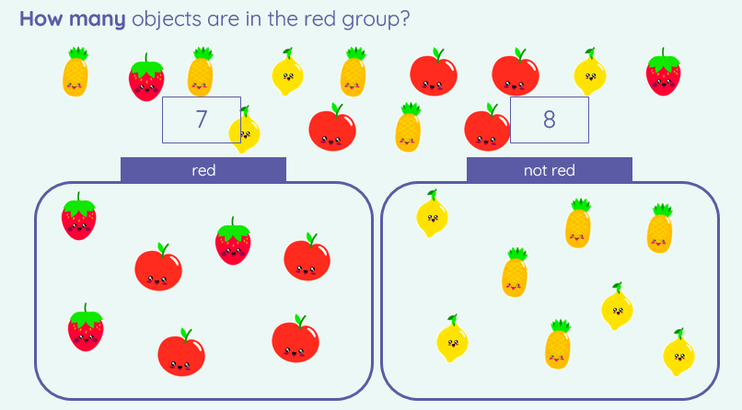

Computing: Teaching Sequence

- To describe, match and label a group of objects.
- To count and group objects.

- To find objects with similar properties.

- To group objects in more than one way.

- To choose how to group objects and record.

- To decide how to group objects and answer a question.

On Line Safety: Health and Well-Being

- To be able to explain how to keep myself safe online at home

Blooms Taxonomy – Specific Verbs to Use in Lesson Aims
Knowledge: Describe, find, identify, list, locate, name, recognise, retrieve Comprehension: Classify, compare, explain, infer, interpret, paraphrase, summarise Application: Carry out, implement, use Analysis: Deconstruct, Organise, outline, structure Synthesis: Construct, design, devise, invent, make, plan, produce, Evaluation: Appraise, assess, choose,

