Key Vocabulary and Definitions:

Salvation | The deliverance from harm.
Christian  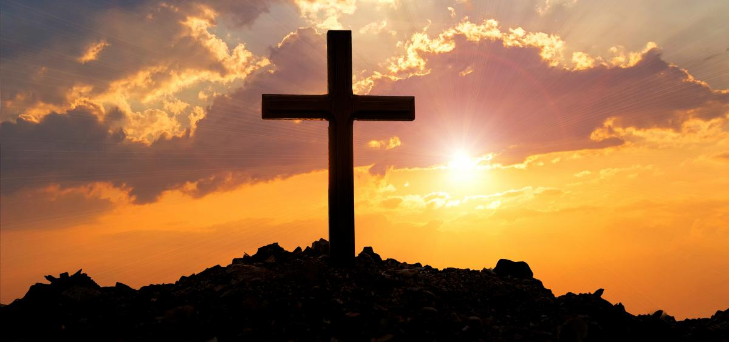 | A person whose religion is Christianity. A person who follows the teachings of Jesus Christ.
Disciples  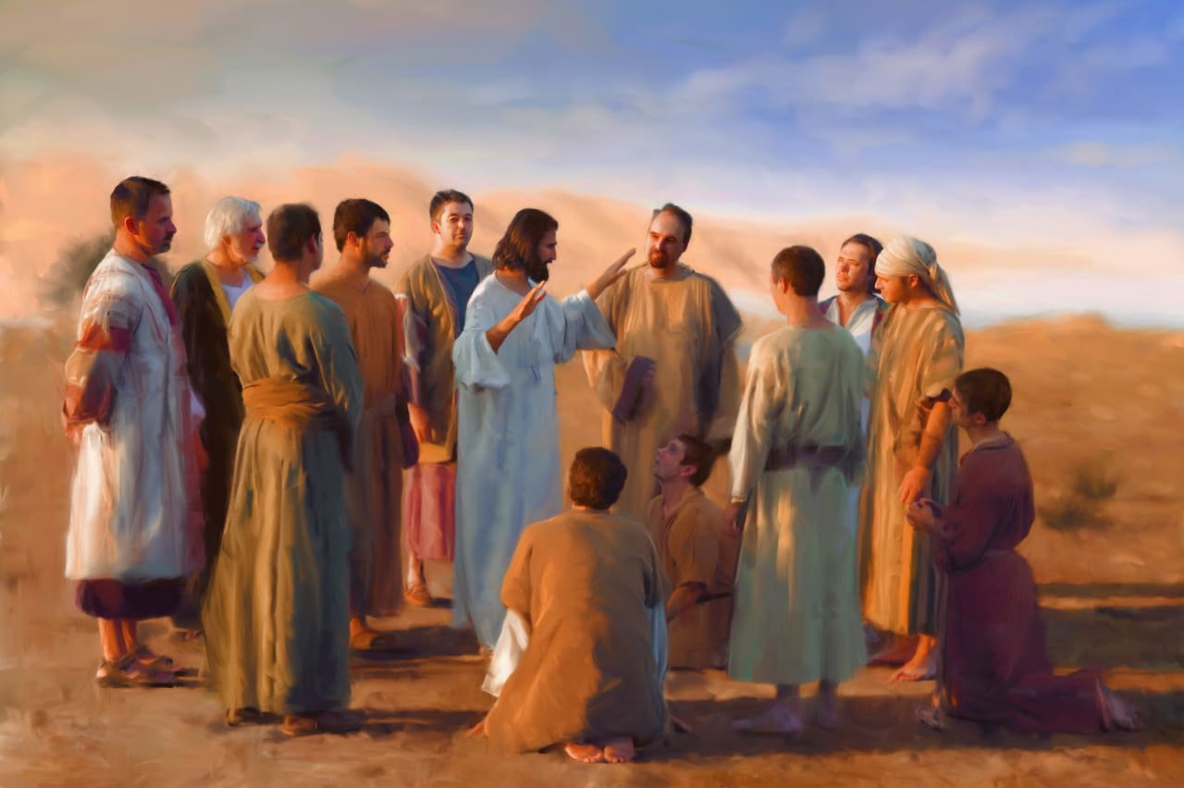 | Jesus’ special friends.
Palm Sunday | The Sunday before Easter when Jesus rode into Jerusalem on a donkey.
Jew  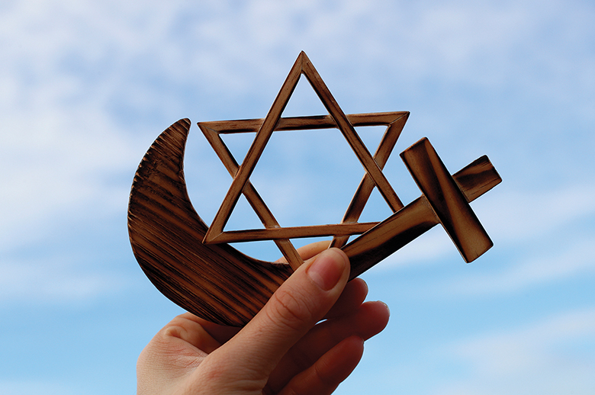 | A person whose ancestors were Biblical Hebrews. A person whose religion is Judaism.
Jesus  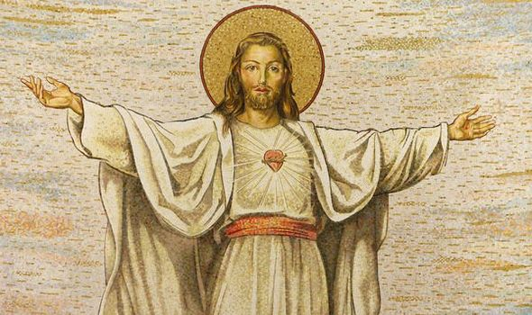 | Christians believe he was the son of God.
Romans  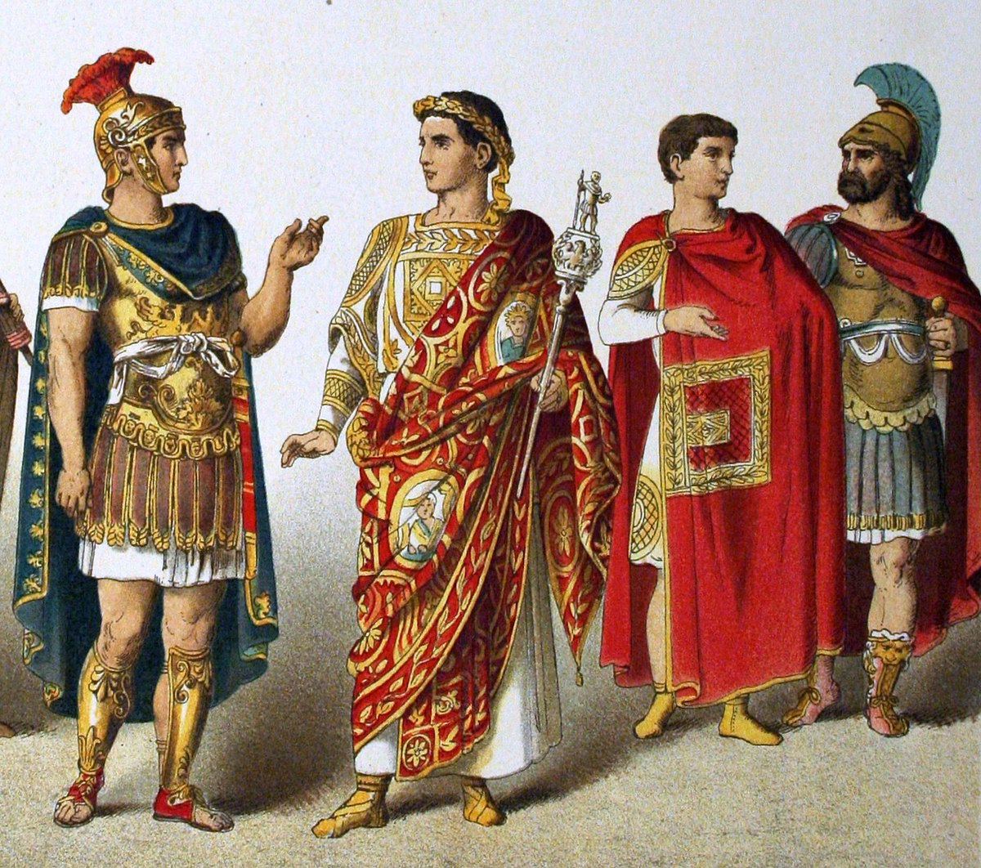 | A powerful nation of people who ruled Jerusalem.

What should I already know?
Discovery RE F2 – Special People.
That Jesus is a special person to Christians today.

RE Skills:
- To be able to consider the views and beliefs of others looking through their eyes.
- To be able to order religious events.

Blooms Taxonomy – Specific Verbs to Use in Lesson Aims
Knowledge: Describe, find, identify, list, locate, name, recognise, retrieve Comprehension: Classify, compare, explain, infer, interpret, paraphrase, summarise Application: Carry out, implement, use Analysis: Deconstruct, Organise, outline, structure Synthesis: Construct, design, devise, invent, make, plan, produce, Evaluation: Appraise, assess, choose,

Teaching Sequence

- I can think about qualities in people I admire
- I can explain why Jesus might have been special or important to the people around him
- I can retell some of the Easter story (Before and during Palm Sunday)
- I can retell some of the Easter story (Palm Sunday to Easter Sunday)
- I can talk about a person I admire
- I can talk about a person I admire and say why I admire them

Key Knowledge
- Christian concept of Salvation: the saving of mankind from permanent separation from God by the death and resurrection of Jesus
- Trinity. This is the ‘complete relationship’ between God (the Father), Jesus (his son) and the Holy Spirit
Palm Sunday is the day where Jesus rode into Jerusalem. He fulfilled Old Testament prophecies which said
that this would happen when the “king” came.
- Christians believe that Jesus is the Son of God, he was put to death on Good Friday and rose from the dead on Easter Sunday

