Key Vocabulary and Definitions:
Branches 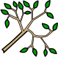 | Part of a tree or bush that grows out from the trunk.
Bulb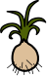 | A plant bud that begins to grow underground.
Fruit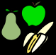 | Part of a plant that has seeds and flesh. It hangs from the stem or branch.
Germinate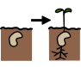 | To begin to grow and put out shoots.
Leaf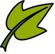 | The green, flat parts of a plant or tree that grows from the stem or branch.
Petal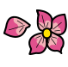 | A different coloured leaf that grows at the top of the stem and attracts pollinating insects.
Plant 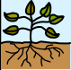 | A living thing that uses sunlight to make its own food.
Pollen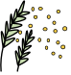 | Yellow powder made by a flowering plant. It helps to fertilize a plant's seeds.
Root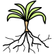 | The part of a plant that grows underground, takes up water and nutrients, and holds the plant in the soil.
Seed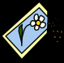 | The small part of a flowering plant that grows into a new plant.
Stem | Part of a plant that grows up from the ground and supports the branches, leaves, flowers, or fruits growing from it.
Vegetable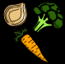 | Part of a plant – such as the root, leaves or stem, which is edible.

What should I already know?
Children know about similarities and differences in relation to places, objects, materials and living things. They talk about the features of their own immediate environment and how environments might vary from one another. They make observations of animals and plants and explain why some things occur, and talk about changes.

Scientific Skills:
- Identify and name a variety of common plants
- Describe the basic structure of a variety of common flowering plants, including trees.
- Explore and answer questions about plants growing in their habitat.
- Observe the growth of flowers and vegetables that they have planted.
- Keep records of how plants have changed over time.

Teaching Sequence

- To talk about what plants need to survive and use my knowledge to plant a seed appropriately.
- To keep a diary of how my plant is changing over time through careful observation.
- To talk about what the different parts of a flowering plant does.
- To identify and name some common plants and trees in the UK.
- To make observations about plants growing in their environment and label parts of the plants [TAPS].
Blooms Taxonomy – Specific Verbs to Use in Lesson Aims
Knowledge: Describe, find, identify, list, locate, name, recognise, retrieve Comprehension: Classify, compare, explain, infer, interpret, paraphrase, summarise Application: Carry out, implement, use Analysis: Deconstruct, Organise, outline, structure Synthesis: Construct, design, devise, invent, make, plan, produce, Evaluation: Appraise, assess, choose,

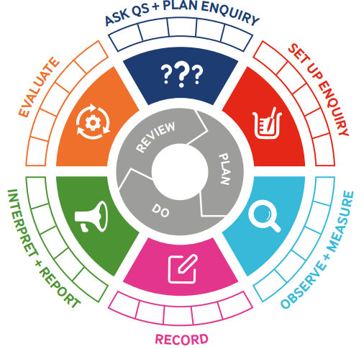

Key Knowledge

Term 4 | Let’s Talk (Explorify) | Scientific Knowledge | Scientific skill
Lesson 1 | The Big Question:  https://explorify.uk/en/activities/the-big-question/what-if-we-planted-a-plant-from-earth-on-mars | Explore and answer questions about plants growing in their habitat. | To observe
Lesson 2 | Odd one out:  https://explorify.uk/en/activities/odd-one-out/the-circle-of-life | Keep records of how plants have changed over time. | To Observe and Measure  Ask Q’s and Plan Enquiry  Interpret and Report  To Record
Lesson 3 | Zoom in, zoom out:  https://explorify.uk/en/activities/zoom-in-zoom-out/green-texture | Describe the basic structure of a variety of common flowering plants, including trees. | To Observe and Measure  Ask Q’s
Lesson 4 | Have you ever?:  https://explorify.uk/en/activities/have-you-ever/seen-trees-in-winter-with-lots-of-leaves | Explore and answer questions about plants growing in their habitat. | Interpret and Report  Evaluate  To Observe and Measure
Lesson 5 | Odd one out:  https://explorify.uk/en/activities/odd-one-out/autumn-leaves | Explore and answer questions about plants growing in their habitat.  Observe the growth of flowers and vegetables that they have planted. | To Observe and Measure  To Record  Interpret and Report  Plan a scientific enquiry to answer a question recognising and controlling variables. (TAPS)

