Technical Knowledge:
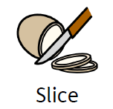 | Slice-To make a thin piece.
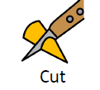 | Cut-To divide something in two.
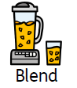 | Blend-To mix something together.
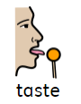 | Taste-A sensation felt in the mouth when eating.
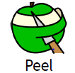 | Peel-To remove a covering.
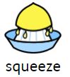 | Squeeze-To firmly press.
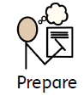 | Prepare – To get ready
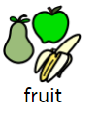 | Fruit – the sweet and fleshy product of a tree or other plant that contains seed and can be eaten as food
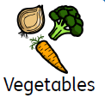 | Vegetable - a plant or part of a plant used as food
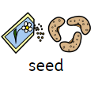 | Seed – something that can be sown and a plant can grow from it

What should I already know? (EYFS)
- Safely use and explore a variety of materials, tools and techniques, experimenting with colour, design, texture, form and function.
- To use everyday language to talk about size, weight, capacity, position, distance, time and money.

DT Skills:
- Chop fruit and vegetables safely to make a smoothie
- Identify if a food is a fruit or a vegetable
- Learn where and how fruits and vegetables grow
- Taste and evaluate different fruit combinations
- Describe the appearance, smell and taste of fruits and vegetables
- Evaluate the smoothie making process

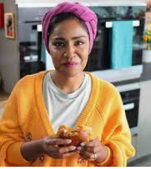
Inspirational Designer: Nadiya Hussain

Teaching Sequence

- To understand the difference between fruits and vegetables
- To cut and slice and taste different fruits
- To plan a design brief for the fruit salad
- To make a fruit salad(including the cutting, slicing and chopping)
- To evaluate the design brief, fruit salad

Blooms Taxonomy – Specific Verbs to Use in Lesson Aims
Knowledge: Describe, find, identify, list, locate, name, recognise, retrieve Comprehension: Classify, compare, explain, infer, interpret, paraphrase, summarise Application: Carry out, implement, use Analysis: Deconstruct, Organise, outline, structure Synthesis: Construct, design, devise, invent, make, plan, produce, Evaluation: Appraise, assess, choose,

