Key Vocabulary and Definitions:

|  |  |
| --- | --- |
| **Shabbat** | The Jewish day of rest. |
| **Kippah** | Skull cap |
| **Tanakh** | Jewish Holy Books |

What should I already know?

Early years

RE Skills:

- To tell you which is my favourite day of the week and talk about food I would like to share in a special meal.

- To use the right names for things that are special to Jewish people during Shabbat and explain why.

- To start to make a connection between being a Jewish child and decisions about behaviour or actions.

Teaching Sequence

1. To be able to talk about my favorite day of the week and say why it is special and I can retell the creation story and how it relates to the Sabbath.
2. I can explain how Shabbat is celebrated
3. I can talk about why a Jewish family might go to a synagogue to celebrate shabbat and I can explain what happens.
4. I can explain why having a regular time of peace or rest might be good for me and others.

Blooms Taxonomy – Specific Verbs to Use in Lesson Aims

Knowledge: Describe, find, identify, list, locate, name, recognise, retrieve Comprehension: Classify, compare, explain, infer, interpret, paraphrase, summarise Application: Carry out, implement, use Analysis: Deconstruct, Organise, outline, structure Synthesis: Construct, design, devise, invent, make, plan, produce, Evaluation: Appraise, assess, choose,

Key Knowledge

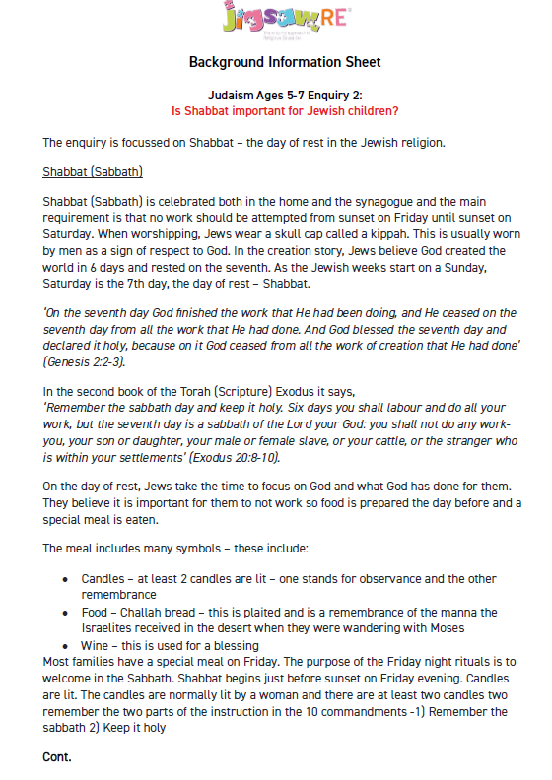

Key Knowledge

