Key Vocabulary and Definitions:

|  |  |
| --- | --- |
| animal | A living thing that can move around by themselves to find food. |
| amphibian | A small animal that spends part of its  life cycle in water and part of its life  cycle on land. |
| bird | An animal with two wings, two feet,  and a body covered with feathers. |
| carnivore | An animal that only feeds on  other animals. |
| fish | An animal that lives in water and has  fins for swimming and gills for  breathing. |
| herbivore | An animal that only feeds on plants. |
| mammal | A warm-blooded animal with fur or hair  on its skin and a skeleton inside its body. |
| omnivore | An animal that feeds on other animals  and plants. |
| reptile | A cold-blooded animal with a skeleton  inside its body and dry scales or hard  plates on its skin. |

Prior Learning

What I should already know?

Use all their senses in hands-on exploration of natural materials. (Nursery - Humans)

Name and describe people who are familiar to them. (Reception - Humans)

Early Learning Goal

Scientific Knowledge:

|  |
| --- |
| Animals vary in many ways having different structures e.g.  wings, tails, ears etc. They also have different skin coverings  e.g. scales, feathers, hair. These key features can be used to  identify them.  Animals eat certain things - some eat other animals, some eat  plants, some eat both plants and animals.  Humans have key parts in common, but these vary from  person to person. Humans (and other animals) find out about  the world using their senses.  Humans have five senses – sight, touch, taste, hearing and  smelling. These senses are linked to particular parts of the  body. |

* Make simple comparisons and groupings
* Communicate observations orally, in drawing, labelling, simple writing and using ICT
* Begin to compare some living things
* Identify key features
* Ask questions

Blooms Taxonomy – Specific Verbs to Use in Lesson Aims

Knowledge: Describe, find, identify, list, locate, name, recognise, retrieve Comprehension: Classify, compare, explain, infer, interpret, paraphrase, summarise Application: Carry out, implement, use Analysis: Deconstruct, Organise, outline, structure Synthesis: Construct, design, devise, invent, make, plan, produce, Evaluation: Appraise, assess, choose,

Teaching Sequence

1. To talk about the characteristics of mammals, birds and reptiles.
2. To identify differences between fish and amphibians.
3. To identify and name a variety of common animals that are carnivores, herbivores, and omnivores. (Field trip Cotswold Wildlife Park)
4. To sort animals into their classes and identify common features of each class.
5. Describe how animals obtain their food from plants and other animals, using the idea of a simple food chain, and identify and name different sources of food.
6. TAPS Identify and name common animals that are carnivores, herbivores and omnivores

Key Knowledge

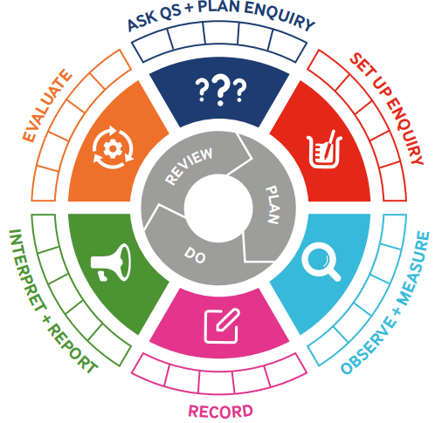

|  |  |  |  |
| --- | --- | --- | --- |
| Term 4 | Let’s Talk (Explorify) | Scientific Knowledge | Scientific skill |
| Lesson 1 | What’s going on? – video  Special Delivery  Zoom in and out  Creature comforts | To talk about the characteristics of mammals, birds and reptiles. | To Observe and Measure |
| Lesson 2 | What’s going on? – video  Unexpected eggs | To identify and name a variety of common animals that are carnivores, herbivores and omnivores. (Field trip Cotswold Wildlife Park) | To Observe and Measure  To Record |
| Lesson 3 | What’s going on? – video  Muddy meal | To identify differences between fish and amphibians. | To Observe and Measure |
| Lesson 4 | Odd one out  Sleepy Heads | To sort animals into their classes and identify common features of each class. | To set up an enquiry  To ask questions  Evaluate |
| Lesson 5 | Odd one out  Different Homes | To describe how animals, obtain their food from plants and other animals, using the idea of a simple food chain, and identify and name different sources of food. | Interpret and Report |
| Lesson 6 | Odd one out  In your eyes | TAPS Identify and name common animals that are carnivores, herbivores and omnivores | To evaluate |