Key Vocabulary:

Sculpture  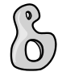 | Art in 3D. Sculptures can be made by carving, modelling or placing materials together
Sculptor  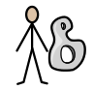 | Someone that makes sculptures.
Materials  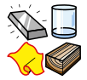 | The substance used to make something like clay, wood, metal, fabric, charcoal.
Construction   | The creation or building of something.
Structure  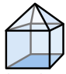 | The placement of different parts of the body, object or composition
Form  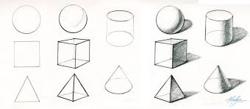 | three dimensional shapes and they have length, width and depth

What should I already know?
(Substantive Knowledge)

- Understand that sculpture is the name sometimes given for artwork which exists in three dimensions.
- Understand the meaning of “Design through Making”
- Look at the work of artists who draw, sculptors, and painters, listening to the artists’ intention behind the work and the context in which it was made.
- Understand we may all have different responses in terms of our thoughts and the things we make. That we may share similarities. Understand all responses are valid.

What will I learn?
(Implicit Knowledge/Skills)

- Use a combination of two or more materials to make sculpture.

- Use construction methods to build.

- Work in a playful, exploratory way, responding to a simple brief, using Design through Making philosophy.

- Reflect upon the artists’ work, and share your response verbally (“I liked…”).

- Present your own artwork (journey and any final outcome), reflect and share verbally (“I enjoyed… This went well”).

- Some children may feel able to share their response about classmate’s work.

Focus Artists
Faith Bebbington
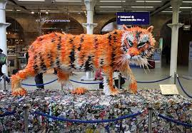

Blooms Taxonomy – Specific Verbs to Use in Lesson Aims
Knowledge: Describe, find, identify, list, locate, name, recognise, retrieve Comprehension: Classify, compare, explain, infer, interpret, paraphrase, summarise Application: Carry out, implement, use Analysis: Deconstruct, Organise, outline, structure Synthesis: Construct, design, devise, invent, make, plan, produce, Evaluation: Appraise, assess, choose,

Glue here.
My Learning Ladder

Learning Objective |  | Pupil Voice | Teacher Assessment
to discover different types of sculpture and record my thoughts
to explore a range of materials and create something
to create my sculpture
to create my sculpture
to finalise my sculpture by adding details

to evaluate my sculpture |  | See below.
Evaluation of my Final Piece


