Key Vocabulary and Definitions:

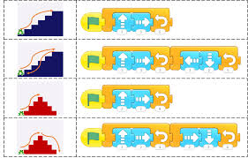 | Algorithm  A set of instructions for a program.
 | Design  A plan.
 | Repeat  Completing the same task.
 | Sprite  A character within Scratch Jr
 | Delete  To remove something.
 | Program  A set of algorithms to complete a sequence.
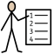 | Instructions  Tasks to be completed in order.

Progression: This unit progresses learners’ knowledge and understanding of programming and follows on from ‘Programming A – Moving a robot’, where children will have learned to program a floor robot using instructions.

National Curriculum:
Understand and use algorithms, create and debug simple programs, use logical reasoning to predict the behaviour of simple programs.

Computing: Teaching Sequence

- Comparing Tools
- Joining Blocks
- Making Changes
- Adding Sprites
- Project Design
- Following a Design

Online Safety: Managing Online Information, Copyright and ownership
- Explain why work I create using technology belongs to me
- Say why it belongs to me
- Save my work under a suitable title
- Understand work that is created by others does not belong to me
Blooms Taxonomy – Specific Verbs to Use in Lesson Aims
Knowledge: Describe, find, identify, list, locate, name, recognise, retrieve Comprehension: Classify, compare, explain, infer, interpret, paraphrase, summarise Application: Carry out, implement, use Analysis: Deconstruct, Organise, outline, structure Synthesis: Construct, design, devise, invent, make, plan, produce, Evaluation: Appraise, assess, choose,

