Key Vocabulary and Definitions:

Equator  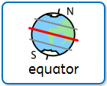 | An imaginary line that is drawn around the middle of the Earth to divide it into the Northern and Southern Hemispheres.
human feature  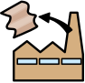 | Something that is built by humans and would not exist without humans.  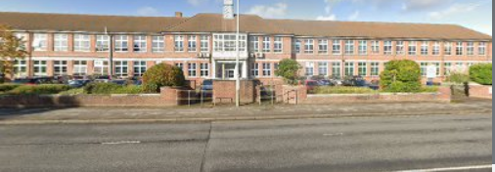
Climate  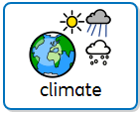 | The weather found in a certain place over a long period of time.
physical feature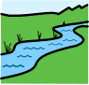 | A natural feature on the world’s surface, such as water, mountains and deserts.  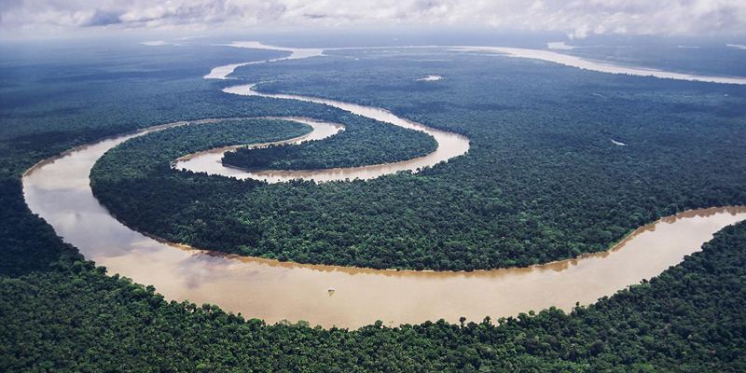
Location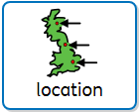 | A location is a fixed place or position.

What should I already know?
- Use appropriate words, e.g. town, village, road, path, house, flat, temple and synagogue to help children make distinctions in their observations.
- To talk about the features of where they live and how environments may change from one another.

Geography Skills:
- Use photographs to recognise landmarks and basic human and physical features.
- Study the location of hot and cold areas of the world in relation to the equator and the North and South poles.
- To use maps and atlas to support knowledge.

Blooms Taxonomy – Specific Verbs to Use in Lesson Aims
Knowledge: Describe, find, identify, list, locate, name, recognise, retrieve Comprehension: Classify, compare, explain, infer, interpret, paraphrase, summarise Application: Carry out, implement, use Analysis: Deconstruct, Organise, outline, structure Synthesis: Construct, design, devise, invent, make, plan, produce, Evaluation: Appraise, assess, choose,

Teaching Sequence

- To understand human and physical features.
- To study the features of a contrasting location (Close to the equator)
- To study the features of a contrasting location (Distant from the equator)
- To compare the contrasting locations (Physical features, human features, climate) Quiz.

