What should I already know?
That Jewish people follow Judaism and worship one God. They also celebrate Shabbat.
Key Vocabulary and Definitions:
Judaism
The religion followed by Jewish people.
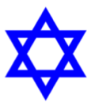
Jew
A person whose ancestors were Biblical Hebrews or a person whose religion is Judaism.

Rosh Hashanah
The day Jewish people celebrate the creation of the universe.

Yom Kippur
A day of atonement, 10 days after Rosh Hashanah.

RE Skills:
- To be able to consider the views and beliefs of others looking through their eyes.
- Empathy.
- To be reflective about the values that religions hold that could be applicable to our own lives.

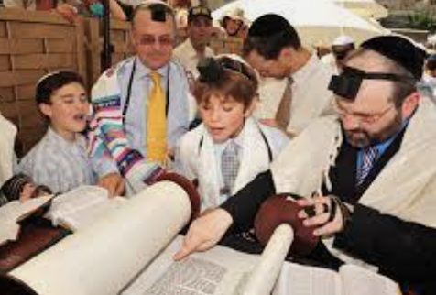



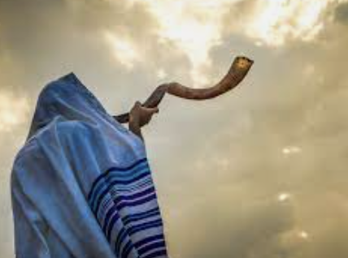

Teaching Sequence

- To explore the meaning of forgiveness and the need for it.
- To learn how and why Jewish people celebrate Rosh Hashanah and Yom Kippur.
- To reflect on the message of perseverance taught at Rosh Hashanah and the importance of Rosh Hashanah and Yom Kippur to Jewish people.

