Key Vocabulary and Definitions:
Game Reserve | 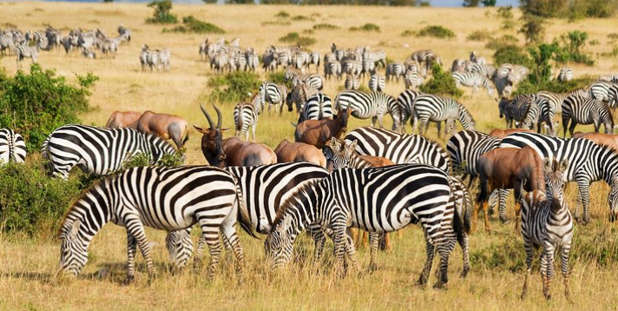 | A large area of land where animals live safely. This is privately owned.
Drought | 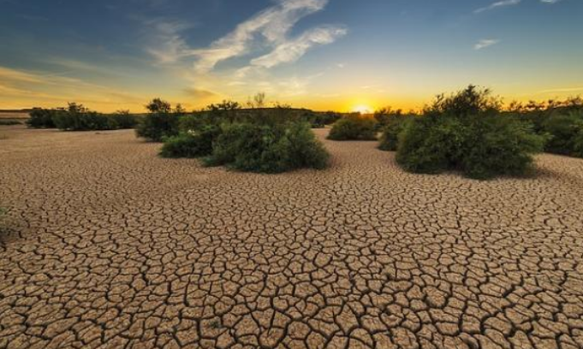 | Very little rain and so there is no water.
Endangered species | 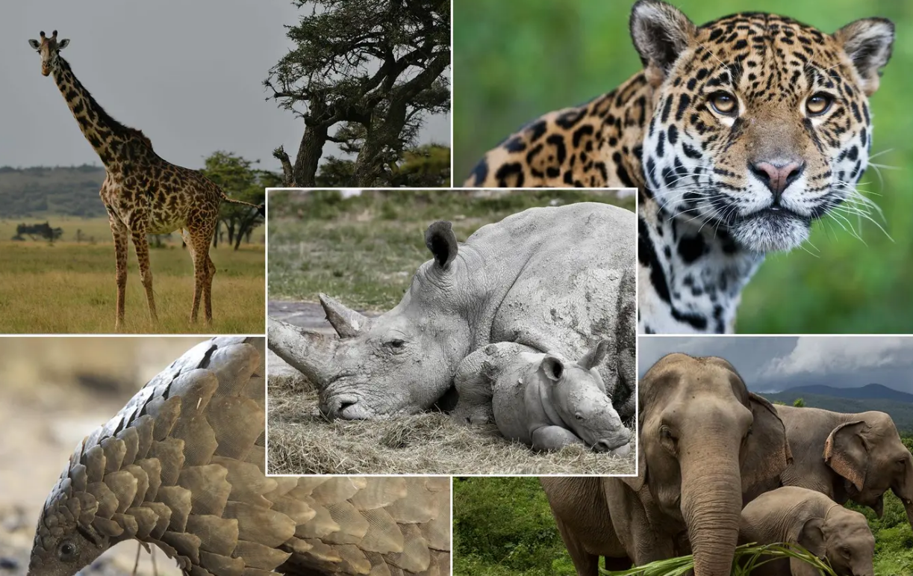 | A species of animal or plant that is at risk of becoming extinct.
Extinct | 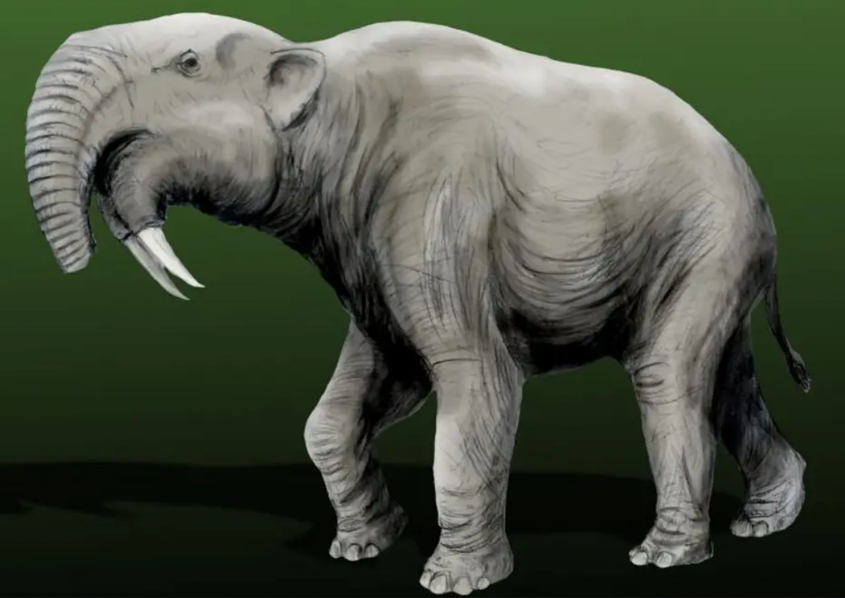 | When a species will never be alive again.
Maasai | 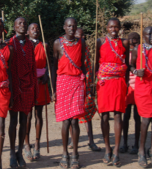 | A well-known group of Kenyan people living together
Nairobi | 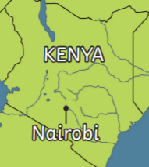 | Kenya’s capital city
National park | 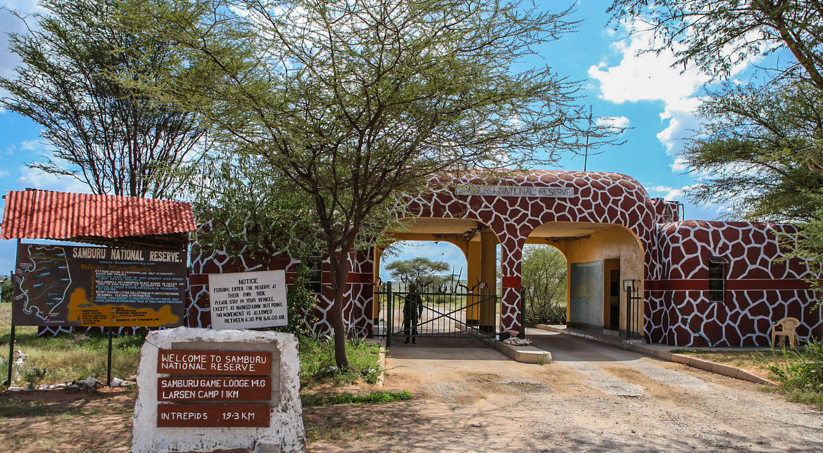 | A national park is a protected area of land where only tourism and research is allowed by humans. No humans live in national parks.
Savannah | 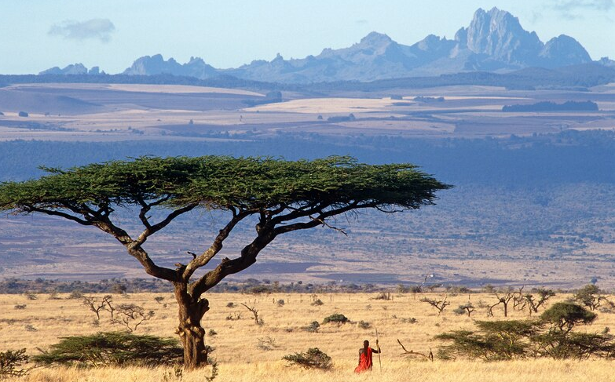 | A grassy plain with few trees.
Tourist | 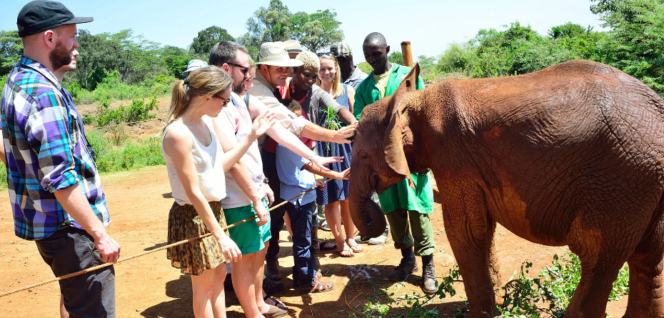 | Someone who is visiting a place for pleasure.

What should I already know?
- Name, locate and identify characteristics of the four countries and capital cities of the United Kingdom and its surrounding seas.
- Name and locate the world’s seven continents and five oceans.
- Use aerial photographs and plan perspectives to recognise landmarks and basic human and physical features: devise a simple map; and use and construct basic symbols in a key.
- Use simple compass directions (North, East, South and West), to describe the location of features and routes on a map.

Geographical Skills
- use world maps, atlases and globes to identify the United Kingdom and its countries, as well as the countries, continents and oceans studied at this key stage.
- To understand geographical similarities and differences through studying the human and physical geography of a small area of the United Kingdom, and of a small area in a contrasting non-European country
- To use basic geographical vocabulary to refer to key physical and human features

Teaching Sequence

1. To understand where Kenya is in the world and locate it on a world map.
2. To use basic geographical vocabulary when researching Kenya’s National parks.
3. To draw a simple free hand map of Kenya, including key geographical features.
4. To understand what life is like in the Maasai and how this compares to my life.
5. To suggest similarities and differences between Kenya and England.
6. To create a fact file showing the big 5 Animals that live in Kenya and why their existence is so important.

Blooms Taxonomy – Specific Verbs to Use in Lesson Aims
Knowledge: Describe, find, identify, list, locate, name, recognise, retrieve Comprehension: Classify, compare, explain, infer, interpret, paraphrase, summarise Application: Carry out, implement, use Analysis: Deconstruct, Organise, outline, structure Synthesis: Construct, design, devise, invent, make, plan, produce, Evaluation: Appraise, assess, choose,

