Key Vocabulary and Definitions:
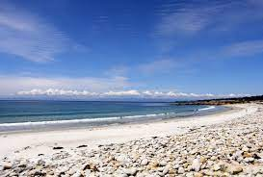 Beach | An area of sand or stones next to the ocean
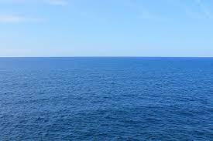 Ocean | Big body of salty water
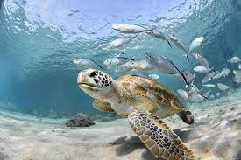 Sea | A body of salt water not as large as an ocean, often surrounded by land.
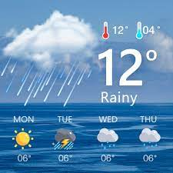 Weather | The daily state of the atmosphere, or air, in any given place.
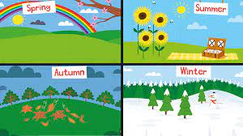 Season | Seasons are four different times during the year with different types of weather.
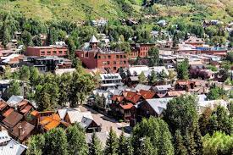 Town | A built-up area with a name, defined boundaries, and local government, that is larger than a village and generally smaller than a city.
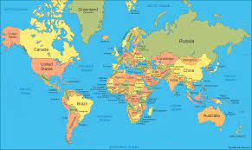 Map | A diagrammatic representation of an area of land or sea showing physical features, cities, roads, etc.
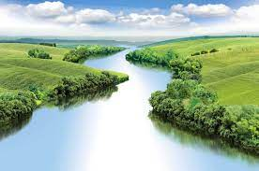 River | A large natural stream of water flowing in a channel to the sea, a lake, or another river.
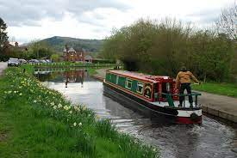 Canal | An artificial waterway constructed to allow the passage of boats or ships inland or to convey water for irrigation.
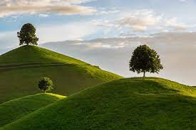 Hill | a naturally raised area of land, not as high or craggy as a mountain.
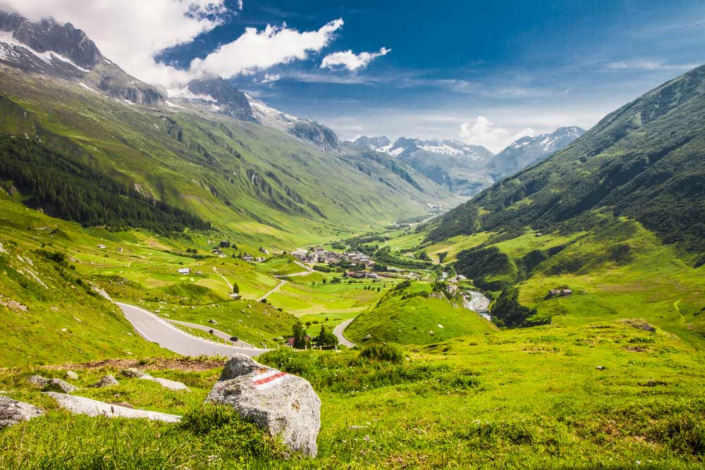 Valley | a low area of land between hills or mountains, typically with a river or stream flowing through it.
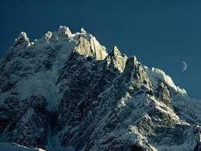Mountain | a large natural elevation of the earth's surface rising abruptly from the surrounding level; a large steep hill.

What should I already know?
- Name, locate and identify characteristics of the four countries and capital cities of the United Kingdom and its surrounding seas.
- Name and locate the world’s seven continents and five oceans.
- Use world maps, atlases and globes to identify the United Kingdom and its countries.

Geographical Skills
- Understand geographical similarities and differences through studying the human and physical geography of a small area of the United Kingdom, and of a small area in a non-European country.
- Identify seasonal/daily weather patterns in the UK and the location of hot and cold areas of the world in relation to the equator and the North and South poles.
- Use basic Geographical vocabulary to refer to key physical features (inc – beach, cliff, coast, forest, hill, mountain, sea, ocean, river, soil, valley, vegetation, season, weather) and human features (inc city, town, village, factory, farm, house, office, port, harbour, shop) of a contrasting non-European country.
- Use aerial photographs and plan perspectives to recognise landmarks and basic human and physical features: devise a simple map; and use and construct basic symbols in a key.

Teaching Sequence –

1. To locate a small Kenyan town (Malindi) and Swindon on a world map.

2. To identify some of the key physical features found in both Malindi and Swindon.

3. To identify some of the key human features found in both Malindi and Swindon.

4. To discuss some similarities and differences between Malindi and Swindon

5. To understand why the weather may be different in 2 different world locations.

Blooms Taxonomy – Specific Verbs to Use in Lesson Aims
Knowledge: Describe, find, identify, list, locate, name, recognise, retrieve Comprehension: Classify, compare, explain, infer, interpret, paraphrase, summarise Application: Carry out, implement, use Analysis: Deconstruct, Organise, outline, structure Synthesis: Construct, design, devise, invent, make, plan, produce, Evaluation: Appraise, assess, choose,

