What should I already know?
- Distinguish between an object and the material from which it is made. (Y1 - Everyday materials)
- Identify and name a variety of everyday materials, including wood, plastic, glass, metal, water, and rock. (Y1 - Everyday materials)
- Describe the simple physical properties of a variety of everyday materials. (Y1 - Everyday materials)
- Compare and group together a variety of everyday materials based on their simple physical properties. (Y1 - Everyday materials)
Key Vocabulary and Definitions:

Classify | 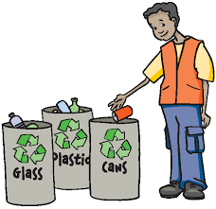 | Sort into a different group or category.
Compare | 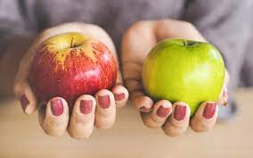 | To examine for similarity or differences
Experiment |  | A carefully planned test used to find out the answer to something you don’t know.
Investigate |  | To look at or explore something carefully to learn the facts about it.
Material | 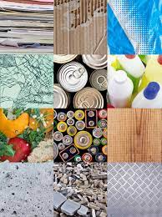 | Anything used for building or making something else.
Observation |  | Noting down something you have seen happening.
Predict |  | To use your knowledge to say what you think will happen before that thing happens.
Properties | 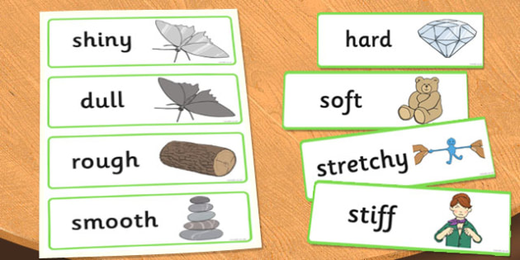 | words that describe what the material is like. Is it rough or smooth, hard or soft?
Suitability | 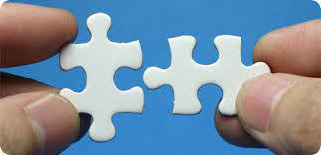 | Being the correct material for the job it is needed for.

Scientific Skills:
- Identify and compare the suitability of a variety of everyday materials, including wood, metal, plastic, glass, brick, rock, paper and cardboard for particular uses.
- Find out how the shapes of solid objects made from some materials can be changed by squashing, bending, twisting and stretching.

Teaching Sequence

1. To identify uses of different everyday materials
2. To identify and group the uses of everyday materials and to record my observations
3. To compare the suitability of different everyday materials (TAPs assessment)
4. To explain how the shapes of objects made from some materials can be changed
*Cross Circular link with D&T*

Blooms Taxonomy – Specific Verbs to Use in Lesson Aims
Knowledge: Describe, find, identify, list, locate, name, recognise, retrieve Comprehension: Classify, compare, explain, infer, interpret, paraphrase, summarise Application: Carry out, implement, use Analysis: Deconstruct, Organise, outline, structure Synthesis: Construct, design, devise, invent, make, plan, produce, Evaluation: Appraise, assess, choose,

Key Knowledge

Term 1 | Let’s Talk (Explorify) | Scientific Knowledge | Scientific skill
Lesson 1 | Stretched a hair band or an elastic band too much? - Explorify | - Identify and compare the suitability of a variety of everyday materials, including wood, metal, plastic, glass, brick, rock, paper and cardboard for particular uses. | To observe and measure
Lesson 2 | Fit for purpose? - Explorify | - Find out how the shapes of solid objects made from some materials can be changed by squashing, bending, twisting and stretching. | To record  To interpret and report
Lesson 3 | Squashed a sandwich in your bag? - Explorify | - Identify and compare the suitability of a variety of everyday materials, including wood, metal, plastic, glass, brick, rock, paper and cardboard for particular uses. | To observe and measure  To record  To ask Qs and plan an enquiry  To evaluate
Lesson 4 | Sorted your toys in different ways? - Explorify | - Find out how the shapes of solid objects made from some materials can be changed by squashing, bending, twisting and stretching. | To ask Qs and plan an enquiry  To observe and measure  To evaluate

