Key Vocabulary and Definitions:
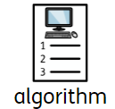 | A set on instructions or programme.
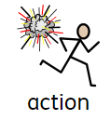 | The activity of using computers and writing programs for them
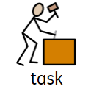 | To describe a software program with a set of actions/instructions.
 | To plan an idea or programme.
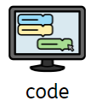 | The process of putting ideas and instructions into language that a computer can understand.
Object | An object is something that you can touch. A material is what the object is made from.
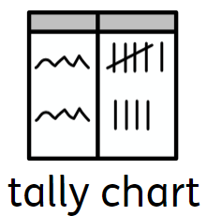 | A tally chart is a table used for counting and comparing the numbers of multiple classes of a data set.
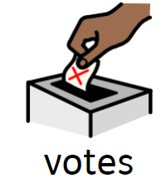 | Individual choice
total | The result of adding.

Progression
- This unit progresses learners’ knowledge and understanding of instructions in sequences and the use of logical reasoning to predict outcomes.

National Curriculum
- Understand what algorithms are; how they are implemented as programs on digital devices; and that programs execute by following precise and unambiguous instructions
- Create and debug simple programs
- Use logical reasoning to predict the behaviour of simple programs
- Use technology purposefully to create, organise, store, manipulate and retrieve digital content

Teaching Sequence

- To explain that a sequence of commands has a start.
- To explain that a sequence of commands has an outcome.
- To create a program using a given design
- To change a given design
- To create a program using my own design
- To decide how my project can be improved
Online safety – Online Bullying

- To explain simple guidance for using technology in different environments and settings e.g. accessing online technologies in public places and the home environment.
- To say how those rules / guides can help anyone accessing online technologies

Blooms Taxonomy – Specific Verbs to Use in Lesson Aims
Knowledge: Describe, find, identify, list, locate, name, recognise, retrieve Comprehension: Classify, compare, explain, infer, interpret, paraphrase, summarise Application: Carry out, implement, use Analysis: Deconstruct, Organise, outline, structure Synthesis: Construct, design, devise, invent, make, plan, produce, Evaluation: Appraise, assess, choose,

Final outcome:
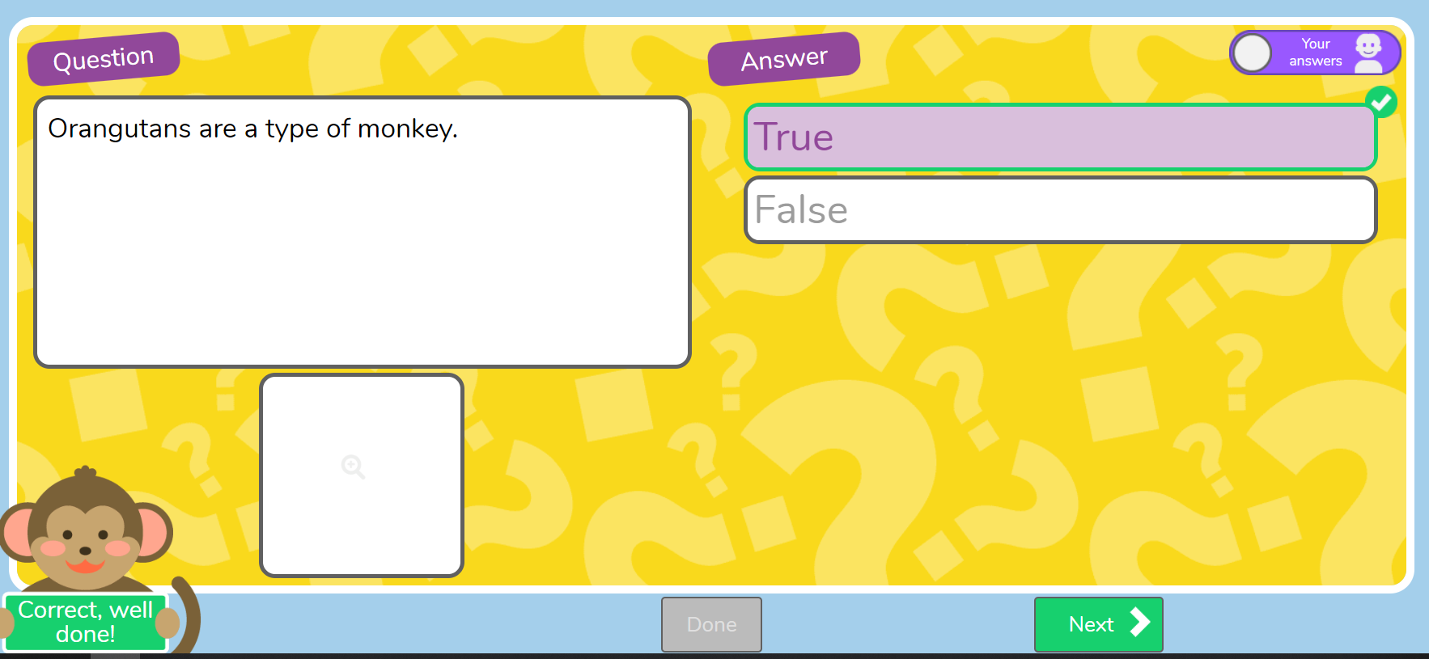

Children to design and make their own quiz about Orangutans.

Concept Cartoon:

