Key Vocabulary and Definitions:

Travel / Transport  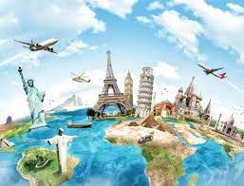 | Moving from one place to another.  Carrying people or goods from one place to another.
Steam engine  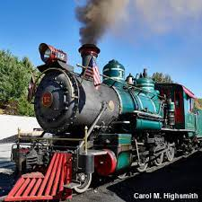 | A steam engine uses steam from boiling water to make it move. The steam pushes the moving parts.
Petrol/Combustion Engine  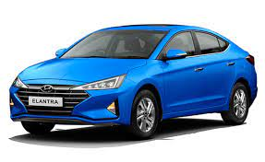 | Combustion means burning. A petrol engine burns petrol to make it move.
Electric car | Electric cars use electricity to make the motor run.
Invention | To think of, come up with, or create something new.
Airplane  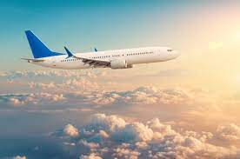 | A machine that can fly because of the force of air upon its wings.
Viking Longboat  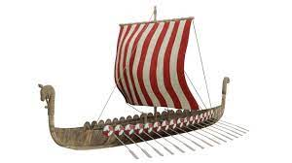 | A medieval ship.
Past | Something that has happened before the present day.
Present | Something happening now.
Future | Something that is happening tomorrow.

What should I already know?

- Sequence events.
- Drama – develop empathy and understanding (hot seating, sp and listening).
- Compare pictures or photographs of people or events in the past.
- Use a source – why, what, who, how, where to ask questions and find answers.

Historical Skills:
- Sequence photos etc from different periods of their life.
- Describe memories of key events in lives.
- Find out about people and events in other times.
- Collections of artefacts – confidently describe similarities and differences.
- Able to identify different ways to represent the past.
- Use of time lines.
- Sequence artefacts closer together in time
- Discuss the effectiveness of sources
- Communicate their knowledge through discussion, drawing pictures, making models, writing and using ICT

Blooms Taxonomy – Specific Verbs to Use in Lesson Aims
Knowledge: Describe, find, identify, list, locate, name, recognise, retrieve Comprehension: Classify, compare, explain, infer, interpret, paraphrase, summarise Application: Carry out, implement, use Analysis: Deconstruct, Organise, outline, structure Synthesis: Construct, design, devise, invent, make, plan, produce, Evaluation: Appraise, assess, choose,

Teaching Sequence

- To find out different ways in which travel and transport has changed from past to present
- To investigate an early form of travel: The Viking longboat
- To discover how cars have changed over time
- To understand the importance of George Stevenson and his inventions
- To understand the importance of the Wright Brothers’ and the invention of the airplane

End of Unit - Key Knowledge Quiz

- What mode of transport did the Vikings use to travel to different countries?

- Can you name the first steam train and its inventor?

- Who invented the first petrol car?

- Who first successfully flew a plane?

- How did people used to travel before cars?

- What mode of transport had one large wheel at the front and a smaller one at the back?

