What should I already know?
- Identify and name a variety of common animals that are carnivores, herbivores and omnivores. (Y1 - Animals, including humans)
- Identify, name, draw and label the basic parts of the human body and say which part of the body is associated with each sense. (Y1 - Animals, including humans)

Key Vocabulary and Definitions:

Basic needs  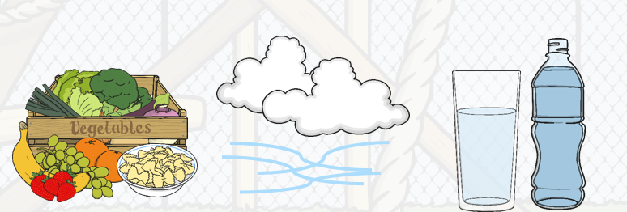 | The things a human or animal need to stay alive.
Froglet  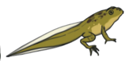 | The stage when a frog still has a tail.
Frogspawn   | The state in which a frog begins their life.
Gills  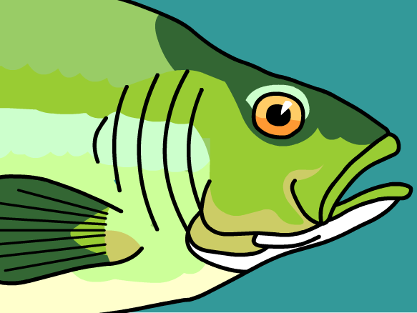 | The flaps through which fish and other creatures breathe underwater.
Habitat  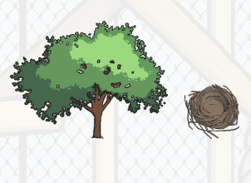 | The home naturally suited to an animal.
Hatch | Emerge from a shell.
Life cycle  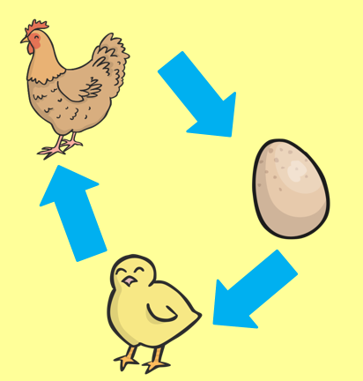 | The pattern of an animal’s life, from birth through growth into adulthood.
Tadpole  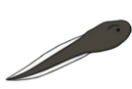 | The second stage in the life of a frog, when they begin to swim.

Scientific Skills:
- Notice that animals, including humans, have offspring which grow into adults.
- Find out about and describe the basic needs of animals, including humans, for survival (water, food and air).
- Describe the importance for humans of exercise, eating the right amounts of different types of food, and hygiene.

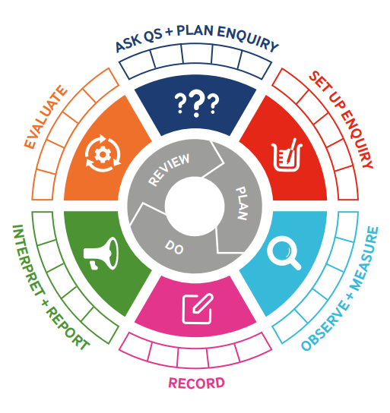
Teaching Sequence

- To organise animals into their groups.
- To match animals and their babies.
- To describe how animals, change as they grow using the life cycle (TAPS).
- To describe the life cycle of humans.
- To describe the basic needs of humans and animals.
Blooms Taxonomy – Specific Verbs to Use in Lesson Aims
Knowledge: Describe, find, identify, list, locate, name, recognise, retrieve Comprehension: Classify, compare, explain, infer, interpret, paraphrase, summarise Application: Carry out, implement, use Analysis: Deconstruct, Organise, outline, structure Synthesis: Construct, design, devise, invent, make, plan, produce, Evaluation: Appraise, assess, choose,

Key Knowledge

Term 3 | Let’s Talk (Explorify) | Scientific Knowledge | Scientific skill
Lesson 1 | Odd One Out  Baby Animals  https://explorify.uk/en/activities/odd-one-out/baby-animals | - Notice that animals, including humans, have offspring which grow into adults. | To Record
Lesson 2 | WHAT'S GOING ON?  Unexpected eggs  https://explorify.uk/en/activities/whats-going-on/unexpected-eggs | - Notice that animals, including humans, have offspring which grow into adults. | To Observe
Lesson 3 | What if?  https://explorify.uk/en/activities/what-if/animals-did-not-have-young | - Notice that animals, including humans, have offspring which grow into adults. | To Observe
Lesson 4 | Have you ever?  https://explorify.uk/en/activities/have-you-ever/helped-an-elderly-relative-do-something | - Notice that animals, including humans, have offspring which grow into adults. | To Set Up and Enquiry  To Ask Qs and Plan Enquiry
Lesson 5 | Have you ever?  https://explorify.uk/en/activities/have-you-ever/cared-for-a-baby-animal | - Find out about and describe the basic needs of animals, including humans, for survival (water, food and air). | To Evaluate

