Key Vocabulary and Definitions:

Seaside  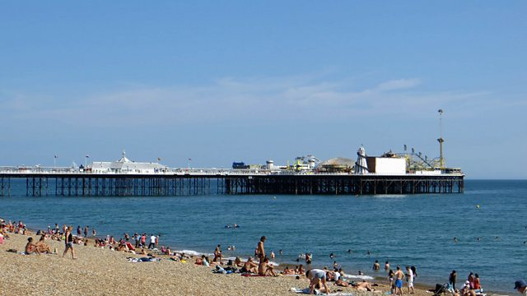 | The land bordering the sea.
Holiday/Vacation   | A period spent away from home or business in travel or amusement.
Past   | Something which has already happened – could be many years ago.
Present   | Something which is happening now.
Bathing Machines  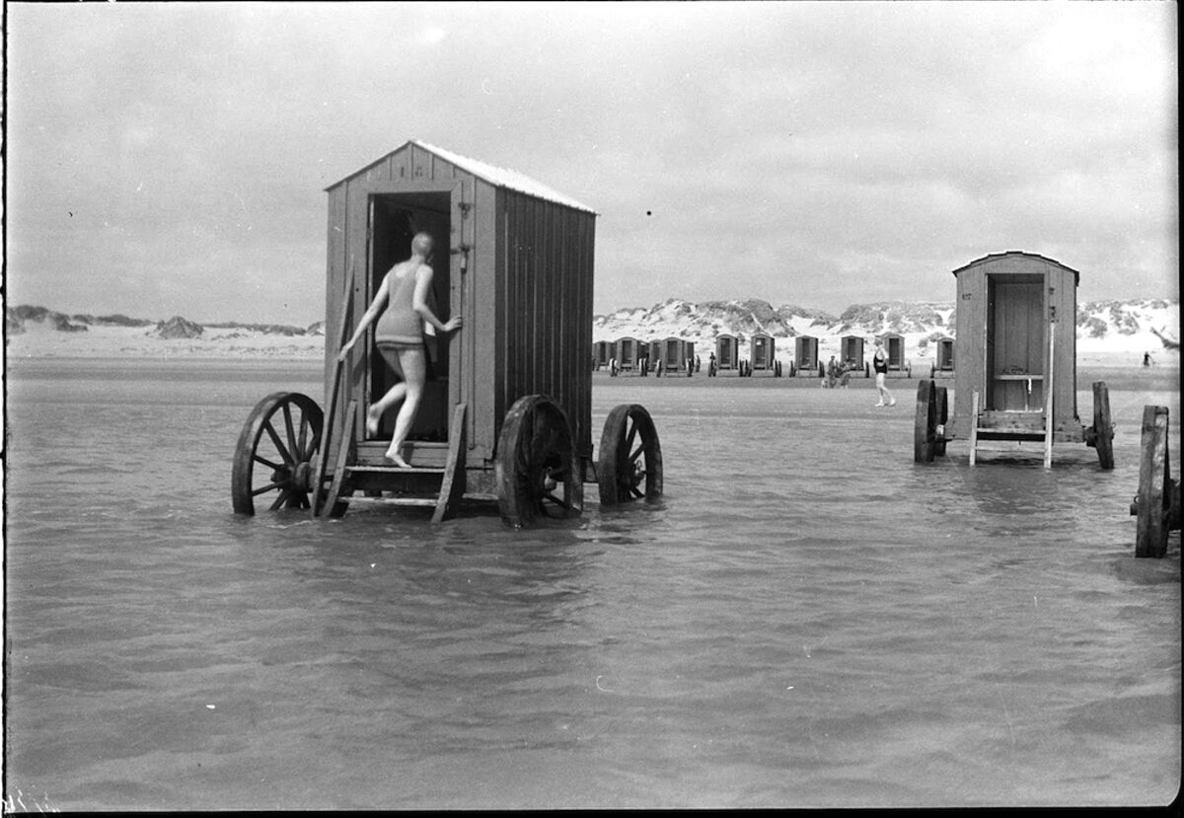 | A wooden hut on wheels which was used to help people participate in the activity of sea bathing.
Donkey rides   | A traditional feature of seaside resorts in the United Kingdom.
Arcade  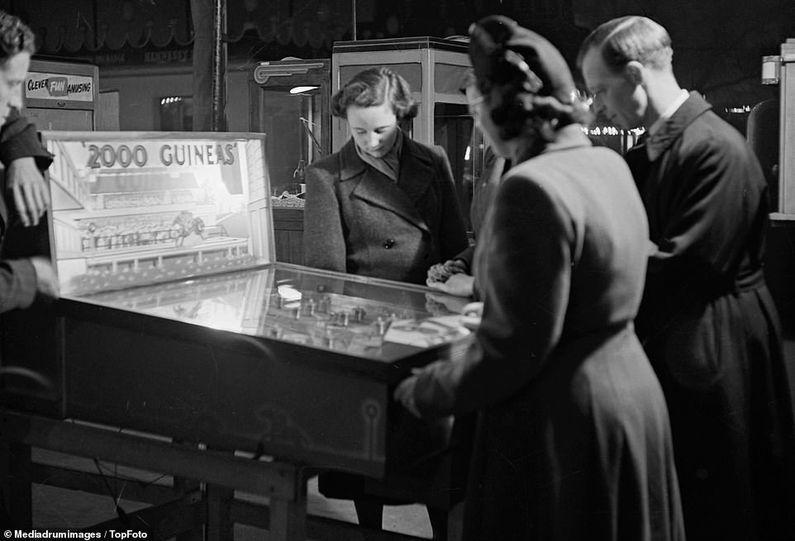 | An indoor area containing coin operated game machines.
Compare | To look for similarity or differences.

What should I already know?
- Sequence events.
- Collections of artefacts – confidently describe similarities and differences.
- Compare pictures or photographs of people or events in the past.
- Drama – develop empathy and understanding (hot seating, speaking and listening)
- Use of time lines.

Historical Skills
- Find out about people and events in other times.
- Communicate their knowledge through discussion, drawing pictures, drama/role play, making models, writing and using ICT.
- Use a source – why, what, who, how, where to ask questions and find answers.
- Compare pictures or photographs of people or events in the past.
- Describe memories of key events in lives.

Teaching Sequence

1. To identify features of a seaside holiday.

2. To use photographs to find clues as to what seaside holidays were like in the past (100 years ago).

3. To find out when and how seaside holidays became popular.

4. To be able to order seaside holidays in chronological order.

5. To be able to identify similarities and differences between seaside holidays now and in the past.

Blooms Taxonomy – Specific Verbs to Use in Lesson Aims
Knowledge: Describe, find, identify, list, locate, name, recognise, retrieve Comprehension: Classify, compare, explain, infer, interpret, paraphrase, summarise Application: Carry out, implement, use Analysis: Deconstruct, Organise, outline, structure Synthesis: Construct, design, devise, invent, make, plan, produce, Evaluation: Appraise, assess, choose,

