Key Vocabulary and Definitions:

Muhammad  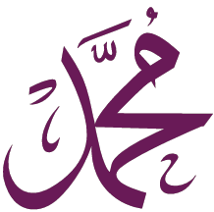 | The name Muhammad is the messenger chosen by Allah
Qur’an  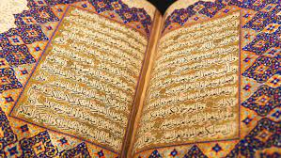 | Holy book – word of Allah, written in Arabic
Saudi Arabia  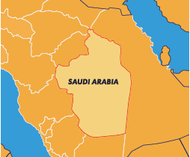 | A country in the Middle east, where Makkah is in
Prophet  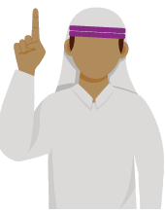 | A person thought of as an inspired teacher or someone who delivers the will of God.
Makkah  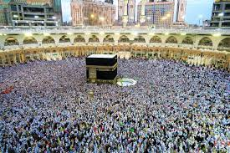 | Holy city in Saudi Arabia
Allah  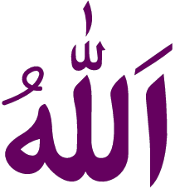 | Muslim name for God
Night of Power  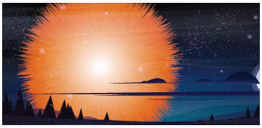 | The night the first part of the Qur’an was given to Muhammad.
Squander   | To spend time, money or effort wastefully

What should I already know?
EYFS – Learning from religious stories (Islam)
EYFS – Looking at special religious places (Islam)
Islam as a religion would not have started without the events in this enquiry. The Qur’an is to Muslims the word of Allah – Islam has now spread all over the world and the Qur’an is a guidebook through life for Muslims.

RE Skills:
Explain why the prophet Qur’an is important to Muslims.
Use the right words to describe how Muslims use the Qur’an and to explain its importance to Muslims.

Teaching Sequence

- To talk about something I have learnt from the story.
- To say how a Muslim might show respect to the Qur’an.
- To order events from the night of the power and say what I think is important.
- To say some of the instructions a Muslim might follow that are in the Qur’an.
- To explain why a Muslim might think the Qur’an is important.
- To consider how some of the things I think are important might be similar to instructions in the Qur’an..
Blooms Taxonomy – Specific Verbs to Use in Lesson Aims
Knowledge: Describe, find, identify, list, locate, name, recognise, retrieve Comprehension: Classify, compare, explain, infer, interpret, paraphrase, summarise Application: Carry out, implement, use Analysis: Deconstruct, Organise, outline, structure Synthesis: Construct, design, devise, invent, make, plan, produce, Evaluation: Appraise, assess, choose,

Key Knowledge
The Qur’an is the holy book for Muslims, but it is also believed to be the actual words of Allah spoken in Arabic, the language chosen by Allah. It is treated with great respect and many Muslims will learn Arabic specially to understand the wri ngs in the Qur’an in the language it was wri en in. Many Muslims take lessons in how to speak Arabic, including schoolchildren. These classes are o en carried out in the Mosque, the Muslim place of worship. The word ‘Qur’an’ comes from the Arabic verb ‘Qura’a’ meaning ‘Recite’, so Qur’an means ‘Recita on’. This is important to remember as the words of the Qur’an were recited to the prophet Muhammad by the Angel Jibr’il. The first me this happened is called ‘The Night of Power’.

On The Night of Power, Muhammad had gone up to a cave on Mount Hira to think on his own, it is just outside the city of Makkah. Muhammad used to go here so that he could think about things that were concerning him, especially the way that the people of Makkah were living a life that God would not approve of. Muslims believe Allah chose Muhammad at this stage and the messages began and carried on periodically over the next twenty years. Muhammad then recited them to others to put down on paper as he could not read or write.

The Qur’an has 114 chapters called surahs. The Qur’an is respected in many ways including: • Being put on a stand when used, so it is not over touched • When not used it is wrapped in a clean cloth • When not being read it should be the highest book in the room • Never being placed on the floor • Hands being washed before it is touched Muslims believe the Qur’an gives informa on on how to live life the way Allah would want. This is important to Muslims as Allah is watching them, life on earth is a test and challenges occur. The way you handle these will be observed by Allah. Muslims want to achieve paradise when they die – the Qur’an offers guidance on how to achieve this. When a Muslim dies their life is considered by Allah on judgment day and their a erlife is decided as a result. Because Muslims are not allowed to draw pictures represen ng Allah, they somemes use beau ful wri ng called Calligraphy to show Allah respect. This calligraphy o en consists of verses from the Qur’an.

