What should I already know?
(Substantive Knowledge)
- Understand that screen prints are made by forcing ink over a stencil.

- Understand that mono print can be used effectively to create prints which use line. That screen prints can be used to create prints which use thicker lines and / or shapes.

- Understand that we can combine collage with other disciplines such as drawing, printmaking and making.

- Understand the concept of still life and landscape painting.
Key Vocabulary:

Layering  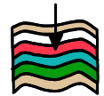 | Putting one thing on top of the other.
Influenced   | To be effected, inspired or changed by someone or something.
Collage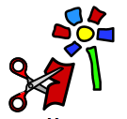 | A piece of art made by sticking various different materials such as photographs and pieces of paper or fabric on to a backing.
Colour   | The different pigments of an object.
Shape  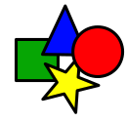 | The external form, contours, or outline of someone or something.
Composition   | The way something is put together in a piece of art or a photograph.

What will I learn?
(Implicit Knowledge/Skills)

- Use mono print or screen print over collaged work to make a creative response to an original artwork. Consider use of layers to develop meaning.

- Cut shapes from paper (free hand) and use as elements with which to collage, combined with printmaking (see column 3 “printmaking”)

- Make a creative response to an original artwork.

- Explore positive and negative shapes, line, colour and composition.

Focus Artists
Henri Matisse and Claire Willberg

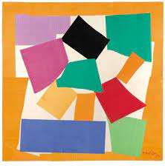

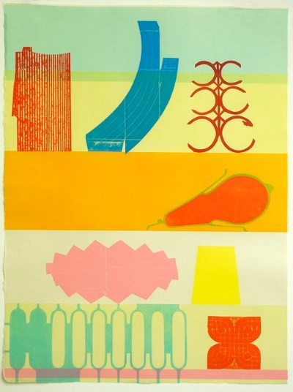

Blooms Taxonomy – Specific Verbs to Use in Lesson Aims
Knowledge: Describe, find, identify, list, locate, name, recognise, retrieve Comprehension: Classify, compare, explain, infer, interpret, paraphrase, summarise Application: Carry out, implement, use Analysis: Deconstruct, Organise, outline, structure Synthesis: Construct, design, devise, invent, make, plan, produce, Evaluation: Appraise, assess, choose,

Glue here.
My Learning Ladder

Learning Objective |  | Pupil Voice | Teacher Assessment
to interpret a piece of chosen artwork focusing on shape, colour and composition
to explore the work of Matisse, Bearden and the techniques of cutting shapes
to create a collage using cutting shapes
to finalise my collage using cutting shapes

to add details to my collage

to evaluate my ‘Drawing with Scissors’ piece |  | See below.
Evaluation of my Final Piece


