What should I already know?

(Substantive Knowledge)

* Understand that screen prints are made by forcing ink over a stencil.
* Understand that mono print can be used effectively to create prints which use line. That screen prints can be used to create prints which use thicker lines and / or shapes.
* Understand that we can combine collage with other disciplines such as drawing, printmaking and making.
* Understand the concept of still life and landscape painting.

Key Vocabulary:

|  |  |
| --- | --- |
| Layering   | Putting one thing on top of the other. |
| Influenced   | To be effected, inspired or changed by someone or something. |
|  | A piece of art made by sticking various different materials such as photographs and pieces of paper or fabric on to a backing. |
|  | The different pigments of an object. |
|  | The external form, contours, or outline of someone or something. |
| Composition   | The way something is put together in a piece of art or a photograph. |

What will I learn?

(Implicit Knowledge/Skills)

* Use mono print or screen print over collaged work to make a creative response to an original artwork. Consider use of layers to develop meaning.
* Cut shapes from paper (free hand) and use as elements with which to collage, combined with printmaking (see column 3 “printmaking”)
* Make a creative response to an original artwork.
* Explore positive and negative shapes, line, colour and composition.

Focus Artists

Henri Matisse and Claire Willberg

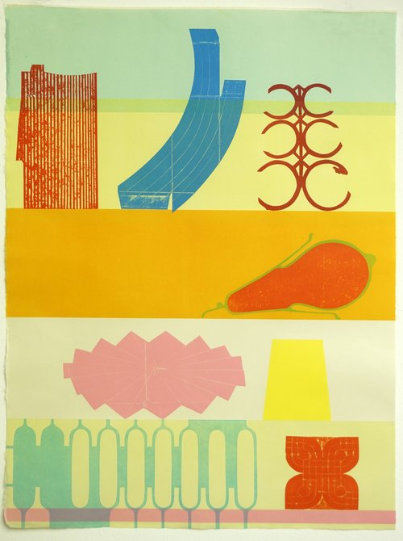

Blooms Taxonomy – Specific Verbs to Use in Lesson Aims

Knowledge: Describe, find, identify, list, locate, name, recognise, retrieve Comprehension: Classify, compare, explain, infer, interpret, paraphrase, summarise Application: Carry out, implement, use Analysis: Deconstruct, Organise, outline, structure Synthesis: Construct, design, devise, invent, make, plan, produce, Evaluation: Appraise, assess, choose,

Glue here.

My Learning Ladder

|  |  |  |  |
| --- | --- | --- | --- |
| Learning Objective | | Pupil Voice | Teacher Assessment |
| to interpret a piece of chosen artwork focusing on shape, colour and composition | |  |  |
| to explore the work of Matisse, Bearden and the techniques of cutting shapes | |  |  |
| to create a collage using cutting shapes | |  |  |
| to finalise my collage using cutting shapes | |  |  |
| to add details to my collage | |  |
| to evaluate my ‘Drawing with Scissors’ piece | | See below. |  |
| Evaluation of my Final Piece | | | |
|  |  | | |
|  |  | | |
|  |  | | |