Key Vocabulary and Definitions:

Compass  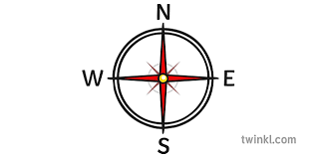 | A device with a magnetic needle that indicates direction on the earth's surface by always pointing north.
Continent  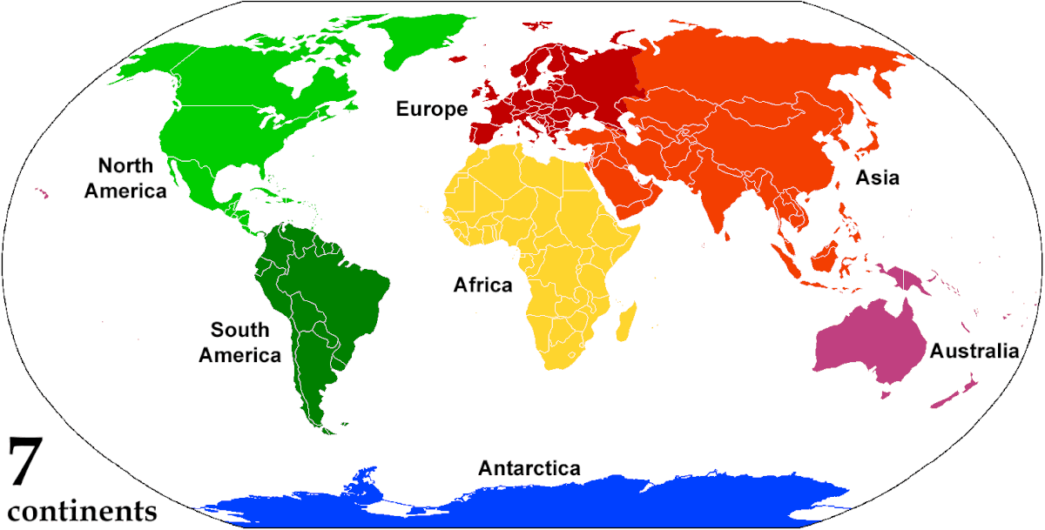 | A large area of the land on Earth that is joined together. There are seven continents in the world.
County  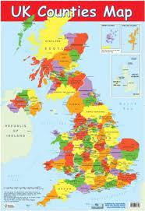 | A specific area of a country.
Human features  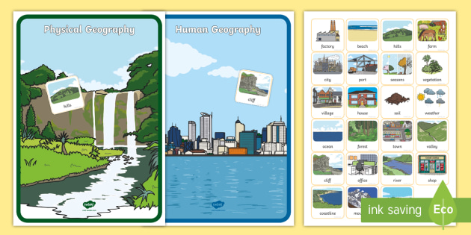 | Ways in which people have affected an area
Location  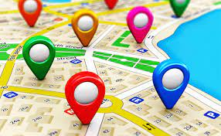 | The place where a particular point or object exists.
Peak  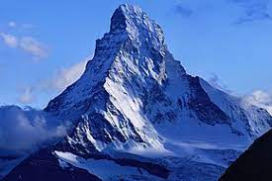 | The highest point of a hill or mountain
Physical features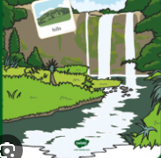 | The natural features of an area, such as mountains, deserts, rivers, and oceans.
Population | The number of people living in a country, city, or area

What should I already know?
- Name, locate and identify characteristics of the four countries of the UK
- Use basic Geographical vocabulary to refer to key physical features
- Use 4 points of a compass

Geographical Skills:
- Name and locate counties and cities of the UK, geographical regions and their identifying characteristics;
- Describe and understand key aspects of Physical geography including key topographical features (inc hills, mountains, coasts, rivers) and land patterns; and understand how some of these aspects have changed over time
- Use maps, atlases, globes and digital/computer mapping (Google Earth) to locate countries and describe features studied
- Learn the eight points of a compass, and four-figure grid references

Blooms Taxonomy – Specific Verbs to Use in Lesson Aims
Knowledge: Describe, find, identify, list, locate, name, recognise, retrieve Comprehension: Classify, compare, explain, infer, interpret, paraphrase, summarise Application: Carry out, implement, use Analysis: Deconstruct, Organise, outline, structure Synthesis: Construct, design, devise, invent, make, plan, produce, Evaluation: Appraise, assess, choose,
Teaching Sequence

- To name and locate the countries and cities of the UK.

- To name and locate the main rivers and seas of the UK using an atlas or map.

- To use a map to locate some of the counties of the UK.

- To use a map or atlas to locate areas of high ground in the UK.

- To describe and understand how the UK has changed over time.

Key Vocabulary and Definitions:

Compass | A device with a magnetic needle that indicates direction on the earth's surface by always pointing north.
Continent | A large area of the land on Earth that is joined together. There are seven continents in the world.
County | A specific area of a country.
Human features | Ways in which people have affected an area
Location | The place where a particular point or object exists.
Peak | The highest point of a hill or mountain
Physical features | The natural features of an area, such as mountains, deserts, rivers, and oceans.
Population | The number of people living in a country, city, or area

What should I already know?
- Name, locate and identify characteristics of the four countries of the UK
- Use basic Geographical vocabulary to refer to key physical features
- Use 4 points of a compass

Geographical Skills:
- Name and locate counties and cities of the UK, geographical regions and their identifying characteristics;
- Describe and understand key aspects of Physical geography including key topographical features (inc hills, mountains, coasts, rivers) and land patterns; and understand how some of these aspects have changed over time
- Use maps, atlases, globes and digital/computer mapping (Google Earth) to locate countries and describe features studied
- Learn the eight points of a compass, and four-figure grid references

Blooms Taxonomy – Specific Verbs to Use in Lesson Aims
Knowledge: Describe, find, identify, list, locate, name, recognise, retrieve Comprehension: Classify, compare, explain, infer, interpret, paraphrase, summarise Application: Carry out, implement, use Analysis: Deconstruct, Organise, outline, structure Synthesis: Construct, design, devise, invent, make, plan, produce, Evaluation: Appraise, assess, choose,
Teaching Sequence

- To name and locate the countries and cities of the UK.

- To name and locate the main rivers and seas of the UK using an atlas or map.

- To use a map to locate some of the counties of the UK.

- To use a map or atlas to locate areas of high ground in the UK.

- To describe and understand how the UK has changed over time.

Key Knowledge

